United Earth initiative

Earth Democracy
About this edition
Edition 2026-08-11.1, 2026-08-11
Language: English
Current edition: https://united.earth/en/
This is a frozen file. The web edition may have been revised since it was produced.
Worried Earthlings (WE) is the informal network of concerned Earth citizens who originated the United Earth Initiative. Building on the work of thousands of thinkers, both historic and contemporary, WE articulated the moral and structural necessity of democratic global governance and developed the core ideas underlying this project.
WE have chosen to remain anonymous due to security concerns and to foster a culture focused on our shared planet and the global society, rather than on individuals. WE are convinced that the exaggerated and cynical individualism of our time, along with obsolete and anachronistic tribalism, has become a structural trap. Seen together, these dynamics obscure the fact that many of the forces shaping individual lives now operate globally, without democratic control. Global democratic governance is necessary precisely to protect individual freedom and local societies against these forces.
About Worried Earthlings (WE)
NB! The information on these pages is a work in constant development, especially after the launch in August 2026. Check here for the latest version.
A fundamental hypothesis underlying these ideas is that the principle of the sovereign nation-state is the major obstacle to solving global existential threats. We understand how sensitive this issue is but urge you to join this critical and challenging discussion with mutual respect and solidarity. The inclusive nature of this project seeks only to promote cooperation and bold thinking in the face of shared global problems threatening us all.
We invite everybody to an open discussion on how governance structures can evolve to meet global challenges while safeguarding cultural identities through a culture-neutral framework of territorial governance. Become an EarthCitizen and discuss at
https://agora.united.earth/demo/
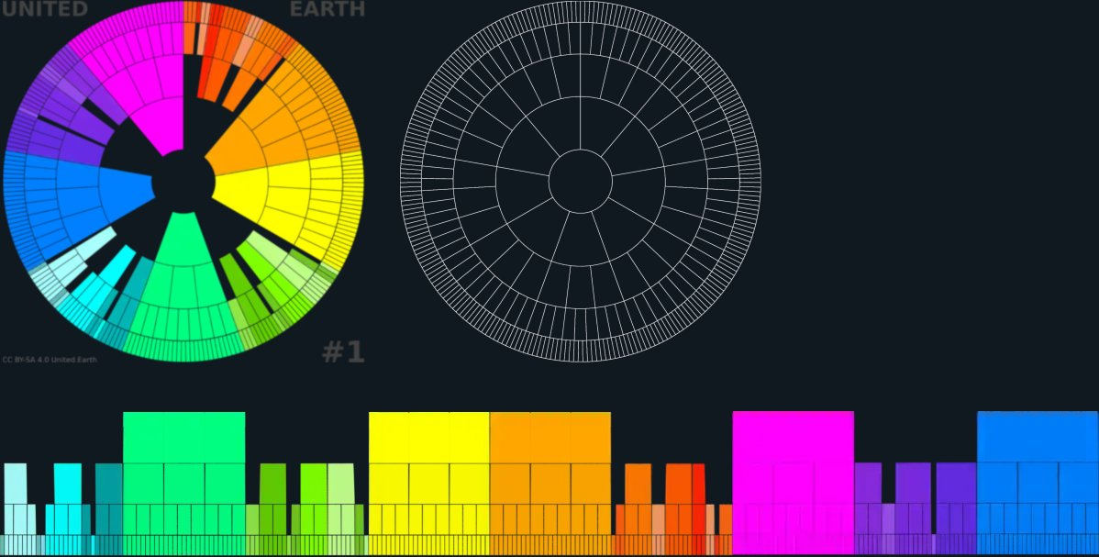
Our “earthwheel” for analysis and proposals
explore here
You may be reading an outdated file. The current edition of this document is always available at https://united.earth/en/downloads/.
Contents
Why global democracy?
Summary
1. Why global governance
1.1 Governance is coordination at the right level
1.2 Sub-global authority cannot solve global problems
1.3 New structure is not a new ideology
1.4 Focus on the solution
2. Geopolitical anarchy
2.1 The geopolitical void
2.2 Sovereignty: random and entrapped
2.3 Oppression of stateless nations
2.4 Paralysis in global crises
2.5 ‘Nation’ is not a synonym for ‘nation-state’
2.6 The academic deadlock: treating global anarchy as inevitable
3. Our possible scenarios - all global
3.1 Global collapse
3.2 Global autocracy
3.3 Global democracy
3.4 Why only these three attractors and paths?
3.5 Democracy must exist before the crisis
4. The glocal connection
4.1 Local is where life takes place
4.2 Destructive, unchecked globalisation
4.3 Global democracy protecting the local
5. Psychological impact and its answer
5.1 Living in global anarchy: numbness and atomised paralysis
5.2 Reclaiming agency and hope: from alarm to structure
5.3 The United Earth Initiative
What is global democracy?
Summary
6. Preconditions
6.1 The intrinsic value of life
6.2 The commons principle
6.3 Subsidiarity and the constitutional allocation of authority
6.4 Separating governance and cultural identities (GOV//ID)
6.5 GeoWeMe: integrating Earth, society, and the individual
6.6 Policy Area Index (PAI)
7. A matrix of geopolitical power
7.1 Reading the GeoMatrix
7.2 Defining the names of the levels
7.3 Defining other common terms
8. The levels of governance
8.1 The global level
8.2 The blocal level (blocs)
8.3 The sub-blocal level (sub-blocs)
8.4 The regional level (regions)
8.5 The local level (loci / local communities)
9. The layers of governance
9.1 Extending the three branches
10. AGORA (layer)
10.1 What AGORA is
10.2 Lifelong civic participation
10.3 Scientific, ethical, and cultural competence
10.4 Learning and competence verification
10.5 Knowledge-weighted direct democracy
10.6 The AGORA Knowledge System (AKS)
10.7 Public AI as democratic infrastructure
10.8 Deliberation, proposals, and the public agenda
10.9 Voting, elections, and continuous democracy
10.10 Transparency, identity, and post-party politics
10.11 Federated architecture, integrity, and resilience
11. The three Councils (layer)
11.1 What the Councils are
11.2 Council of Science
11.3 Council of Ethics
11.4 Council of Culture
11.5 Shared responsibilities and stewardship
11.6 Evaluation, warnings, and public knowledge
11.7 Composition, independence, and democratic legitimacy
11.8 Relationship to AGORA and the branches
12. The three branches (layer)
12.1 The transformed role of the branches
12.2 The legislative branch
12.3 The executive branch
12.4 The judicial branch
12.5 Democratic finality and constitutional revision
12.6 Transparency, accountability, and institutional memory
12.7 Separation and mutual constraint
13. The units of governance
13.1 One governance unit
13.2 The common internal architecture
13.3 The democratic decision cycle
13.4 Relations between units and levels
13.5 The governance-unit headquarters and AGORA node
13.6 The global-blocal node interface
14. The bloc-based peacekeeping system
14.1 One global state, distributed control of military force
14.2 Global authority without global domination
14.3 Procedural escalation and democratic control
14.4 Predictable conflict typology
14.5 Collective security without veto or imperial logic
14.6 No guarantees, but greatly reduced risk
15. A sustainable and just economic system
15.1 The economy as a tool of society
15.2 A post-ideological economic order
15.3 One economic order, distributed authority
15.4 Glocal subsidiarity and local resilience
15.5 The regional level as the primary physical‑ecological coordination layer
15.6 Blocal and global economic coordination
16. Earth civilisation
16.1 A global democratic civilisation
16.2 Governing the planetary commons
16.3 Nature/humanity: 50/50
16.4 Permanent peace as a structural condition
16.5 Prosperity and justice within ecological limits
16.6 A civilisation designed for uncertainty
17. Earth Citizenship
17.1 Citizenship beyond identity
17.2 Rights as conditions for participation
17.3 Responsibilities and fair obligations
17.4 Democratic participation on fair premises
17.5 Living locally in a global civilisation
How can we build it in time?
Summary
18. Build before the crisis
18.1 From alarm to alertness
18.2 Build before authority
18.3 A strategy, not a prediction
19. The global political community
19.1 Earth Parliament Day
19.2 Earth Citizenship introduction
19.3 AGORA and the node network
19.4 Growth as shared capacity
20. GOV//ID as the principle of transition
20.1 From recognised diagnosis to a transition premise
20.2 Map what separation requires constitutionally and legally
20.3 Trace the cultural consequences
20.4 Carry the premise into implementation
20.5 Build global momentum for voluntary transition
20.6 A parallel process that can begin immediately
21. The democratic proto-system
21.1 From movement to proto-organisation
21.2 Build AGORA, the Councils, PAI and AKS
21.3 Develop knowledge-based direct democracy
22. The constitutional order in proto version
22.1 Build the proto-institutions
22.2 Develop the Rights of Life and Earth Constitution
22.3 Build constitutional succession into the system
23. Transformation from within
23.1 Earth Citizens act in two political realities
23.2 Build transitional parties and alliances
23.3 Translate the transition into each political system
23.4 Open the nation-state structure
24. Completing the global and bloc levels
24.1 Form the GOV//ID blocs
24.2 Move sovereignty and execution to bloc level
24.3 Build the global democratic core
24.4 Connect Parliament and blocs
25. The threshold: 4 billion Earth Citizens
25.1 Grow the movement and the system together
25.2 Meet the popular and institutional thresholds
25.3 Trigger the constituent process
26. The first global referendum
26.1 Ratify a known constitutional alternative
26.2 Hold a direct global vote
26.3 Make ratification a real democratic choice
27. Activate the constitution
27.1 Activate constitutional succession
27.2 Transfer the proto-system from United Earth
27.3 Turn proto-authority into constitutional authority
27.4 Declare the constitutional order active
28. Complete the constitutional order
28.1 From active to constitutionally complete
28.2 Transform and integrate existing institutions
28.3 Establish legal and administrative continuity
29. Complete the global federation
29.1 Complete the federalisation of the blocs
29.2 Make the peacekeeping system operational
29.3 Make Earth Government operational
30. Resolve the global crises and restore the Earth
30.1 Turn knowledge into coordinated action
30.2 Protect and restore life
30.3 The system is a means, not the end
31. How the transition could unfold
31.1 One possible sequence
31.2 Different places, different speeds
31.3 Begin where we are

Why global democracy?
Why can’t we seem to act rationally as a global society: stop wars, control climate change, solve the other global threats, and create a peaceful and sustainable society for future generations?
Why is the current stage in our geopolitical evolution outdated, and why is global democracy our only chance of survival?
Why do you need it, and why do we need your participation?
Why “United Earth” and this initiative?

Summary
Our geopolitical anarchy is a condition, not a system, and mounting global pressures will not allow it to remain unchanged. The threats to the biosphere and humanity are global and can only be addressed effectively through coordinated policies and execution at the global level.
We are rapidly approaching a bottleneck with only three possible paths forward: global collapse, global tyranny, or global democracy. To survive the multi-crisis and preserve human freedom, we must establish a global democracy. Crucially, this democratic alternative must be built, tested, and socially rooted before an acute planetary panic makes top-down, totalitarian authority unavoidable.
The questions are: What does global democracy look like, and how do we build it in time?

1. Why global governance
Global governance is a practical necessity. It is the coordinating structure we need when institutions below the global level are structurally incapable of solving shared planetary problems.

1.1 Governance is coordination at the right level
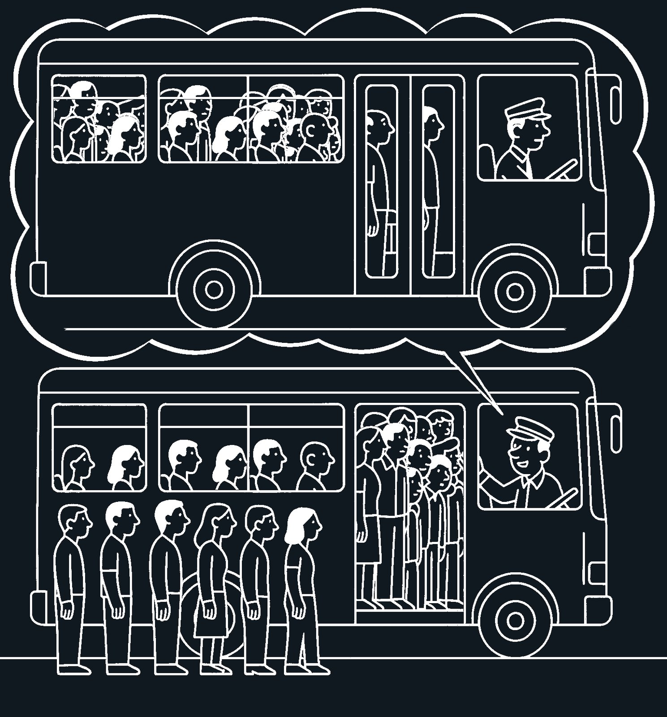
bus-driver-governance
CC BY-SA 4.0 United.Earth Project

The crowded bus paradox
We’ve all experienced it: the front of the bus is crowded, people outside can’t get in, and yet there’s space in the back. No one acts until the driver speaks. Why? Because the collective need for coordination and individual awareness rarely aligns spontaneously.
Individualistic reasons: People are distracted, exhausted, or focused on their immediate journey. Some hesitate because they are travelling a short distance or carrying heavy bags; others assume someone else will act first.
Systemic reasons: People fear social friction. It is not their designated job to direct the crowd. Even those eager to move are physically blocked by the passive majority. When people see that no one else is moving, they conclude that trying is futile.
The paradox illustrates a fundamental truth: the shared needs of a collective cannot be met by individual goodwill alone. Cooperation remains paralysed until the system introduces a recognised coordinating role with a clear mandate to act.
The question of what governance is may seem overwhelmingly complex, but the answer can be quite simple: it is the basic act of enabling a group to solve a shared problem together. When a situation requires collective action and no one has the mandate to coordinate, even obvious solutions fail. People hesitate, wait for others, or assume someone else will act.
Today, humanity shares one interconnected reality: ecological, economic, and digital. Managing this complexity effectively and sustainably requires governance at the same scales on which these systems operate.
Sovereignty and governance must follow the principle of subsidiarity: authority should remain at the lowest level capable of solving a problem, moving upward only when lower levels are structurally insufficient.
As with any shared framework, people naturally comply when coordination is reasonable, applies equally to all, and serves a clear collective purpose. Under these conditions, governance is experienced not as top-down domination, but as system facilitation. Earth society has reached a level of interdependence where such facilitation has become a matter of survival.

1.2 Sub-global authority cannot solve global problems
But our political toolkit was designed for a world of mostly separate societies. The scale of our problems has become global, while the scale of our governance has remained static. When a problem spans the entire planet, no city, nation-state, or alliance can coordinate a complete solution on its own.
Our current international treaties and frameworks remain trapped by a fatal flaw: they depend entirely on the voluntary consent and compliance of sovereign states. While every human desires a livable future, each nation-state is structurally accountable only to its own national population, not to humanity as a whole.
Consequently, even when the world agrees on a catastrophic diagnosis, no institution possesses the legitimate authority to make and enforce the collective decisions required to fix it. This is not a moral failure of world leaders; it is a fundamental design flaw in our global architecture.

1.3 New structure is not a new ideology
The United Earth initiative does not ask the world to adopt a new, all-encompassing political ideology. Instead, it recognises a mechanical fact: the scale of our shared problems has simply outgrown the scale of our governance tools.
This is not a matter of left versus right, or the global North versus the global South. Nor does it require humanity to dissolve its rich cultural identities into a homogenised global monoculture. It is a strictly practical mission: building the democratic, constitutional architecture that today’s interconnected world requires to function safely.

1.4 Focus on the solution
Most of us are already acutely aware that we live in a time of severe, compounding risks. We do not need to list or describe these crises in exhaustive, terrifying detail here. Each specific problem already has its own dedicated communities spanning every aspect of it, from science to politics. Where specific problems are mentioned, like climate change below, it is to exemplify the general points we try to make.
This initiative focuses on the shared, high-level structural barrier that prevents those scientific solutions from being implemented at scale, and on building the solution that removes that barrier.
The following section (#) and the accompanying Earthwheel diagrams provide the deeper geopolitical analysis of this barrier.

2. Geopolitical anarchy
Humanity faces global threats that no state, coalition, or institution can solve alone. Yet our political structure remains fragmented: nearly two hundred sovereign states, each accountable primarily to its own population and commonly deriving legitimacy from a bounded polity. In many cases, that polity is closely associated with a dominant national, ethnic, religious, ideological, or combined cultural identity. Because no shared authority exists at the planetary level, the global arena remains an anarchic void: decisions are needed, but no legitimate actor can make them.

2.1 The geopolitical void
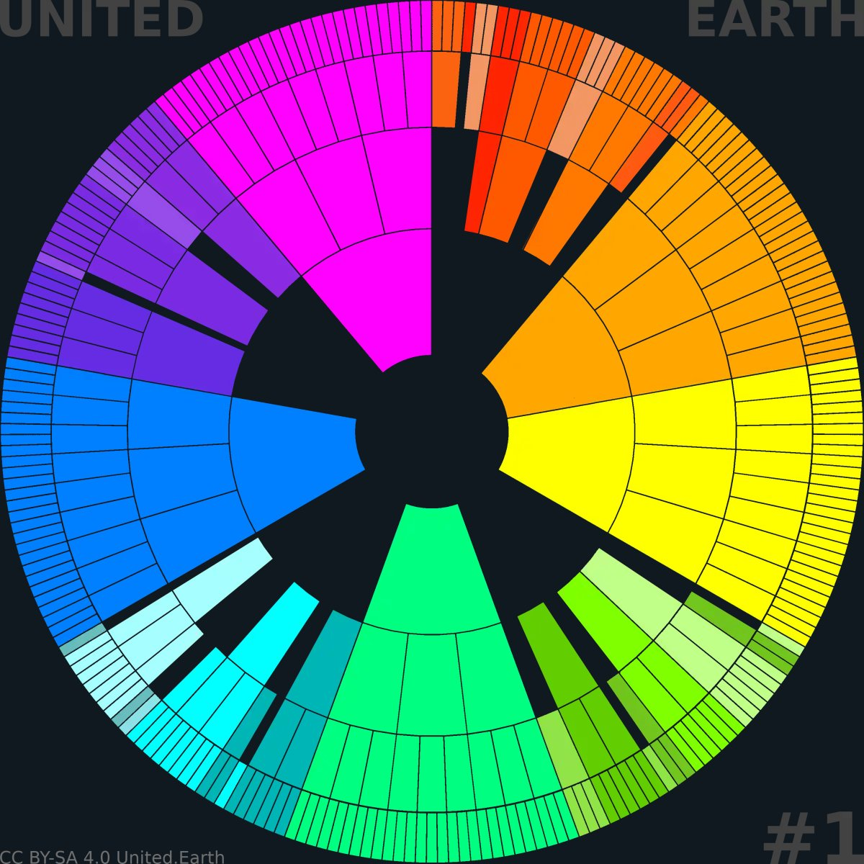
EARTHWHEEL 1/18

A historic result and not a system
The first “earthwheel” illustrates our current geopolitical condition: separate political units of very different sizes, all sovereign nation-states separated by hard borders, and only connected by a fragile set of agreements and institutions at the global level. Without those, we would probably have been in a much worse situation, but they are far from what we need to tackle the global threats adequately.
The empty centre represents the geopolitical void: a missing layer where coordinated authority should exist. The void has an irregular shape since many parts of the world have yet to form blocs.
Read more about the earthwheels here.
Throughout history, the global arena has been shaped by shifting balances of power rather than by a shared political system. Empires, alliances, and spheres of influence have come and gone, but there has never been a democratic framework representing humanity as a whole.
In the second half of the 20th century, the so-called “Pax Americana” created a degree of stability for some parts of the world, but at the cost of proxy wars, military interventions, and an economic order that has disproportionately favoured a small global elite.
The UN system performs indispensable humanitarian, diplomatic, normative, and technical work. Yet it remains constitutionally dependent on its sovereign member states and lacks independent democratic authority over them. The arrangement with five permanent veto powers—a historical compromise frozen since WW2—illustrates how limited and imbalanced the institution is when facing today’s global challenges.
The result is what the first “wheel” shows: a world full of powerful actors and institutions, but no centre—no legitimate place where pressing global existential problems can be solved.

2.2 Sovereignty: random and entrapped
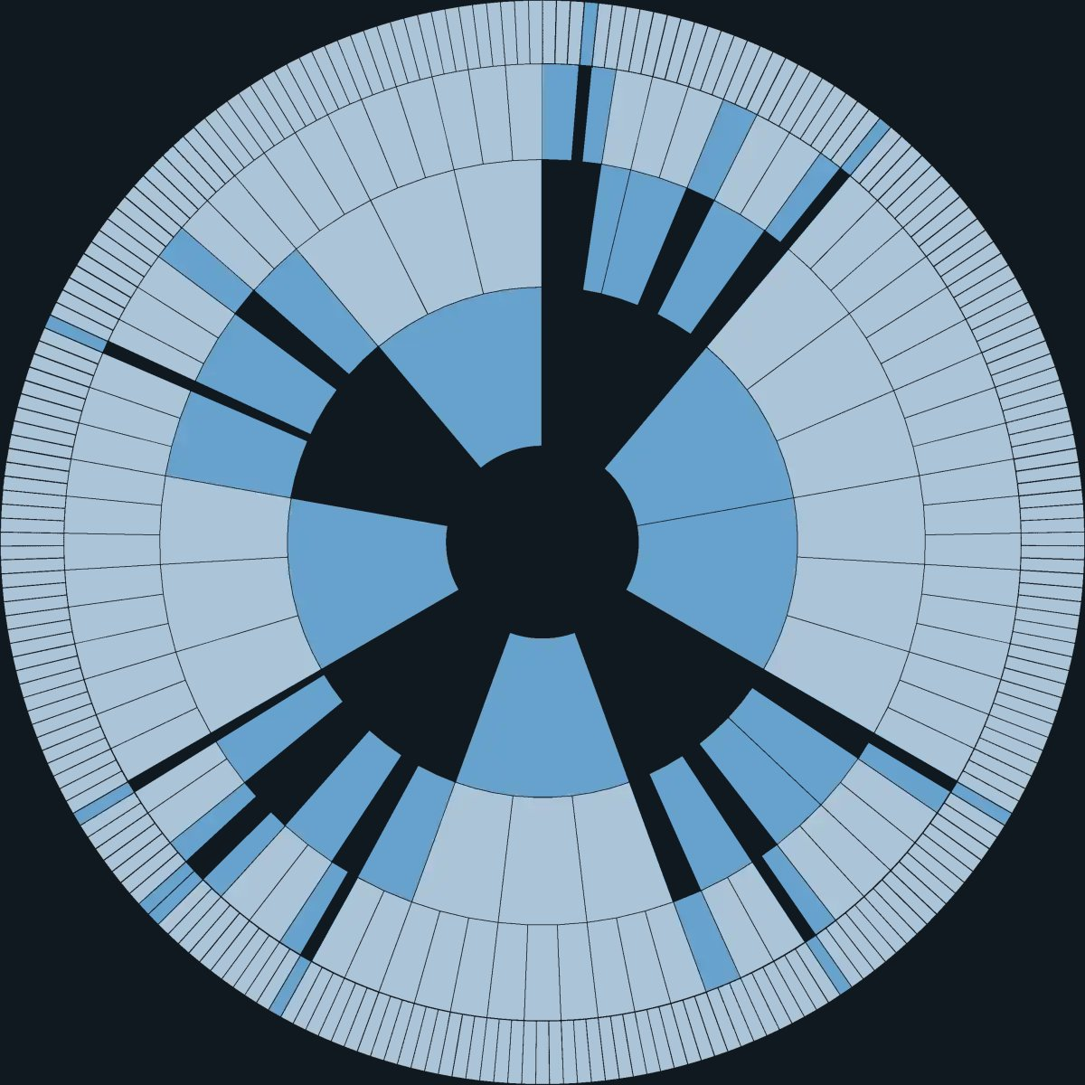
Fragmented sovereignty
CC BY-SA 4.0 United.Earth Initiative

Fragmented sovereignty
Here, our “earthwheel”, with its five levels, is used to illustrate how sovereign nation-states today vary in size and population.
The giants, Brazil, China, India, the USA, Russia, and others, are units at the bloc level.
Medium-sized states, the largest group, are at the sub-bloc level. They are comparable in size to provinces in Canada, China or India, oblasts in Russia, or states in Brazil or the USA.
The smallest ones are comparable to regional or even local units within the sub-blocs, including island nations formed through decolonisation, and European microstates.
Political authority today is distributed unevenly across the planet. Some nation-states are continent-sized, others smaller than medium-sized cities, yet all are treated as equally “sovereign” in international law. This randomness in size is not only a historical accident — it produces real distortions. Fair representation becomes extremely difficult to design at the global level, power imbalances become extreme, and large states can use economic or political leverage to secure support from very small ones. Under these conditions, global democracy risks becoming a theatre rather than a meaningful system.
Tuvalu, with fewer than 12,000 inhabitants, and India, with more than 100,000 times that population, both count as fully sovereign nation-states in international law, holding the same formal status and equal voting rights in the UN General Assembly despite their vastly different scale, capacity, and global impact. The problem is not that small states are illegitimate, but that formal sovereignty is distributed among territorial units of radically different scales without a coherent global constitutional structure. This problem alone calls for a real and properly designed geopolitical system.
On its own, this randomness would be a practical challenge — but not an impossible one. The deeper structural problem is that sovereignty and cultural identity are fused. Political authority is commonly justified through identity—national, ethnic, religious, ideological, or a combination of these—and the dominant identity in turn depends on sovereignty to maintain its political position and territorial claim.
As a result, sovereignty becomes extremely difficult to redistribute or reorganise. Any shift toward shared governance can be experienced as a threat to the dominant identity. Sovereignty becomes a shield—held tightly not only for effective governance, but to preserve identity-based control. This stops political evolution at the nation-state level and blocks the development of higher-order structures.
The result is the pattern shown in the earthwheel image: sovereignty exists on local, regional, sub-bloc, and bloc levels, but the global level remains empty. As long as sovereignty cannot move upward, coordinated planetary governance remains structurally impossible.
The current pattern of sovereignty is therefore random, rigid, and incomplete. We need to redesign this pattern based on new first principles.

2.3 Oppression of stateless nations
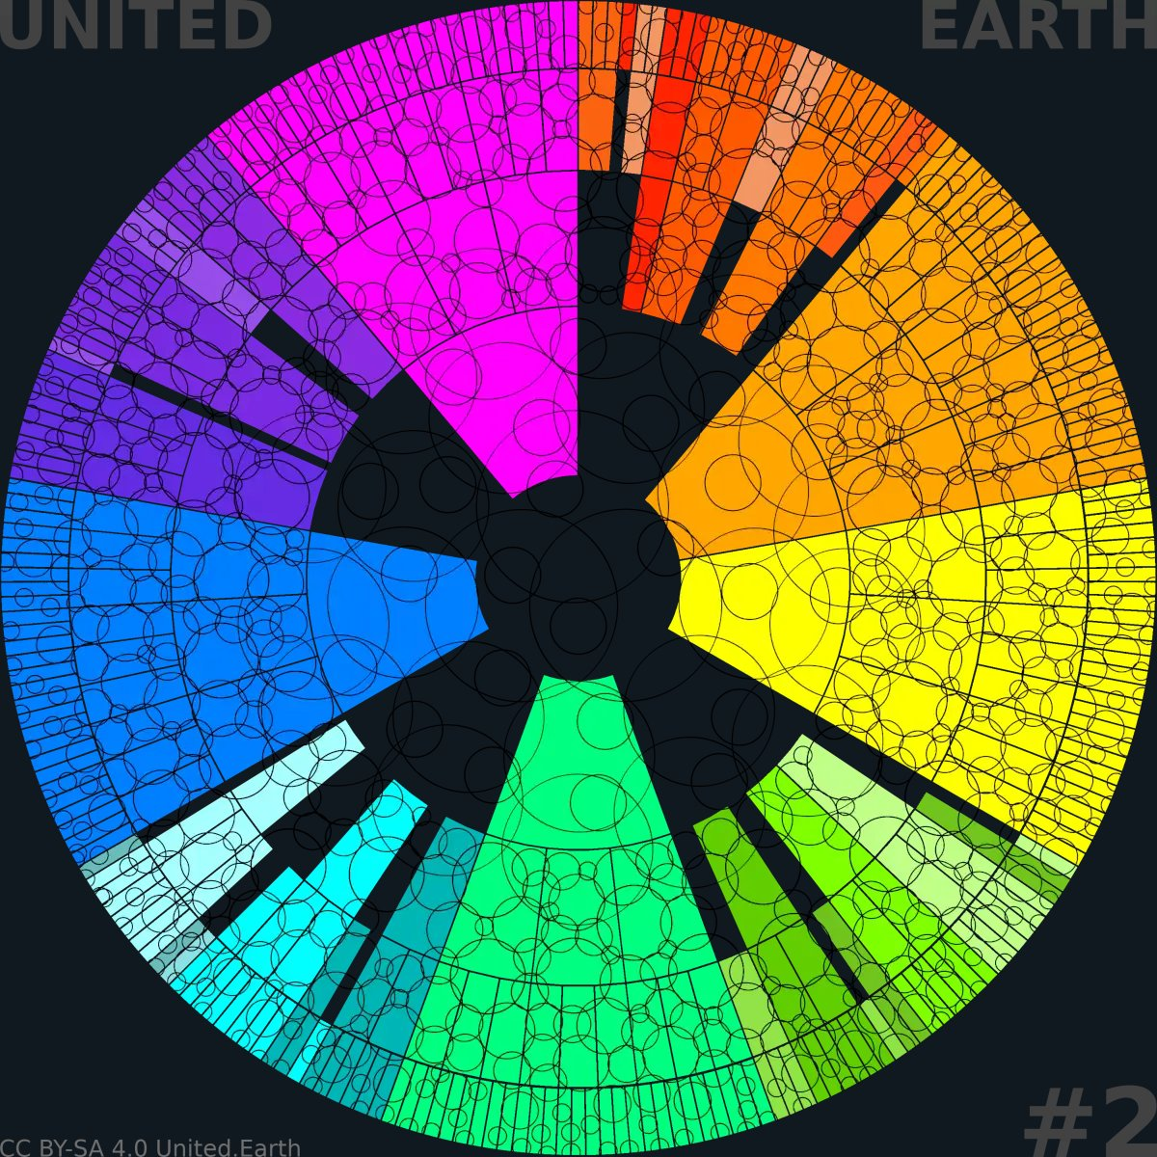
EARTHWHEEL 2/18

A perpetual cause of conflict and war
There are thousands of cultural identities without sovereign territorial recognition, including many groups commonly called “stateless nations”, which may span borders or be dispersed across the globe. By some estimates, those who define themselves as belonging to stateless nations or comparable identities could constitute as much as 20% of humanity, including most indigenous peoples, estimated to constitute 4–7% of us.
The overlapping circles illustrate how cultural identities cross territorial borders and may lack equal political recognition within the fewer than 200 sovereign nation-states.
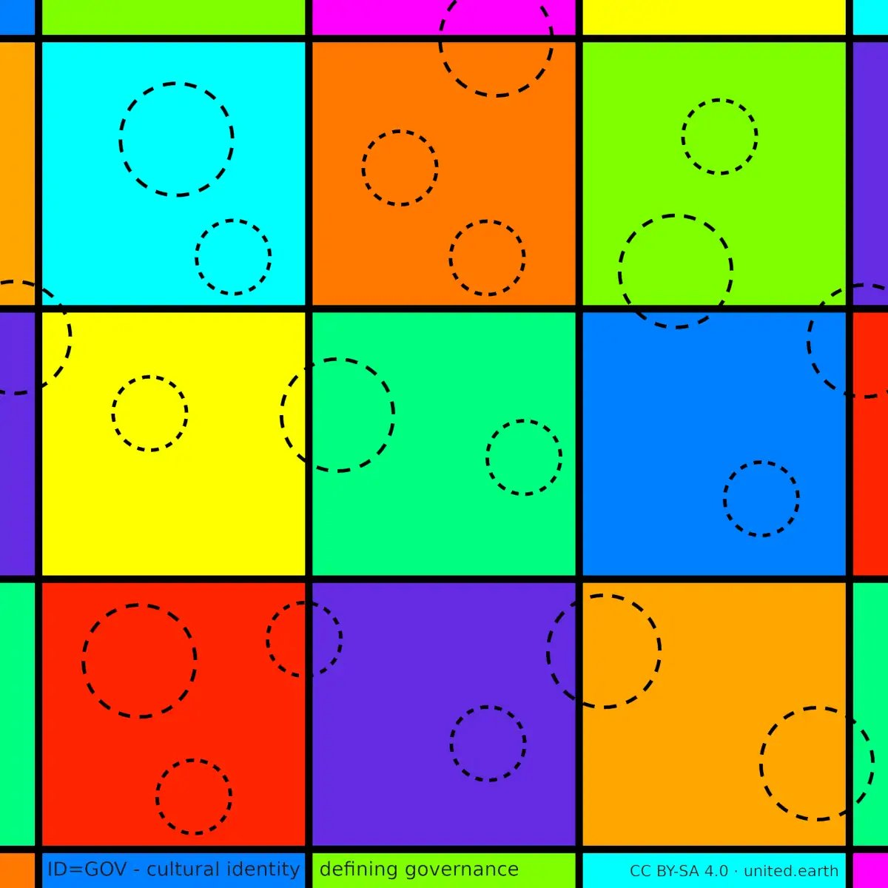
ID=GOV principle
The ID=GOV “idgov” condition:
Identity (ID) defines and justifies governance (GOV)

A more schematic illustration
The squares in this illustration represent units of governance, corresponding to today’s nation-states.
The straight continuous lines represent their hard borders, and the black dashed circles represent stateless nations and other identities that may be marginalised within states whose dominant identities won statehood in “history’s lottery”.
In an identity-based state system, each territory is commonly formally linked to one dominant identity: a nation (ethnic and/or civic), a religion, an ideology, or usually a mix of these. People who define themselves through other identities may then be pressured to assimilate, accept permanent minority status, or resist.
This is a huge issue, which is often minimised by those who happened to win statehood through what might reasonably be described as “history’s lottery”: the result of events like wars, royal marriages, or colonialism. By some estimates, up to one-fifth of humanity belongs to communities that see themselves as nations, peoples, or cultures without their own recognised territory; the “stateless nations”. Most Indigenous peoples are in this situation. Many more live as minorities inside states that officially represent another national, ethnic, religious, or ideological identity.
These groups are not only underrepresented; they are often treated as security problems, internal enemies, or bargaining chips in regional conflicts. Demands for recognition can trigger repression, secession wars, forced assimilation, population transfers, even genocide or ethnic cleansing. The result is a permanent source of instability built into the system itself.
The conclusion should be obvious by now: a geopolitical order that ties political authority to a single cultural identity will, by design, keep producing recurring conflicts. This is a core flaw of our geopolitical condition.
Separating government from cultural ownership would remove the assumption that recognition and security require exclusive control of territory by a single identity group. This is the key move to unlocking the potential humanity has for peaceful and sustainable coexistence with one another and with the biosphere.

See our ID=GOV>GOV//ID page; a proposal for creative and innovative terms providing the conceptual language needed for a peaceful and sustainable Earth civilisation.

2.4 Paralysis in global crises
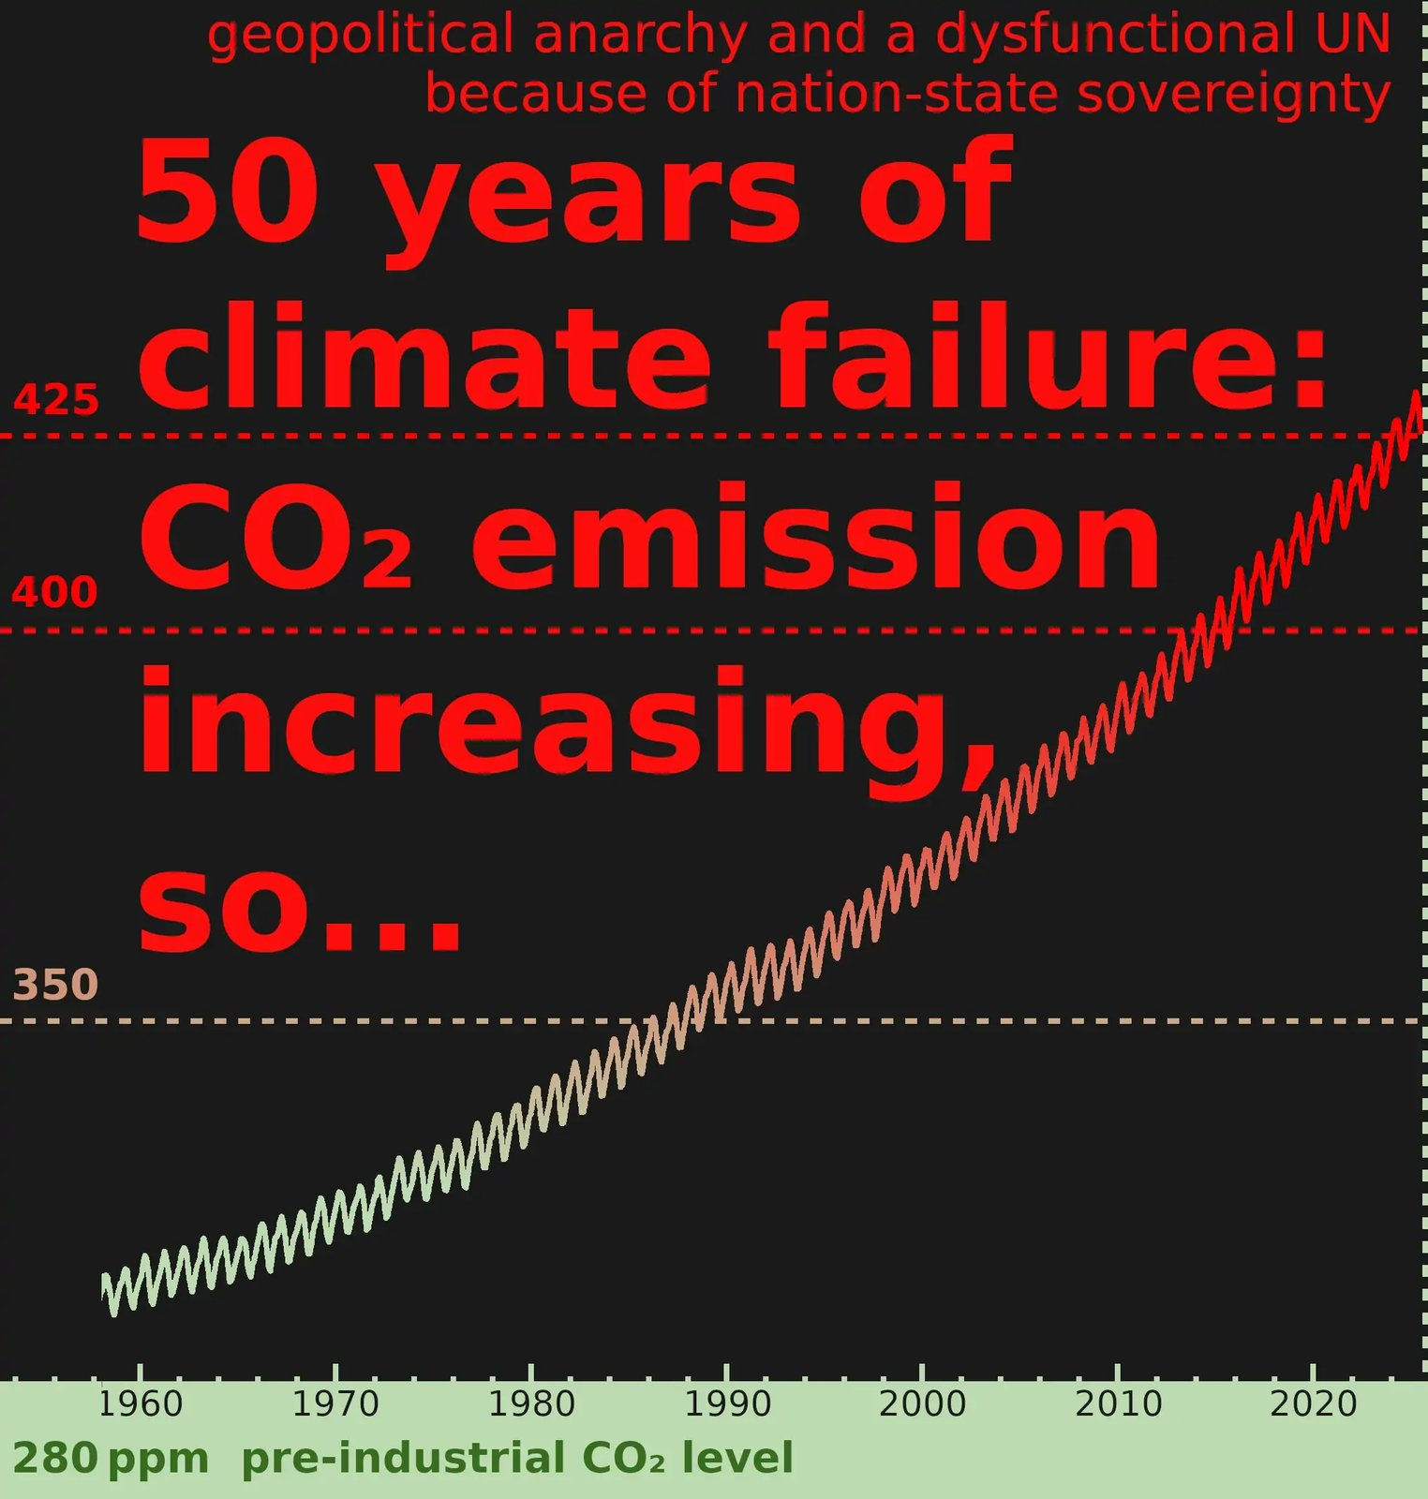
Climate paralysis 2025

A systemic failure on display
The Keeling curve shows what happens when global crises encounter a system without global authority. For more than 50 years, atmospheric concentrations of CO₂ and other greenhouse gases have increased despite countless summits and agreements, because the nation-state anarchic condition has failed to produce binding coordination capable of overcoming the political and economic forces driving them. Our overall attempt at coordinated global climate action has been a tragic failure, despite all the honourable efforts of millions of committed individuals. We’ve even reached such a low point that many world leaders dare to lie publicly, claiming that the problem doesn’t even exist. It may get them votes from the many who share that denial as a temporary comfort strategy, but the result is obvious: this shameless populism only makes the problem worse for us all.
It’s time to face the simple fact: Without a real geopolitical structure of governance, we cannot stop climate destruction.
CC BY-SA 4.0 United.Earth Initiative
Climate is the clearest, but not the only, example of how geopolitical anarchy blocks rational global action. For more than half a century, governments have known that rising greenhouse gas emissions threaten the stability of the entire biosphere. They have negotiated treaties, set targets, and announced pledges—yet the overall curve keeps climbing. The UN climate process has produced knowledge, agreements, and partial progress, but not binding global coordination sufficient to reverse the overall trajectory.
This outcome is not the result of ignorance, indifference, or a lack of technological options alone. It also follows from a basic coordination dilemma: Governments know that coordinated action would benefit all, but they also know that acting alone carries costs if others do not follow. Accountability, however, stops at national borders, while the atmosphere is shared by all life. In the absence of an authority with the mandate to align efforts across those borders, hesitation becomes rational, and delay becomes systemic. The fragmented political order has not been able to overcome fossil interests, technological lock-in, economic inequality, domestic political resistance, and other forces through binding coordination at the speed and scale required.
The same pattern appears beyond climate. Biodiversity loss, ocean degradation, unmanaged pandemic risks, and the rapid deployment of powerful technologies all unfold in a world where responsibility is global, but authority remains fragmented.
These crises are therefore handled as negotiations between competing interests rather than as shared responsibilities requiring binding coordination.
The conclusion is not that humanity lacks concern, knowledge, or capability. It is that it lacks legitimate democratic authority at the global level. Such authority would not need direct executive control over people’s daily lives or over the land territories where they live. It would need only what any effective coordinator requires: the mandate to align collective action toward shared goals when individual, national, or voluntary action is structurally insufficient.
As long as this coordinating level is absent, global crises will continue to be managed below the scale at which they occur. That is why we conclude:
Global anarchy makes global sustainability impossible.

2.5 ‘Nation’ is not a synonym for ‘nation-state’
A central reason why the current geopolitical order persists despite its growing dysfunction lies not only in power structures, but in language itself.
In political discourse, media, education, and much academic writing, the terms nation, nation-state, state, and country are routinely used as if they were interchangeable. This practice collapses fundamentally different phenomena into a single, seemingly self-evident concept.
This is not a neutral linguistic shortcut. It has decisive structural consequences. By collapsing cultural identity and systems of territorial governance into one concept, public discourse consistently obscures the fact that the nation-state is nothing but one of several possible choices for governance design, historically produced and contingently maintained, rather than an inevitable feature of political life.
This semantic fusion functions as a form of structural propaganda without a propagandist. No coordinated effort is required to defend the nation-state model; its assumptions are continuously reproduced through habitual language use. Over time, this creates a cognitive taboo: the nation-state is treated as the unquestionable unit of political reality, while alternative structures become difficult even to articulate.
As a result, political debate is overwhelmingly confined to questions of policy within the nation-state framework, while the framework itself is rarely subjected to structural scrutiny. Questioning the nation-state is easily perceived as questioning identity, belonging, or legitimacy itself, even though these are conceptually distinct.
The consequence is a form of intellectual paralysis. Global crises are analysed in detail and their urgency widely acknowledged, yet the structural conditions that prevent effective global coordination remain largely unexamined. The nation-state persists not because it works, but because public discourse consistently closes the conceptual space required to question and redesign it.
This semantic lock-in helps explain why proposals for global governance are so often dismissed as unrealistic, dangerous, or utopian, while a status quo demonstrably failing at the global level is treated as inevitable. It also helps explain the recurring academic tendency to treat global anarchy as inevitable, which is addressed in the following section.

See our ID=GOV>GOV//ID page; a proposal for creative and innovative terms providing the conceptual language needed for a peaceful and sustainable Earth civilisation.

2.6 The academic deadlock: treating global anarchy as inevitable
A further obstacle to geopolitical evolution is intellectual rather than structural. For decades, structural realism within International Relations (IR) has treated international anarchy as a persistent defining condition of world politics. This tradition sees global anarchy as an unchangeable condition.
This framework describes many of the incentives and power dynamics created by the present geopolitical structure well. The problem begins when this conditional description is treated as evidence that global anarchy is permanent, or that a democratic global political system cannot be built.
The fact that the nation-state system has dominated the past does not prove that humanity cannot evolve beyond it. Structural realism explains how states behave under anarchy; it does not by itself prove that anarchy cannot be constitutionally replaced. When the present structure is treated as inevitable, a historical arrangement is turned into a practical limit on political evolution.
Such intellectual resignation is harmful. When global anarchy is presented as permanent, it can legitimise a system that is already failing in the face of climate change, biodiversity loss, pandemics, technological risks, and escalating conflicts. It narrows imagination at exactly the moment when humanity needs new thinking.
In an interdependent world, treating democratic global governance as impossible is not a neutral conclusion. It can help preserve a failing status quo by preventing structural alternatives from being seriously considered, such as constructivism. A descriptive theory becomes politically conservative when its account of existing incentives is used to rule out institutional transformation.
We challenge this in two ways:
1) Global realism — We propose a new theoretical perspective that reframes the term realism for the 21st century. True realism today must be defined by the concern for how structures are capable of handling global threats.
2) Global Relations (GR) — We propose renaming the entire field. The term international presupposes that nations and nation-states are the primary building blocks of political order. This embeds the current system into the discipline’s base language. Renaming the field to Global Relations acknowledges our global realities as the main framing for the whole field of study.

See the article Global Realism and Global Relations (GR)

3. Our possible scenarios – all global
Humanity now shares a single global destiny. What happens next no longer depends on decisions made by individual nation-states, but on whether we actively choose to shape power at the planetary level or allow it to form blindly in a panic. We are rapidly approaching a bottleneck with only three possible paths forward.
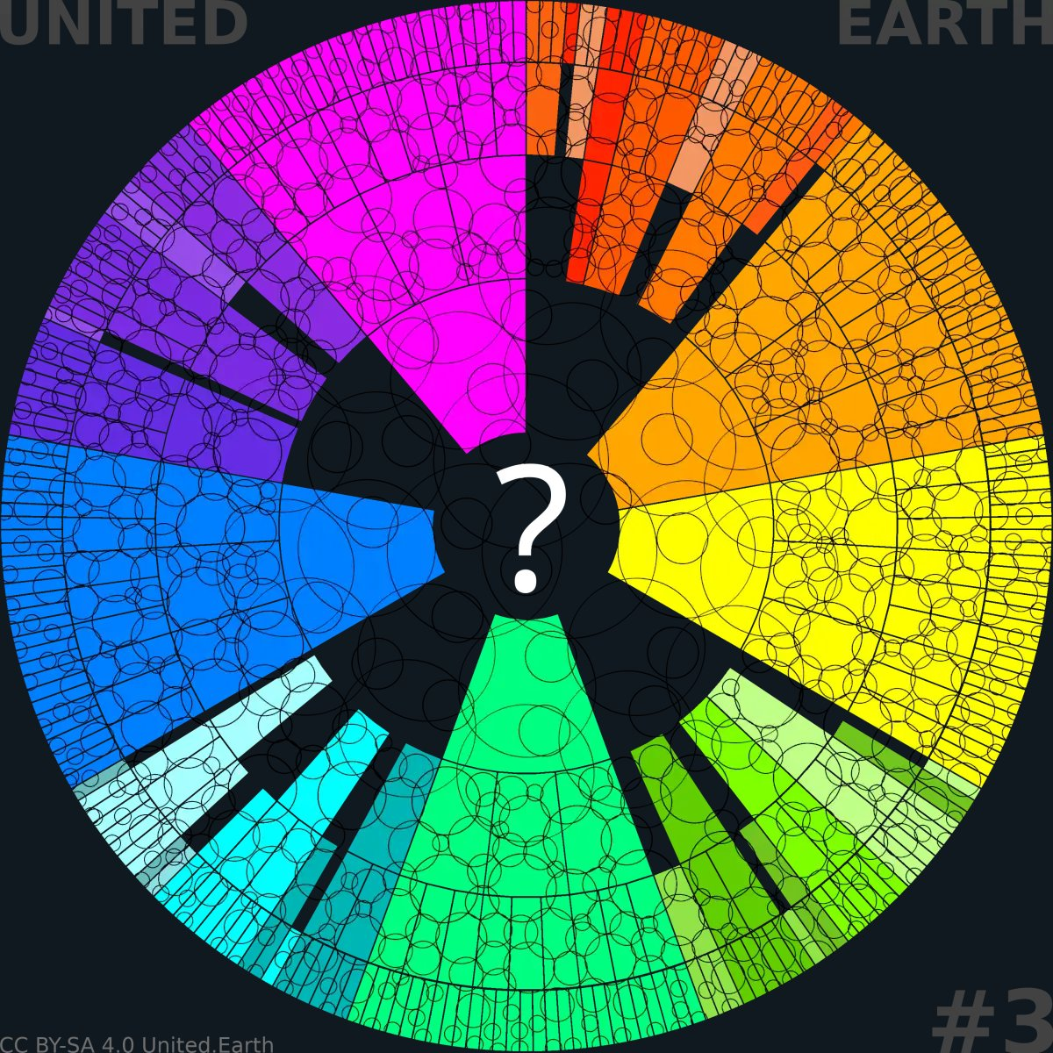
EARTHWHEEL 3/18

Where can we go from here?
Business as usual (whatever that is anymore)?
Trusting nationalistic protectionist populism?
Betting on a big-tech global takeover?
Hoping for a theocratic solution?
Or…
… build a fair and inclusive global democracy for all ethnicities, nations, religions, ideologies, and other socio-cultural identities, protecting them all, while governing pragmatically for the optimal living conditions within sustainable boundaries?

3.1 Global collapse
When we speak of collapse, we mean a trajectory in which ecosystems are severely damaged or destroyed, large regions of the Earth become uninhabitable, sea levels continue rising for centuries as ice sheets melt, and global temperatures increase far beyond levels compatible with organised society. Such pressures will fuel famine, mass displacement, widespread conflict, and probably the use of nuclear or other weapons of mass destruction. Other global risks exist as well, such as asteroid impacts, supervolcano eruptions, or extreme solar storms, but the most immediate danger comes from our inability to coordinate at the global level to prevent the collapse we can already foresee.
This is the path we are already drifting toward. Climate impacts worsen, ecosystems weaken, and societies become more polarised and fragile. As pressures rise, states turn inward, cooperation breaks down, and essential systems fail in sequence: food, economy, security, and governance. Once key tipping points are crossed, no emergency measures can restore stability.
Collapse is not a choice. It is what happens if we do nothing about the core problem: the lack of global governance.

3.2 Global autocracy
Where cooperation fails, power concentrates. Around the world, democracy is retreating, and authoritarian leaders gain influence by exploiting crises and weakening institutions.
A global autocracy could emerge via different paths: through coalitions of authoritarian blocs, tech-driven systems of behavioural control, or militarised alliances consolidating power in the name of stability. As global crises deepen, the need for coordinated action will only increase, and the likelihood of these forces fusing into a global system will be high.
Yet such a system can only postpone collapse, not create long-term sustainability. A global tyranny would depend on coercion, surveillance, and the suppression of dissent. This would weaken the open information, criticism, trust, and voluntary cooperation needed to detect errors, correct policy, and mobilise humanity for sustained collective action. It would also concentrate the consequences of misjudgement and institutional capture within a system with no external corrective power.
Under the combined pressure of repression, inequality, internal rivalry, and a deteriorating biosphere, such a system would eventually fracture or lose the capacity to govern the crisis. An authoritarian world order may impose temporary stability and preserve pockets of luxury for the few, but it cannot resolve the underlying crisis. It leaves humanity on a slower and more oppressive path toward collapse.
The development of AI is emerging as a new and main component in this picture. Not only are AI systems being embedded in surveillance and military systems, which increases the power of elites tremendously. But AI systems are on the verge of creating their own agencies, which could very well lead to a world ruled by them. This threat is increasingly being warned about by many of the people who are central in the development of this technology. There is a real chance that autocratic AI will rule humanity…
… or simply kill us all as the useless stewards of Earth we so far have proven to be.

3.3 Global democracy
Global democracy means placing only those policy areas that genuinely require global coordination under binding global authority. It does not mean cultural homogenisation, as many fear; it can and must be constructed to safeguard the dignity and continuity of all identities while ensuring that governance itself remains impartial. It requires a political culture that looks beyond identity conflict toward shared responsibility for life on Earth.
Humanity has already agreed on the foundational principles of the Universal Declaration of Human Rights. Now we simply must build upon that foundation to include all life and the entire climate and biosphere. Global democracy is not an ideology; it is a pragmatic response to our interdependence. It offers what no other system can:
- The ability to prevent war through legitimate cooperation
- The coordination needed for climate and ecosystem restoration
- The safe governance of digital and orbital infrastructures
- The protection of basic rights across borders
Global democracy is the only scenario capable of long-term stability, because it offers a path where everyone is included without being forced or oppressed, but by respectfully welcoming the creative contributions from all of us.
Most importantly, a democratic global system provides a framework where everyone can contribute freely, creatively, and without fear. Without harvesting this shared potential, humanity will not get through the coming turmoil.
For both practical and ethical reasons, global tyranny cannot be the path forward. Only a democratic global system has the legitimacy, adaptability, and resilience needed to avert collapse in the long run.
Global democracy does not assume that human aggression, tribalism, short-termism, or struggles for power will disappear. Its purpose is to limit and distribute power, expose conflict to law and public scrutiny, and prevent any single institutional or political failure from becoming planetary collapse.

3.4 Why only these three attractors and paths?
Our mixed world is not a stable model for the future. It is a temporary state, sustained only because global pressures have not yet crossed the threshold that demands binding planetary coordination.
Today, modern civilisation relies on tightly coupled systems: climate, ecosystems, finance, and security. Under rising stress, these systems do not fail in isolation; they compound. Ecological degradation triggers resource scarcity, scarcity ignites global conflict, and war destroys the very capacity for international cooperation. In this multicrisis, fragmented authority is fatal. Delayed decisions, vetoes, and free-riding stop being political friction; they become direct triggers for cascading global failure. At this threshold, binding coordination is forced upon us by the physics of survival.
For planetary coordination to work, it must operate within a coherent political and constitutional structure. At the highest level, this structure must rest on a coherent principle of legitimacy, because the final authority to make and enforce binding decisions cannot rest indefinitely on both consent and control. Democracy and autocracy are mutually exclusive foundations of final authority: one governs by consent, the other by control.
A hybrid global order is therefore not a durable, integrated endpoint. It is either the continuation of the current fractured world or a transitional arrangement awaiting the final crisis.
Under existential pressure, this middle ground dissolves. The global system will be driven toward one of three broad attractors:
- Collapse: Coordination fails, resource wars escalate, and the biosphere and human civilisation undergo a cascading breakdown.
- Authoritarian consolidation: Global order and resource rationing are imposed through concentrated, top-down power.
- Democratic integration: Binding planetary coordination is established through shared, legitimate governance and enforceable universal laws.
At the level of final authority, a global system must rest on the same constitutional foundation throughout. An authoritarian world order cannot allow democratic enclaves to retain sovereign authority indefinitely, because they challenge centralised control. A democratic world order may temporarily include non-democratic units during a transition, but their populations cannot be denied democratic rights and participation indefinitely without undermining the legitimacy of the system as a whole.
There is no durable hybrid future at the level of final global authority. Faced with a destabilised biosphere and the threat of total war, humanity will either fail to establish sufficient coordination and collapse, or establish a binding global order. If we succeed, that order will ultimately derive its legitimacy from either control or consent: autocracy or democracy.
The question is not simply whether global governance will emerge, but whether coordination fails, or which form of global governance prevails.

3.5 Democracy must exist before the crisis
Democratic global governance cannot be improvised once an existential crisis already demands immediate coordination and execution. It requires a global political community, a functioning public sphere, democratic procedures, legal principles, institutional checks on power, a resilient knowledge infrastructure, and a foundational trust developed through actual practice.
If these pillars do not exist when the need for binding global authority becomes unavoidable, the immediate advantage will belong to the institutions and actors that already control capital, technology, data, security systems, and physical force.
Global autocracy does not need to begin with a single, coordinated seizure of power. It can emerge organically as emergency governance that gradually becomes permanent.
The democratic alternative must therefore be developed, tested, and socially rooted before the crisis makes the choice acute.
Humanity must build the democratic global system before the world is forced to choose a global system in panic.

4. The glocal connection
The glocal reality is already here: the global and the local are inseparable, and the quality and integrity of each depend on the other. The everyday conditions of our streets, workplaces, homes, and local cultures ultimately reflect systemic forces operating far beyond them.
Local meets global: A tightrope performer balances above a street in Ladakh, western Himalayas, beneath advertising from the globalised communications economy. Image by PublicDomainPictures from Pixabay
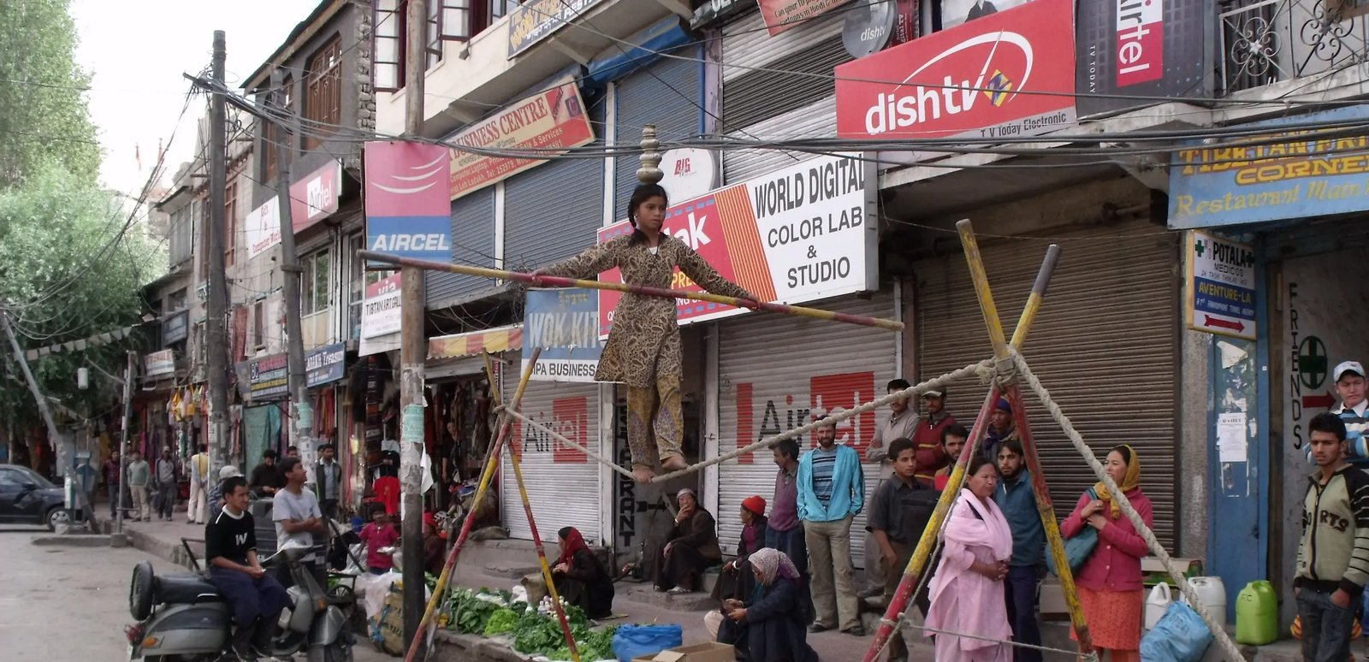
Local meets global in Ladakh, western Himalayas

4.1 Local is where life takes place
All human experience is local. We eat, sleep, work, raise families, and build culture in physical environments shared with neighbours, not inside abstract states, trading blocs, or geopolitical categories. Even the individuals who make monumental decisions in parliaments, ministries, corporate boardrooms, or international summits do so inside buildings embedded within local communities.
This groundedness makes the local level the true cradle of human meaning and belonging. It is where identity forms, where community is felt, and where the visceral consequences of political decisions are experienced.
Any higher level of governance must therefore be judged by a single, uncompromising question: Does it protect and sustain the specific places where people actually live their lives?
Higher levels of governance are instruments, not ends in themselves. Their ultimate purpose is to protect the conditions under which local life can remain viable, free, and diverse. Yet local communities no longer control all the forces that shape those conditions.
Local life is lived locally, but it is increasingly shaped globally.

4.2 Destructive, unchecked globalisation
Today’s dominant form of globalisation has evolved without democratic governance operating at the same global scale. Corporations, financial actors, digital platforms, supply chains, and powerful states move resources and exercise power across frontiers, while democratic authority remains largely confined within national borders. The severe externalised costs of their actions are routinely pushed downward onto local environments, workers, and vulnerable communities.
Jobs vanish, local economies are destabilised, public spaces and local cultures are hollowed out, and environmental degradation is left in the backyards of ordinary people. Decisions taken thousands of miles away become conditions that must be endured locally.
This systemic loss of control produces a powerful psychological backlash. Confronted by distant, unaccountable forces, many people retreat into defensive nationalism, aggressive protectionism, identity politics, and deep distrust of global institutions. This desire to defend one’s community and reclaim agency is entirely rational.
It is therefore completely understandable why global governance itself can appear to be part of the threat. Yet the destructive forces of globalisation do not arise from democratic authority at the global level. They can operate across and damage communities precisely because no such authority exists to govern them.
Nation-state governments can regulate within their own jurisdictions, but they cannot single-handedly govern transnational corporations, cross-border financial flows, global supply chains, borderless digital architectures, or a collapsing biosphere. A political retreat behind national borders does not bring these forces back under nation-state control. The forces remain global; only democratic oversight retreats.
The absence of democratic global governance is not a shield against destructive globalisation. It is the very vacuum that allows it to remain unchecked.

4.3 Global democracy protecting the local
The antidote to destructive globalisation is not a political retreat into smaller, fragmented units, but democratic governance at the level where global power operates. When planetary coordination is democratic and accountable, it ceases to be a distant threat and becomes a protective framework for the places where life actually unfolds.
Global democracy must be structurally strong enough to govern global forces, yet constitutionally limited enough to leave local life locally governed. This vital balance is secured through the principle of subsidiarity: authority remains at the lowest level capable of handling a matter, moving upward only when the problem exceeds the capacity of the levels below.
Under this architecture, global institutions must regulate the systems and activities affecting the climate, govern the global commons and transnational economic and technological power, and maintain international peace and security. Simultaneously, local and regional communities must retain full authority within their constitutional areas of competence.
By setting enforceable boundaries for large-scale economic, technological, and political forces, global democracy restores rather than removes local agency. It creates the structural conditions for the macroeconomic and ecological stability required for cultural identities, neighbourhoods, workplaces, and ecosystems to thrive rather than be overwhelmed by unregulated global pressures.
The goal is to stabilise the planetary conditions that allow diverse local societies to remain free, secure, and viable.
As stated above, and it is worth repeating: it is understandable why many people see the very idea of global governance itself as a part of the threat. This scepticism is what fuels the withdrawal to nationalism and other identity-based protectionism that we see all over the world nowadays.
This is a huge mistake. It only makes all the real global problems worse. We challenge this trend with the following claim:
Global democracy is not the enemy of local freedom. It is the missing constitutional structure required to defend it!

5. Psychological impact and its answer
The fragmented geopolitical conditions described above produce not only the risk of material catastrophe, but also widespread psychological distress and disengagement. These effects are neither random nor signs of individual weakness. They signal a structural failure, which means that a credible political response must also be structural.

5.1 Living in global anarchy: numbness and atomised paralysis
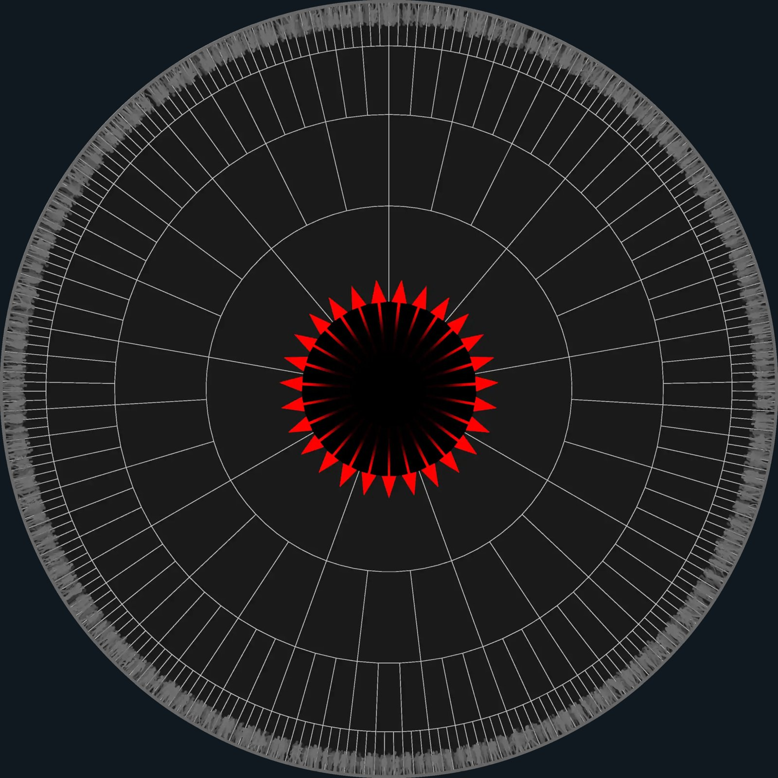
Paralysis caused by overwhelming global threats and geopolitical anarchy

Paralysis caused by overwhelming global threats and geopolitical anarchy
Here, our Earthwheel model serves as a metaphor for widespread political paralysis. Humanity appears as a passive grey mass, while the missing global core manifests as a black hole emitting continuous alarms. The red arrows represent relentless signals of existential danger that find no coordinated collective response.
CC BY-SA 4.0 United.Earth Initiative
Numbness describes a condition in which repeated distress signals no longer produce a meaningful response. A comparable paralysis now characterises much of our global political reality.
People are exposed daily to a compounding cascade of crises: climate inaction, ecological collapse, economic instability, territorial wars, and the erosion of international law. Yet many feel fundamentally unable to respond in ways that matter. Some look away and focus on the parts of life they can still influence. Others concentrate on valuable local projects or throw themselves into global activism, only to burn out when their efforts fail to alter the larger structure. While each response is deeply understandable, none can by itself compensate for the missing global architecture. The collective result remains atomised paralysis.
This pattern should not be mistaken for apathy, ignorance, or a lack of human empathy. It is a predictable psychological response to prolonged exposure to existential alarm without access to a credible and effective vehicle for collective action.
This withdrawal is further reinforced by a global political landscape increasingly dominated by extreme rhetoric, blatant institutional contradictions, and the open abandonment of shared international principles. Highly visible leaders make claims that were recently unthinkable, reverse positions without explanation, and treat raw power as its own justification.
When this behaviour is repeated without consequence, public attention can shift from analytical understanding to raw emotional reaction, and eventually to disengagement. The core issue is not the character of these individual actors, but what their actions expose: a world order where systemic coherence is unravelling and reasoning increasingly fails to constrain power.
The structural truth remains simple: no single individual, community, NGO, or nation-state can resolve planetary challenges in isolation. Millions of well-intentioned individual actions cannot by themselves produce a global solution if the coordinating layer is missing, especially when powerful state and corporate actors remain free to actively undermine the common good.
This is precisely why voluntary frameworks such as the COP process cannot deliver sufficient results on their own. People can see this systemic insufficiency directly: despite decades of global treaties, atmospheric CO₂ concentrations continue to rise year after year. It is no surprise that hope erodes. Many people and institutions are trying, but our current tools remain structurally incapable of delivering results at the scale required.
Numbness, then, is not a personal failure. It is a rational protective response in a system where perception does not reliably lead to effective collective consequence.

5.2 Reclaiming agency and hope: from alarm to structure
Political agency does not emerge simply because individuals work harder, shout louder, or feel more intense outrage. It emerges when a shared, legitimate structure exists that can coordinate human effort at the scale required by the problem.
What humanity lacks today is not concern, intelligence, or moral commitment, but a legitimate global institution capable of translating collective awareness into binding, enforceable decisions. Without this architecture, alarms accumulate, geopolitical contradictions multiply, and paralysis deepens.
The way forward, therefore, is not to intensify public outrage, personalise political blame, or demand constant, exhausting engagement from an already depleted population. The task is to build the missing structure that bridges human perception and planetary action.
The answer to political powerlessness is not moral reassurance, but democratic organisation. Hope becomes politically meaningful only when citizens can enter a credible structure through which shared understanding is transformed into collective power.
Crucially, this structure cannot remain a mere blueprint for the future. It must begin to exist now: built, tested, refined, and socially rooted before an acute planetary crisis turns the need for binding global authority into panic that favours authoritarian power.
Building it will require sustained contributions from individuals across cultures, professions, and borders, together with broad consent, shared learning, democratic deliberation, and participation in voting as the architecture matures. Democratic participation must now explicitly encompass the global scale.
The urgent question is no longer whether such a structure is necessary, but how we begin building it now.

5.3 The United Earth Initiative
The United Earth Initiative exists because a structural crisis demands a structural solution. We propose a democratic geopolitical framework and a credible, practical method for building it.
This is neither an activist campaign nor an ideological coalition. It is an operational initiative designed to build and test the democratic infrastructure that a future global constitutional process will require to function democratically.
United Earth does not claim the right to design, own, or dictate humanity’s future political order. It exists to initiate and facilitate the open, democratic process through which humanity can construct that order for itself.
The initiative is dedicated to developing the global political community, public sphere, democratic procedures, legal foundations, knowledge infrastructure, and institutional safeguards required to make global democracy a reality. These structures must be shaped, tested, and continuously revised through the active participation of an expanding community of Earth Citizens, rather than imposed from above by the initiative’s initial organisers.
The future system’s final name, constitutional form, governing institutions, and leadership must be determined through the democratic process itself. United Earth is therefore strictly the working name for the initiative and the transition, not a title imposed in advance on a future global state.
Furthermore, the valuable knowledge, specialised institutions, and technical capacities developed through the United Nations and other international bodies must not be discarded. They should be structurally transformed and integrated wherever they can serve a democratic constitutional order endowed with genuine global authority.
Again: we must build the democratic global system before we are forced to choose a global system in panic. The United Earth initiative is an attempt to start that process.
Let’s aim at the first goal: to create the Earth Parliament!

What is global democracy?
What principles must it be based upon?
What could a democratic geopolitical system actually look like?
What kind of civilisation could this create?
What will it be like to live and participate in it?

Summary
This page develops a first-principles structural model for a democratic global constitutional order capable of operating coherently from the local to the planetary level.
The model rests on foundational preconditions, of which the first four are: the intrinsic value of life, the commons principle, the constitutional allocation of authority through subsidiarity, and the separation of governing authority from cultural identity.
The proposed architecture combines a vertical hierarchy of governance levels with a set of functional layers operating across them. Authority is distributed from local governance units, or loci, to the global state, while AGORA, the three Councils, and the three branches operate across all levels. The Policy Area Index (PAI) provides a shared structure for knowledge, legislation, administration, judicial review, and democratic participation throughout the architecture.
Earth Citizens exercise substantive democratic authority through AGORA, while parliaments organise and formalise legislative processes at each level. AGORA connects continuous direct participation with publicly governed learning and topic-specific knowledge, so that democratic influence is based on demonstrated understanding rather than wealth, identity, affiliation, or party representation.
Earth Parliament is the highest legislative institution within the global constitutional order, and valid global law prevails over conflicting law at lower levels. Its legislative competence is constrained by constitutionally defined responsibilities, subsidiarity, necessity, proportionality, and judicial review.
Executive power follows a different, territorially distributed structure. Earth Government exercises direct authority over the planetary commons, while the blocs retain sovereign territorial executive authority on land, exercised through their lower governance units according to subsidiarity.
The following sections describe how this institutional architecture supports collective security, economic resilience, ecological stewardship, Earth civilisation, and Earth Citizenship.
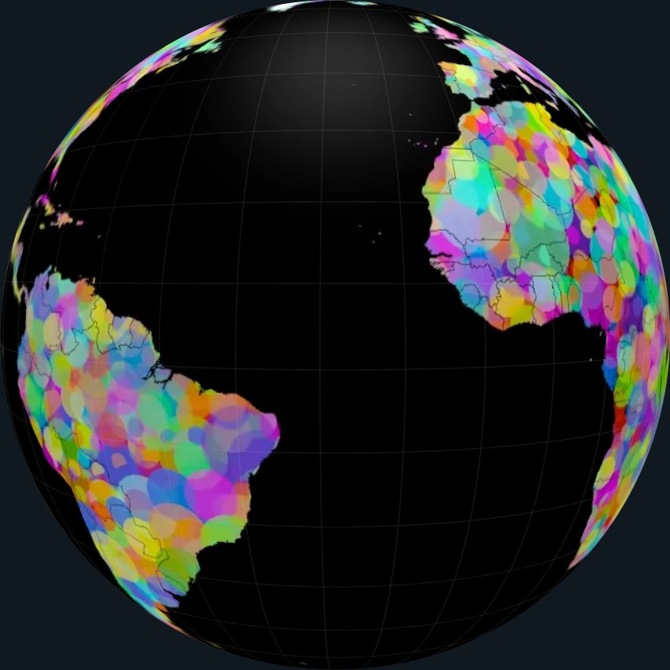

A shared human landscape
A peaceful, prosperous, socially just, and sustainable Earth civilisation is possible. Achieving it requires a political structure capable of coordinating planetary action while protecting local autonomy, cultural diversity, democratic freedom, and life itself.
The WHY page established why humanity must build democratic global governance before an acute crisis forces global authority to be constructed in panic and concentrated from above. This page presents a first-principles model of what that democratic order could be.
The proposal combines a single global constitutional order with constitutionally enforced subsidiarity, distributed executive power, direct knowledge-based democracy, and the separation of governance from cultural identity. It is presented as a working structural blueprint to examine, challenge, improve, and ultimately build through a global democratic process.
CC BY-SA 4.0 United.Earth Project

6. Preconditions
Humanity needs a geopolitical system capable of resolving conflicts, coordinating urgent responses, and fostering long-term solutions that protect the biosphere and secure a stable future. At the same time, this system must be possible to implement step by step, honouring cultural identities and ensuring broad democratic participation throughout the transition.
While many principles ultimately shape such a system, the first four subsections below form its essential constitutional foundation. GeoWeMe and the Policy Area Index then provide the analytical and structural frameworks through which that foundation can be applied coherently.

6.1 The intrinsic value of life
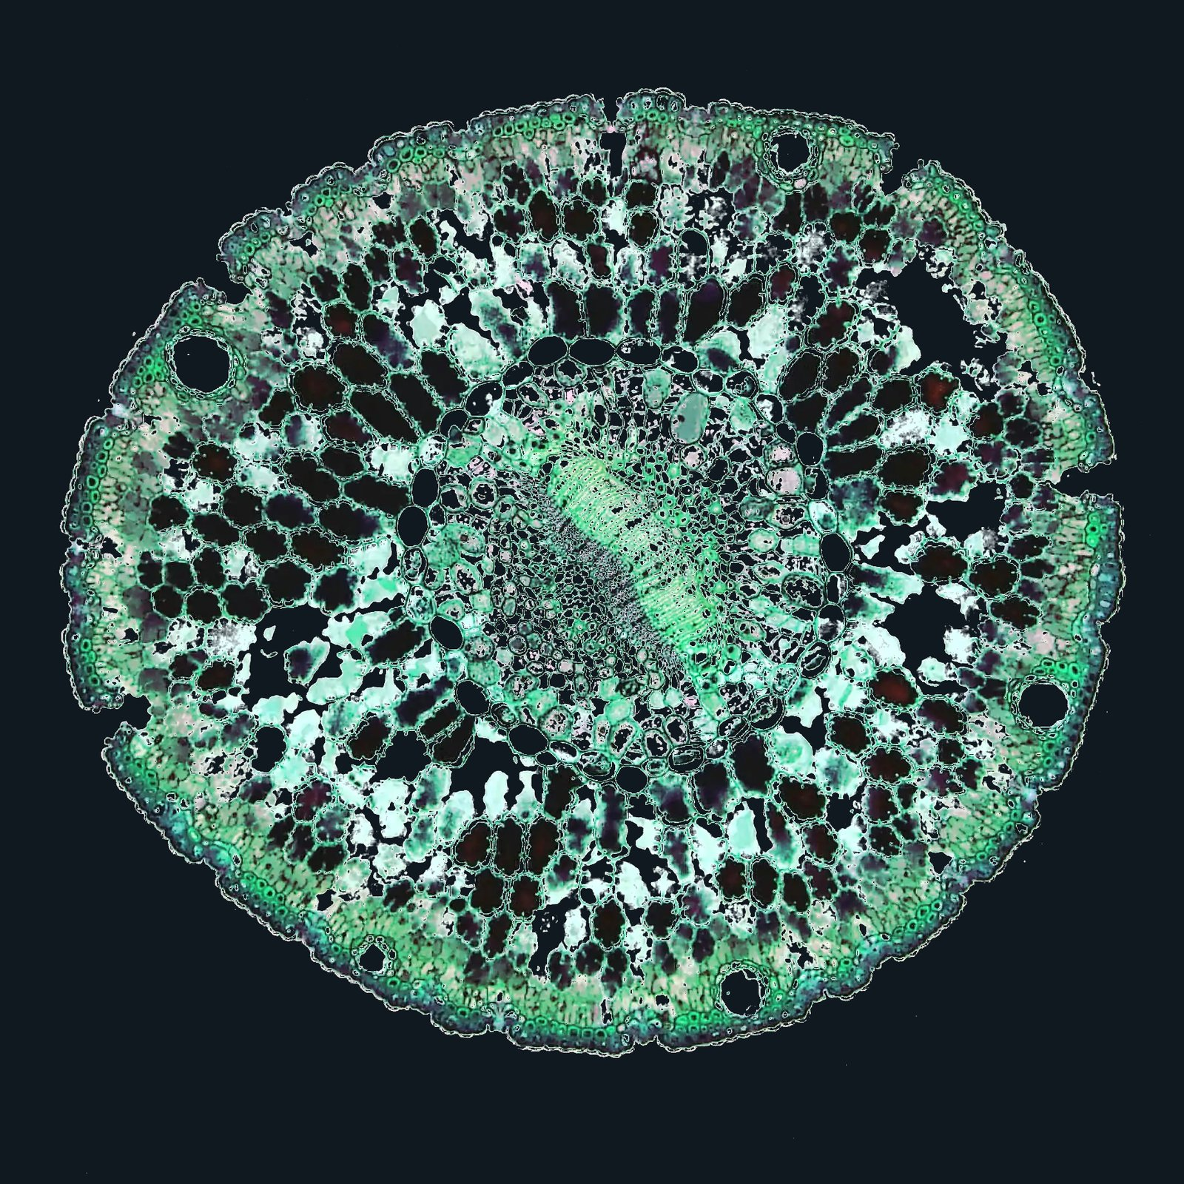
Plant cells

Life is the foundational premise
Life exists before belief, identity, or governance. It is the condition upon which all human systems ultimately depend.
Humanity does not agree on where life comes from, nor on all ethical boundaries governing interaction with it. What can be established as a shared constitutional starting point is a single foundational premise:
Life has intrinsic value and must be protected as far as practically possible.
Where the practical boundaries should be drawn is a question of constant ethical debate and political deliberation.
Image by Fayette Reynolds M.S.: A cross-section of a living plant stem
This statement does not claim universal truth, metaphysical certainty, or moral consensus. It does not define what life is, why it exists, or how it ought to be lived. It expresses a democratically chosen minimum: that life shall not be reduced to a mere instrument, resource, or collateral effect of power, identity, belief, or ideology.
This premise is necessary not because humanity agrees on its justification, but precisely because humanity does not.
Across cultures, religions, and ideologies, people hold profoundly different beliefs about the meaning of life, death, dignity, sacrifice, nature, and authority. No single worldview commands global consensus, and none can legitimately serve as the foundation of planetary governance. For this reason, the proposed system does not derive its ethical basis from any particular religion, tradition, philosophic school, or ideology, but from a collective political decision to treat life itself as worthy of protection.
Within the present constitutional proposal, this principle applies exclusively to biological life. Artificial systems remain human-made tools and do not acquire the status or rights of living beings through intelligence, autonomy, complexity, or apparent consciousness. Any future extension of the principle beyond biological life would require an explicit constitutional amendment.
By affirming the intrinsic value of life, the system establishes a common point of reference from which ethical deliberation becomes both possible and necessary. It does not resolve all questions within bioethics, warfare, self-defence, punishment, animal use, or resource extraction. Instead, it establishes that such questions must be addressed deliberately, transparently, and with the explicit aim of protecting life as far as practically possible.
This single premise is sufficient to ground a wide range of otherwise contested conclusions, for example:
- that the systemic conditions for life — climate stability, ecosystems, biodiversity, water cycles, and the biosphere as a whole — must be actively protected;
- that war and large-scale violence constitute a fundamental governance failure rather than a normal political instrument;
- that all human beings must be afforded conditions that allow for a dignified and viable life, including fair access to resources and opportunities;
- that treating human beings as property, such as in slavery, is categorically incompatible with the system.
At the same time, the premise remains intentionally open. It does not prohibit all use of force, all taking of life, or all restriction of freedom. Such matters are subject to ongoing ethical assessment concerning proportionality, necessity, and democratic control within the system’s institutions.
The intrinsic value of life is therefore not a complete ethical doctrine, but a constitutional starting point. It obliges the system to engage continuously in ethical boundary-setting rather than to assume that those boundaries are already known.
This principle is formally articulated in the Declaration of the Rights of Life and must be embedded in the Earth Constitution. Together, they define the sole non-negotiable ethical foundation of the proposed system. All other rules, institutions, and policies remain open to revision within this framework.
Once constitutionally adopted, this principle binds all people and institutions, including those who fundamentally disagree with it. Governance must therefore sometimes constrain intentions and actions that deny the intrinsic value of life. This is not a claim to absolute moral authority, but an exercise of collectively mandated political authority, bounded by law and subject to ongoing ethical scrutiny.

6.2 The commons principle

Human activity is expanding beyond Earth. We therefore propose declaring a Solar Commons: a shared constitutional framework for peaceful coordination and long-term stewardship throughout the Solar System, with the Earth-Moon system as the immediate practical priority.

Earth-Moon commons

Foundation and definition
The commons principle states that the systems, spaces, resources, and conditions essential to shared life must be governed as responsibilities extending beyond individual ownership, territorial borders, and present generations.
Their common character is not created by human law. The atmosphere, the climate system, the water cycle, ecosystems, biodiversity, and the biosphere already function as interconnected conditions of life. Political and legal systems must recognise this reality and protect their integrity.
The commons are not merely resources available to humanity. They are the larger systems within which humanity exists. The economy exists to serve people and the living planet, not the other way around. Civilisation must operate within their biophysical boundaries and accept that its immediate interests remain subordinate to the continued integrity of the whole.

Solar Commons
Some commons are inherently planetary, while others extend beyond Earth. The atmosphere, open oceans, polar regions, orbital space, and the wider Earth-Moon system cannot be governed adequately as separate territorial possessions.
Human activity already depends on shared orbital environments and is extending towards the Moon, Mars, Lagrange points, and other parts of the Solar System. The Solar Commons applies the commons principle to this emerging civilisational domain.
Space debris, satellite systems around Earth and other celestial bodies, access to Lagrange points, activity on the Moon and Mars, research programmes, resource use, and future infrastructures that cannot yet be foreseen must be governed through peaceful coordination, common rules, and long-term stewardship.
This is not a claim of ownership over the Solar System. It is a commitment to coordinated civilisational expansion rather than a new territorial, military, or commercial space race.
The extraterrestrial hypothesis remains unresolved. The United Earth initiative therefore neither assumes that humanity is alone nor treats an unverified presence as a basis for public governance. Until another intelligent presence is publicly and conclusively established, humanity must take responsibility for governing its own expanding activity throughout the Solar System.
For the immediate future, the Earth-Moon system remains the practical priority.

Natural commons
Natural systems cross both political and property boundaries. Freshwater systems, rivers, aquifers, watersheds, fertile soils, migratory routes, forests, oceans, and connected ecosystems must be governed at the levels necessary to protect their integrity as complete systems.
The natural commons also include Earth’s remaining and recoverable natural fabric: the large, connected ecosystems required to protect biodiversity and preserve the free continuity of life processes on land and at sea.
Their common character does not mean that all land, ecosystems, or biological resources must be governed identically. It means that political boundaries, property rights, and rights of use remain subordinate to the continued functioning of the ecological systems on which life depends.
See sections 11.2 and 11.3 for the role of the planetary and natural commons within Earth civilisation.

Urban commons
The urban commons comprise the shared built and inhabited environments through which collective life is experienced.
Streets, squares, neighbourhoods, parks, landscapes, shorelines, skylines, transport systems, and other spatial structures shape health, freedom, participation, mobility, beauty, orientation, and belonging.
Individual buildings and sites may be subject to different forms of ownership and use, but their cumulative effects form a shared environment. Private control over individual components does not remove the public interest in how villages, towns, cities, and inhabited landscapes develop as a whole.
The urban commons must therefore be governed and planned as connected physical environments rather than treated merely as the accumulated result of separate property decisions.

Digital commons
Digital space has become an essential environment for communication, knowledge, economic activity, democratic participation, and access to public institutions.
The protocols, civic identity systems, communication networks, public data, and digital infrastructures on which society depends cannot be governed solely according to private ownership or commercial interest. Where digital systems perform essential public or constitutional functions, they must remain interoperable, accessible, accountable, secure, and protected against monopolistic control.
Private services and enterprise operate within digital space, but no private actor can possess permanent control over the infrastructures through which citizens exercise fundamental rights, access public knowledge, or participate in democratic governance.

A post-ideological economic order
The proposed economic order is post-ideological. Capitalism, socialism, communism, and other comprehensive economic ideologies are treated as historical paradigms rather than constitutional templates for society.
The economy exists within human society as a practical tool for organising material life, while society itself remains embedded within and dependent upon the biosphere. Its institutions, incentives, and activities must remain subordinate to the Rights of Life, ecological boundaries, social rights, and democratically defined goals.
Markets remain practical mechanisms for decentralised communication, exchange, innovation, and coordination. Public institutions, cooperatives, private enterprise, democratic planning, and other forms of economic organisation are used where they function best. Their roles are determined pragmatically according to knowledge, context, governance level, and purpose rather than economic dogma.
Regional planning coordinates the material foundations of society, including land use, settlement patterns, food systems, infrastructure, transport, energy, resource flows, and ecosystem restoration. Markets operate within these democratically established ecological and social frameworks and must account for the costs they impose on people and the commons.
Economic success is measured by human well-being, social justice, ecological regeneration, and systemic resilience rather than unlimited material growth or capital accumulation. Economic power remains subordinate to constitutional rights, democratic authority, ecological reality, and the common good.
See section 10, A sustainable and just economic system, for the proposed constitutional principles and distribution of economic authority.

Ownership and stewardship
Personal ownership remains protected for personal possessions, a person’s home, and, where appropriate, a constitutionally limited area for individual use. Diverse forms of enterprise and constitutionally defined rights of use also exist within this framework.
Ownership of buildings or infrastructure, and rights of use over land or resources, cannot include an unlimited right to destroy, exhaust, poison, fragment, misuse, or permanently appropriate their shared life-supporting functions.
This includes the misuse of food-producing land, freshwater systems, and water resources in ways that undermine long-term fertility, ecological integrity, food security, or fair access
Large-scale corporate land acquisitions, commonly operating as land grabbing, are structurally incompatible with this framework and must be systematically halted and reversed. The practice of transnational corporations, sovereign wealth funds, or private equity vehicles permanently capturing vast tracts of agrarian, forest, or ecological spaces undermines local food sovereignty and fragments the natural commons. Under the Earth Constitution, no corporate charter or financial instrument can grant perpetual extraction rights or territorial alienation over the biophysical foundations of shared life. Existing corporate concessions that violate ecological minimum standards, displace local communities, or operate as speculative financial assets will be legally dismantled, returning the land to regional or local public stewardship trusts
The commons principle, together with the Rights of Life, is incompatible with treating land, forests, freshwater, and other terrestrial natural resources as permanent private capital. Such control weakens society’s ability to govern ecosystems and resources coherently and sustainably. It also enables extreme inequality by allowing a minority to control the material foundations required by others for housing, food, water, livelihood, and a dignified life.
These resources must therefore be held in common under the responsibility of the appropriate governance level, according to their scale and ecological context.
They are managed through secure, long-term stewardship rights subject to democratically defined ecological and social minimum standards grounded in the Rights of Life.
Where the required standards are not met, the stewardship responsibility must be transferred to entities capable of the task. These entities are cooperatives or other democratically accountable public forms of organisation.
Existing private and inherited lineage-based ownership is not confiscated. It is gradually converted into stewardship through voluntary transfer, sale, or the loss of ownership rights when the required ecological and social standards are not met. Over time, this replaces inherited lineage-based ownership with democratic, accountable, and productive management of the commons.

Scale and time
The scale of stewardship must follow the scale of the commons:
- Local public spaces and civic environments should normally be governed locally.
- Settlement patterns, transport systems, watersheds, and connected ecosystems may require regional or bloc-level coordination.
- Essential digital infrastructures must be governed at the lowest level capable of protecting their function, while shared protocols and constitutional systems require coordination across levels.
- The atmosphere, open oceans, polar regions, and near space require global authority.
- Activity throughout the wider Solar System requires peaceful coordination through the Solar Commons.
Section 1.3 defines how responsibility is allocated between governance levels through the principle of subsidiarity.
The commons principle also extends through time. The living and material inheritance received by one generation cannot be consumed as though future generations had no claim upon it.
Stewardship therefore includes protection, restoration, fair access, careful use, and the obligation to pass the commons forward in a condition capable of sustaining life.
Together with the intrinsic value of life, the commons principle establishes a fundamental constitutional obligation:
What sustains shared life must be protected as a shared responsibility.

6.3 Subsidiarity and the constitutional allocation of authority
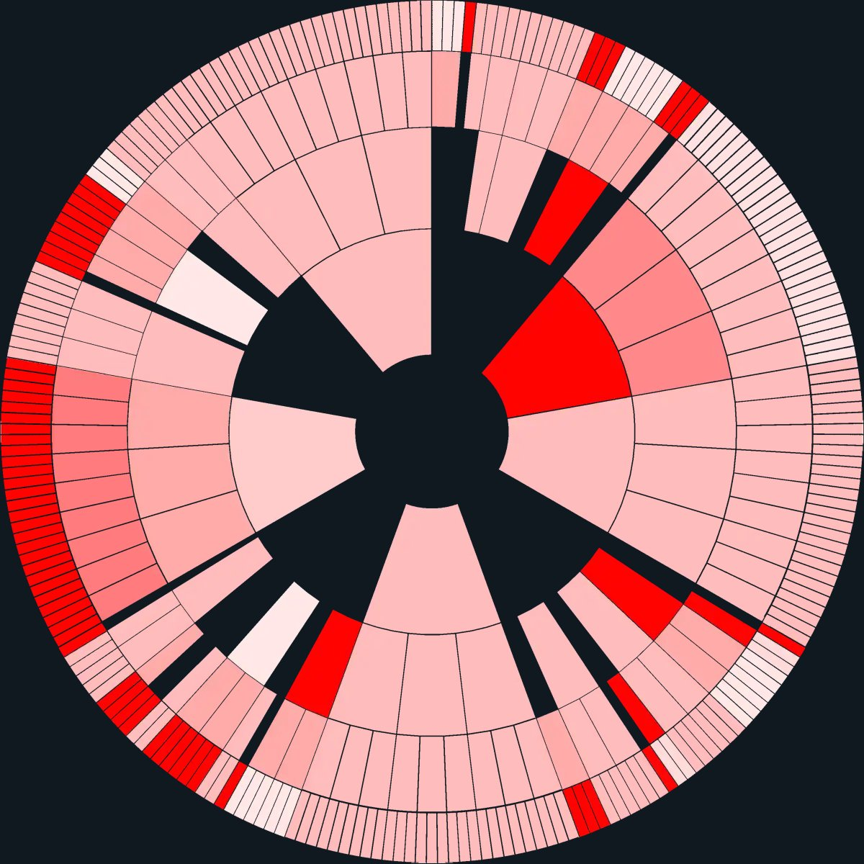
Subsidiarity now

Fragmented allocation of authority
Today, political systems distribute authority according to widely different and often incompatible principles. Some concentrate most power at the top, while others restrict collective authority so strongly that shared problems remain unmanaged.
The resulting pattern reflects political history, ideology, conflict, and institutional habit rather than a coherent relationship between the scale of a task and the level responsible for it.
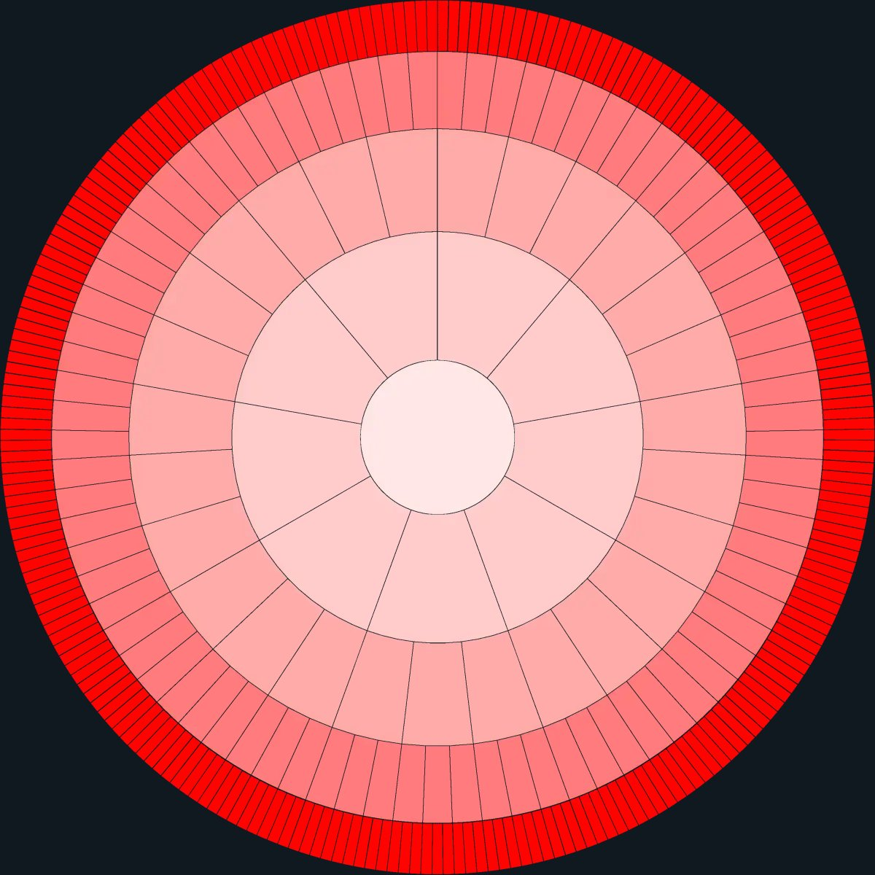
Subsidiarity future

Glocally balanced subsidiarity
The proposed system applies one constitutional principle throughout the entire structure: every responsibility belongs at the lowest governance level capable of handling it effectively, fairly, and sustainably.
Local and regional governance therefore carries most of the responsibilities connected to everyday life and physical territory, while bloc and global authority remains limited to tasks that genuinely require coordination at those scales.
Subsidiarity is the constitutional principle that allocates authority throughout the proposed system. Every governing responsibility must remain at the lowest level capable of handling it adequately, fairly, and sustainably.
Authority moves upward only when the scale, interdependence, cross-border effects, or systemic consequences of a matter exceed the capacity of the levels below. This creates a constitutional presumption in favour of lower-level authority.
The burden of justification rests with the higher level seeking to assume or retain a responsibility. It must demonstrate that lower-level action is structurally insufficient and that intervention from above is necessary. The scope of the intervention must also be proportionate to the problem and leave the greatest possible political, legislative, and administrative freedom to the levels below.
Greater efficiency, administrative simplicity, or global uniformity alone does not justify moving authority upward.
A higher level may establish common baseline standards, boundary conditions, or frameworks for coordinated action where necessary, while leaving implementation and all remaining decisions to lower levels. This allows higher levels to be decisive within narrow areas of responsibility without becoming broadly dominant.
Subsidiarity must be embedded in the Earth Constitution as a binding rule for the allocation and interpretation of governing competence. The Constitution defines the responsibilities that necessarily belong to each higher level and the procedures through which additional authority may be transferred upward.
Responsibilities that have not been constitutionally assigned or shown to require higher-level action remain at the lowest capable level.
The judicial system must be able to review whether legislation or executive action respects necessity, proportionality, and the constitutional distribution of authority. Lower governance units retain the full right to challenge higher-level overreach through this constitutional process.
Valid higher-level law remains binding while such a challenge is resolved, preserving a coherent legal order without permitting unilateral nullification.
Applied throughout the structure, subsidiarity protects local autonomy, clarifies responsibility, reduces unnecessary bureaucracy, and prevents power from drifting upward by default. It also gives higher levels the authority required to address problems that lower levels cannot solve alone.
The result is a glocally balanced system: strong local self-government, substantial regional responsibility, limited bloc and global mandates, and effective coordination wherever the integrity of the whole requires it.
Section 3 applies this constitutional principle to the specific levels of governance.

6.4 Separating governance and cultural identities (GOV//ID)
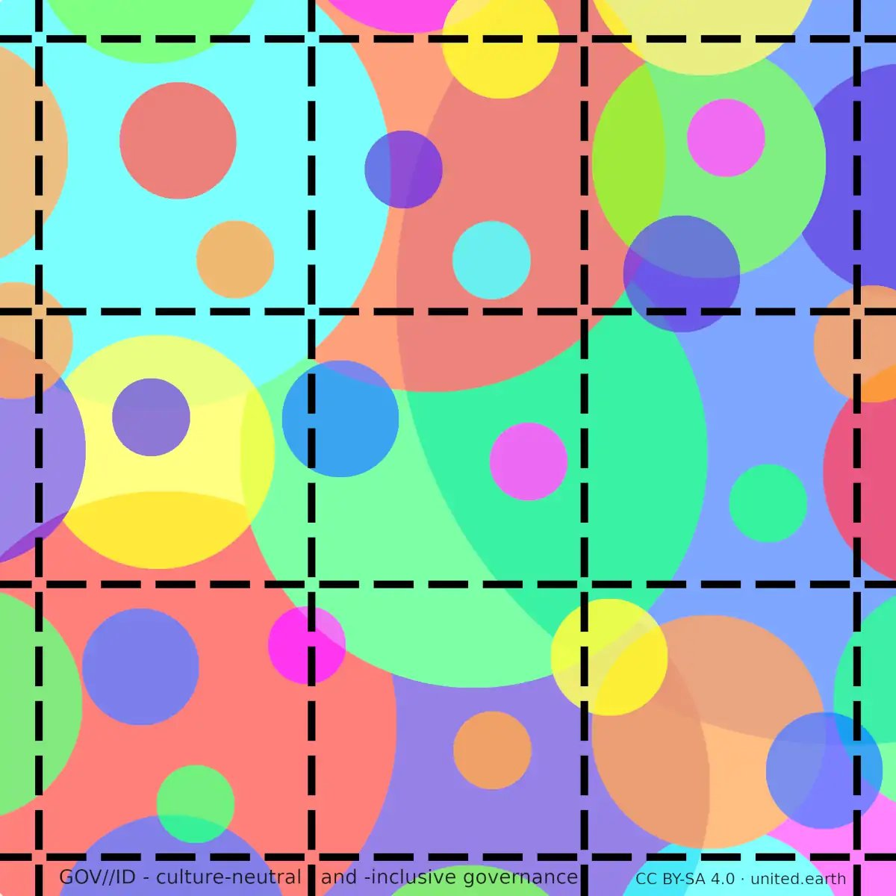
GOV//ID principle
The GOV//ID (pronounced: “gov-id”) condition:
Identities (ID) do not define governance; they coexist in parallel with one another and with governance (GOV)

The GOV//ID principle
The squares in this illustration represent governance units within the new geopolitical system. Their boundaries are soft and purely administrative. They define the territorial scope of public responsibilities, but they do not separate territories belonging to different nations, ethnicities, religions, ideologies, or other collective identities.
The same higher-level constitutional and legal framework applies on both sides of every administrative boundary. Laws at lower levels may differ wherever authority remains with those levels under the principle of subsidiarity.
The circles represent identities, often overlapping one another and crossing administrative boundaries. They have equal constitutional protection, but none possesses governing status or territorial sovereignty.
For a democratic global system to function, governance must belong equally to all citizens, regardless of identity. No national, ethnic, religious, ideological, organisational, or other collective identity can legitimately own the state, claim geographic territory as its exclusive political domain, or possess public authority of its own.
History shows that when governing authority is tied to cultural identity, territory becomes a struggle over collective ownership, recognition, security, and control. In a crowded, multicultural, and interconnected world, this structure cannot provide stable and equal governance.
Separating governance from cultural identities means:
- Territorial governance protects and serves all citizens and identities without constitutionally representing any one of them.
- No collective identity may claim ownership of territory, law, or governing institutions.
- Political authority belongs to citizens as equal individuals, not to identities or organisations as collective political persons.
- Citizens remain free to hold, express, advocate, and vote according to their religious, cultural, national, philosophical, or ideological convictions. A law may therefore be inspired by beliefs associated with an identity, but it cannot derive its authority from that identity.
Democratic outcomes may reflect the beliefs of the citizens supporting them and may differ between governance units according to subsidiarity.
GOV//ID does not predetermine the substantive outcomes of democratic decisions. It determines the source and constitutional limits of governing authority and prevents any identity or comprehensive ideology from becoming the permanent organising principle of the state.
Proposals that would establish identity-based governing authority are constitutionally inadmissible and do not enter the ordinary democratic agenda. Other proposals, including those concerning identity-related practices, may be debated and decided through the ordinary democratic process, provided that they fall within the unit’s competence and comply with higher law and equal constitutional rights.
Parties and identity-based organisations may exist as voluntary associations for advocacy, education, deliberation, and mobilisation. They hold no constitutional mandate, reserved representation, ownership of political offices, or authority over public institutions.
Freedom of expression remains broad, but it does not protect advocacy for identity-based domination or for denying other identities equal constitutional status, freedom, or protection.
This principle preserves cultural freedom, continuity, and dignity while removing a major structural basis for territorial domination and rivalry: the claim that governing territory belongs to a particular identity. It establishes a constitutional foundation for peaceful coexistence on a shared planet.
GOV//ID does not require identities to withdraw from public life. People remain free to express, develop, organise, protect, and transmit their cultures, beliefs, languages, traditions, political ideas, and collective interests.
The separation applies to governing authority, not to cultural freedom or individual political motivation.
Post-ideological does not mean post-political, value-neutral, or without disagreement. It means that no comprehensive ideology possesses constitutional authority or predetermines how society and the economy must be organised.
This applies equally to economic ideologies. Capitalism, socialism, communism, and related doctrines remain free as bodies of thought, political identities, and sources of analysis, but none defines the state or serves as the permanent constitutional template for the economy.
Markets, democratic planning, public institutions, cooperatives, private enterprise, and other forms of economic organisation are treated as practical instruments. Their roles are determined democratically according to the Rights of Life, the commons principle, subsidiarity, knowledge, and the conditions of the policy area involved.
Applied constitutionally, GOV//ID ends the model of the state as the possession or political expression of a nation*, religion, ideology, party, class, or other collective identity. This includes nation-states, theocracies, one-party states, and systems in which capitalism, socialism, communism, or another comprehensive ideology functions as the permanent organising principle of governance.
The constitutional settlement is clear: governance relinquishes cultural ownership, while the constitutional order guarantees every identity equal freedom, protection, continuity, and participation, limited by the equal rights of others and the principle of non-domination.

)* A nation is a sociocultural community, while a nation-state is a system of territorial governance whose legitimacy and identity are tied to a nation. See the WHY section ‘Nation’ is not a synonym for ‘nation-state’ and the dedicated article ID=GOV → GOV//ID for the full analysis and terminology.

6.5 GeoWeMe: integrating Earth, society, and the individual
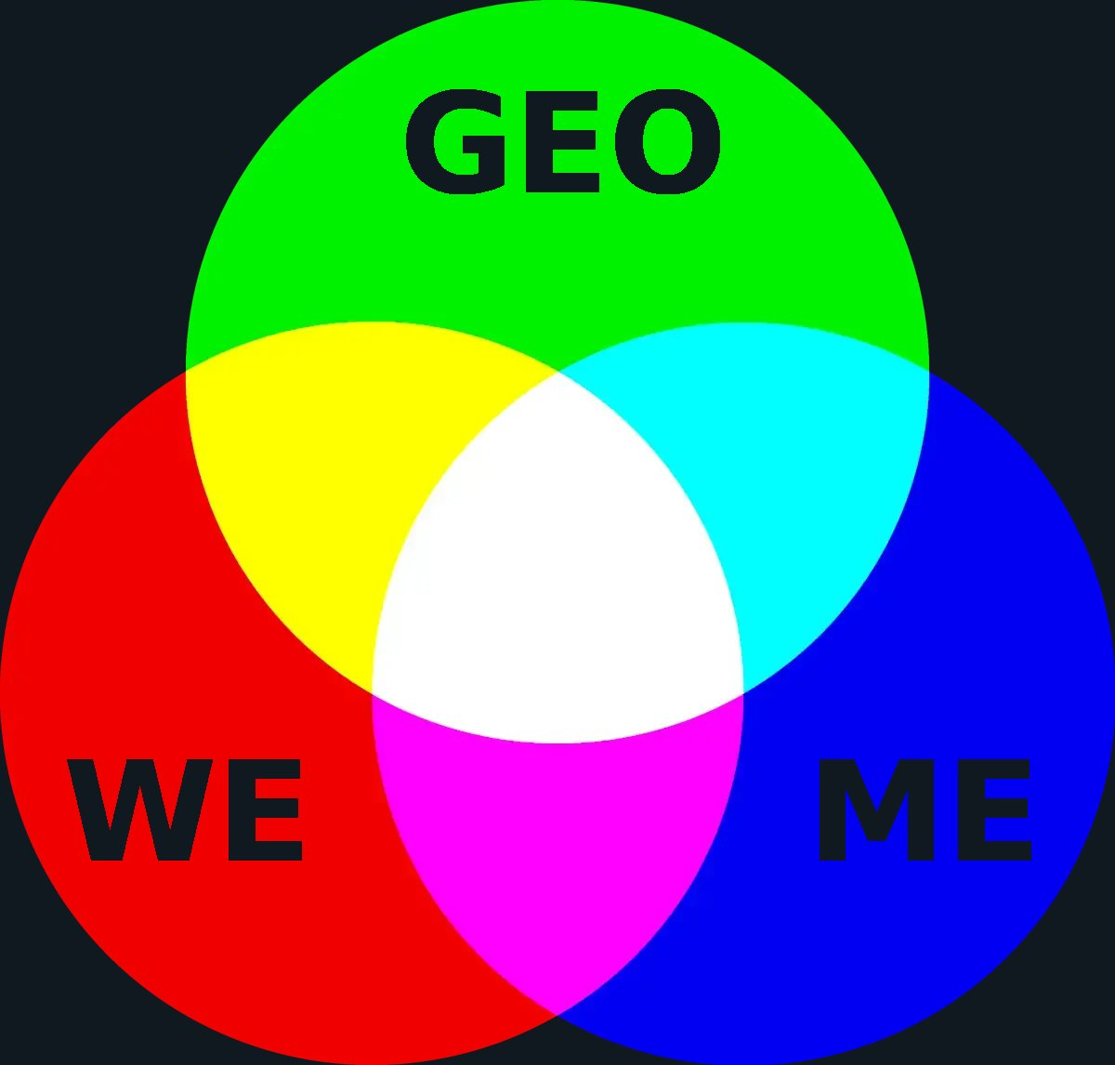
Additive red, green, and blue (RGB) light mixing.
Political ideologies and parties use colour labels inconsistently and often misleadingly. GeoWeMe uses the RGB model as an analytical framework and to illustrate a path beyond outdated political simplifications.

Three dimensions of political judgement
GeoWeMe describes three distinct and irreducible dimensions of political reality:
Geo, shown in green, represents Earth and the long-term conditions of shared existence: the biosphere, ecological limits, planetary systems, security, and future generations.
We, shown in red, represents society and collective life: community, solidarity, justice, institutions, public capacity, and the common good.
Me, shown in blue, represents the individual person: freedom, autonomy, dignity, diversity, and the right to pursue a personal life.
The conventional left-to-right axis is an inadequate map of political reality. It compresses a multidimensional field into a single line, groups very different positions under broad labels, and has no inherent place for Earth, the biosphere, or the planetary systems on which all politics depends.
GeoWeMe replaces this flat metaphor with three permanent dimensions of political judgement. Geo, We, and Me are not competing ideologies. They are unavoidable realities. Human beings are individuals with rights, needs, capacities, and personal lives. They are also members of societies that depend on cooperation, institutions, trust, and fair distributions of responsibility. Both individuals and societies exist within ecological and planetary systems whose physical limits cannot be negotiated away.
Ideologies arise when theories, values, historical experiences, and interests interpret and weigh these dimensions in different ways. They become cultural identities when these interpretations are assembled into comprehensive narratives, symbols, organisations, and loyalties.
Political parties institutionalise such ideological identities. To compete for power, they must combine positions across many different policy areas into recognisable programmes, preserve organisational continuity, accommodate internal interests, distinguish themselves from competitors, and present the result as a coherent political alternative.
The resulting programmes are therefore not derived from knowledge and philosophical reasoning alone. They are also shaped by historical positions, electoral strategy, internal bargaining, interest groups, personalities, and the need to market a recognisable political identity. Voters must then choose between complete packages that may combine positions they support with others they reject or regard as unrelated.
GeoWeMe makes the underlying considerations within these packages more visible. It also helps identify political imbalance.
An excessive emphasis on Me can turn freedom into market absolutism, weaken shared institutions, and externalise social and ecological costs.
An excessive emphasis on We can turn solidarity into conformity, collective purpose into majoritarian domination, and public organisation into suppression of individual autonomy.
An excessive emphasis on Geo can turn ecological necessity into technocratic command and justify authoritarian action in the name of planetary survival.
These are not automatic consequences. Particular situations may legitimately require one dimension to carry exceptional weight. An ecological emergency, a social catastrophe, and a direct attack on fundamental rights require different priorities. The problem arises when one or two dimensions become structurally dominant, and the consequences for the others are ignored or treated as irrelevant.
GeoWeMe therefore does not prescribe a permanent midpoint or an equal three-way balance. The white centre of the RGB model does not represent one correct political conclusion. It represents a field of judgement in which Geo, We, and Me are all visible and none is structurally excluded.
This framework continues the separation established by GOV//ID. Ideologies, parties, religions, nations, and other identities remain free to exist, organise, advocate, and influence personal political judgement. They do not own governing authority or control political representation.
Citizens are therefore not required to abandon their convictions. They are released from having to accept complete ideological packages in order to participate politically. Each question can instead be examined according to its actual conditions, evidence, consequences, uncertainties, and trade-offs.
Within the proposed system, GeoWeMe works together with the Policy Area Index and AGORA. PAI structures political domains, relevant knowledge, and the relationships between issues. GeoWeMe makes the fundamental considerations within each issue visible. AGORA enables citizens to learn, deliberate, develop proposals, revise their understanding, and make decisions within this shared structure.
GeoWeMe consequently has both a transitional and a permanent function. It helps explain why ideological parties should no longer organise democratic governance. It can then remain a tool for personal orientation, proposal analysis, democratic deliberation, and the evaluation of political consequences.
Sustainable and legitimate politics must consider Earth, society, and the individual together.

Read the full GeoWeMe article for the analysis of the left-to-right axis, political ideologies, party programmes, the complete diagram sequence, and the framework’s application within knowledge-based direct democracy.

The sequence illustrates a transition from politics organised through separated or competing ideological packages towards a shared field of judgement in which Earth, society, and the individual are all present. The point is not equal weighting or the end of disagreement, but the end of structural exclusion.

6.6 Policy Area Index (PAI)
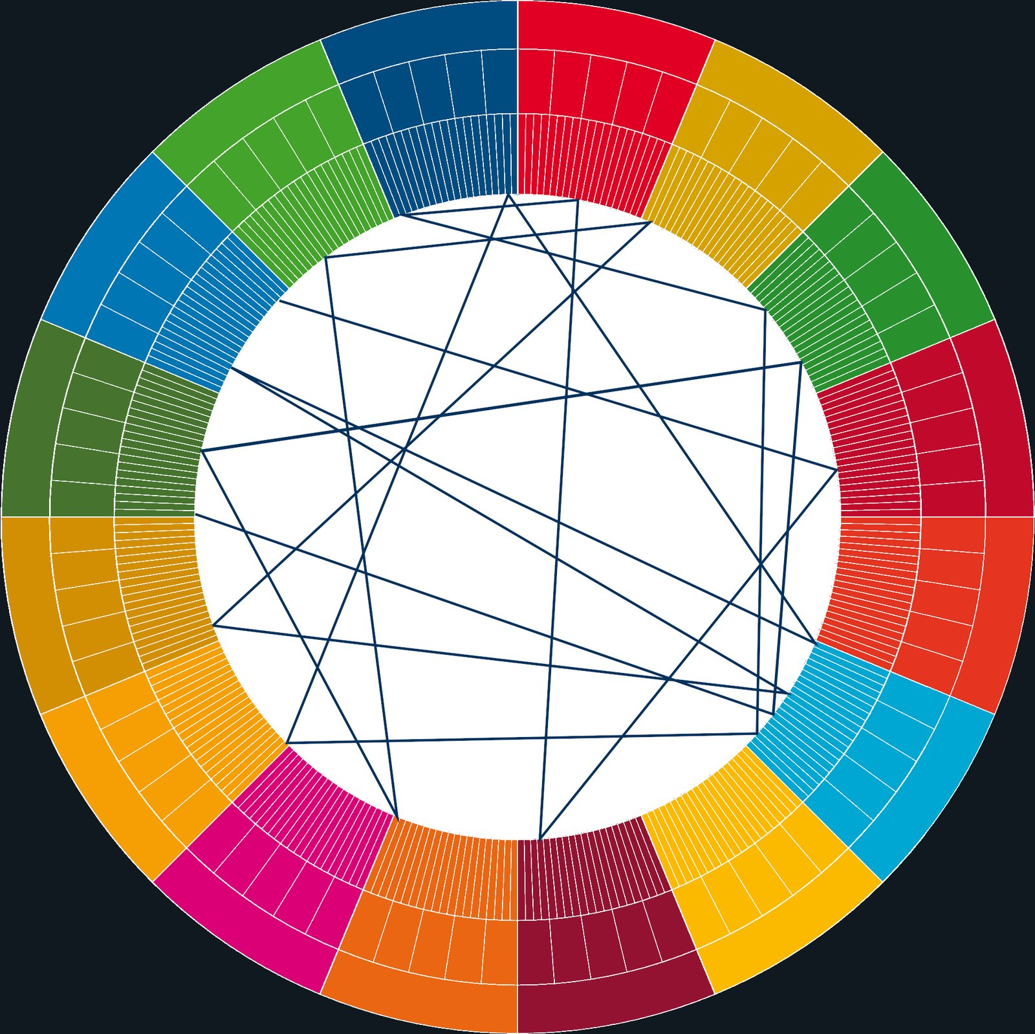
PAI connections
PAI conceptually illustrated with 16 main categories and two subdivisions. The lines show relationships between policy domains.
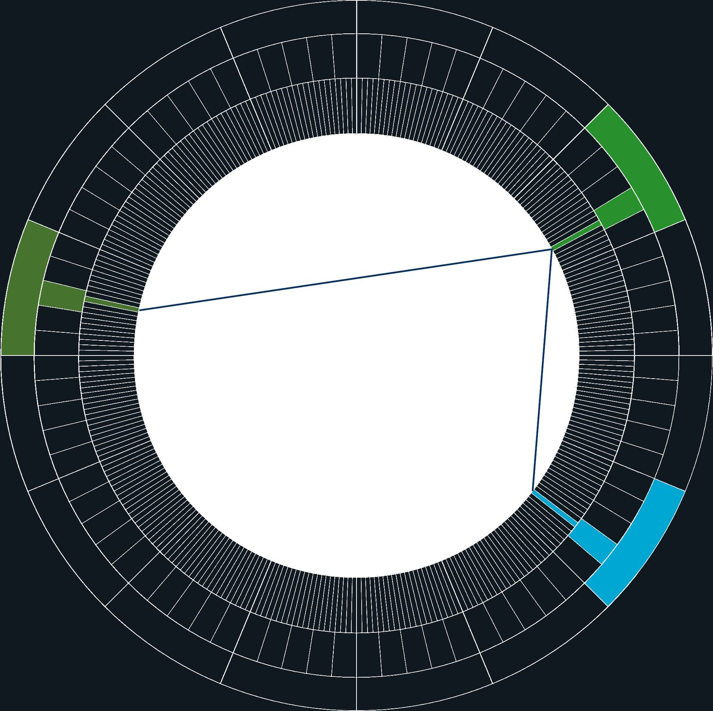
PAI connections illustration
Conceptual illustration of one relational set involving three policy domains. A classic example is infrastructure, land use, and climate.

A shared global standard for categorising political domains
The illustrations show the Policy Area Index (PAI) as a shared, global index for political governance. The circular form is a conceptual visualisation. In practice, the Policy Area Index exists as structured data that can be queried and visualised in many ways.
The outer ring shows the full scope of governance-relevant policy domains, such as land use, infrastructure, education, and health.
The connecting lines in the centre show relationships between policy domains. Real political issues are often cross‑cutting and involve several domains at the same time. The illustrations therefore show both the structural division of policy domains and the relationships between them.
The PAI circle has no structural relationship to the Earthwheel models, which describe the geopolitical structure as a whole.
The Policy Area Index (PAI) defines what political governance is about in the proposed system. A global governance system cannot function without a shared and explicit classification of what governance is responsible for.
While governance levels define where authority is exercised, and governance layers define how power, knowledge, and participation are organised, the PAI defines which domains of reality political decisions relate to. It provides a shared, non-ideological map of the full political problem space.
PAI is therefore not a programme, an agenda, or a set of priorities. It is a structural classification system that ensures democratic deliberation, knowledge production, and institutional decision-making are oriented toward the same set of real-world domains.

From implicit politics to an explicit global structure
All modern governance systems already rely on policy-area classifications. These appear as ministries, parliamentary committees, budget chapters, regulatory agencies, or sector-based mandates. The same applies to international organisations such as the UN and the EU. The problem is not the absence of such structures, but their fragmentation.
In conventional political systems, the scope of politics is defined implicitly through party programmes, ideological traditions, institutional history, and ad hoc compromises. As a result, policy domains overlap or remain undefined, cross-sector problems fall between institutional silos, and political conflict often concerns what the issue even is rather than how it should be addressed. PAI replaces this implicit structure with an explicit, shared, global standard.
It defines a finite set of policy areas that together cover the full spectrum of governance-relevant reality — from health, education, and infrastructure to climate, global commons, AI, security, and planetary boundaries.
These domains are designed to be comprehensive, as clearly differentiated as possible, ideologically neutral, and sufficiently stable to provide a common reference over time. Their definitions and relationships remain open to transparent, democratically governed revision as knowledge and political reality develop.
Political disagreement does not disappear under this structure. It becomes situated: disagreement occurs within clearly defined policy domains, rather than through continual redefinition of the political terrain itself.

A common reference across all governance layers
PAI functions as a shared reference system across the entire governance architecture:
- The legislative branch uses PAI to structure the political agenda and decision procedure
- The executive branch uses it to organise implementation and coordination,
- The judicial branch uses it to contextualise interpretation and accountability,
- The Councils use it to anchor ethical, scientific, and cultural evaluation,
- AGORA uses it to structure learning, deliberation, proposals, and voting.
Without such a shared policy grammar, multi-level and multi-actor governance collapses into parallel and incompatible conversations. With it, complexity becomes navigable.
PAI thus acts as the semantic backbone of the proposed system, enabling coherence across institutions, levels, and jurisdictions that today operate with incompatible or incomplete classifications.

Stewardship and democratic legitimacy
Because the Policy Area Index defines the shared reference frame for political governance, its maintenance carries structural significance. Changes to the index can shape how political questions are framed, compared, and coordinated across the system.
For this reason, stewardship of the PAI must rest with a democratically legitimised and competence-based institution within the system as a whole. In the proposed system, this responsibility lies with the Councils, which together safeguard scientific integrity, ethical coherence, and cultural neutrality.
The process of maintaining and updating the PAI is conducted openly and transparently, with broad participation enabled through AGORA. Proposed revisions, evaluations, and justifications are made publicly accessible, allowing citizens and institutions at all levels to follow, scrutinise, and contribute to the evolution of the index.

The following sections describe the levels, layers, and governance units that operate through this shared political structure.

7. A matrix of geopolitical power
A well-functioning geopolitical system relies on a balanced structure of governing units, defined by precisely defined levels and by three layers: the traditional branches, councils, and the global network connecting governance and people. Precise naming and clear distinctions between these dimensions are essential for democratic participation, effective coordination, and accountability.
The following sections outline a first-principles rebuild of humanity’s political architecture — repurposing and supplementing today’s geopolitical condition to replace fragmentation with a coherent structure. It is designed for peacekeeping, cooperation, and global democratic governance, protecting the local and delegating power upwards only where strictly necessary.
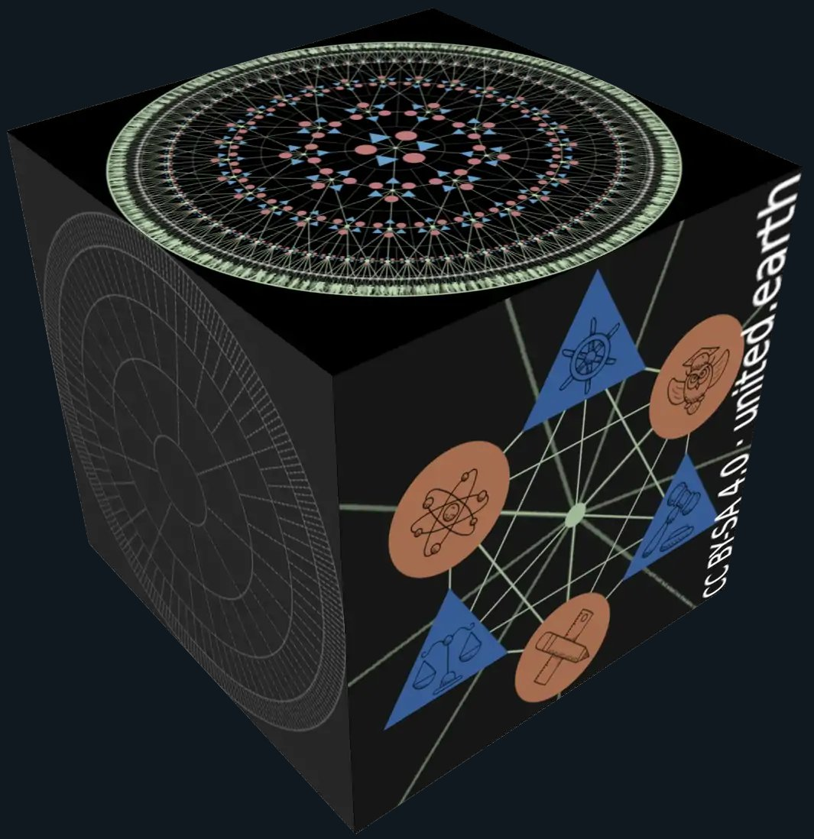
United Earth GeoMatrix

The three dimensions of the matrix
A geopolitical system can metaphorically be seen as a combination of three dimensions:
- The “horizontal”: Units of governance forming a complete pattern on each level (right)
- The “vertical”: Levels of the system (left)
- The “depth”: Layers of different components that are present in all units and on all levels (top)
Advisory bodies, oversight institutions, and long-term guardianship functions — historically added piecemeal as horizontal extensions of the three powers — are here gathered into a single, clearly defined layer of Councils, with explicit mandates for ethics, science, and culture.
The only genuinely new layer is the digital public square: a constitutional infrastructure that connects all components across all dimensions and provides a knowledge-based, direct, and fair interface for political participation. We propose calling this layer AGORA.
We do not insist on a single unifying term for this mental model, though in this overview we use the term “GeoMatrix”.

7.1 Reading the GeoMatrix
The GeoMatrix is a conceptual model to describe how political authority is organised in our proposed system. It does not prescribe final borders, exact numbers of units, or complete institutional procedures. Instead, it separates three structural questions that are currently often mixed: at what scale authority is exercised, which governance units exercise it, and which institutional systems operate within them.
A governance level is a complete constitutional scale within the hierarchy, from local to global.
A governance unit is one territorial political entity situated at a particular level. Together, the units form the complete territorial pattern of that level.
A governance layer is a recurring functional and institutional system that operates within governance units and connects them across levels.
In the GeoMatrix, the levels form the vertical dimension, the units form the horizontal pattern, and the layers form the depth dimension. None of these dimensions is sufficient alone.
Levels without layers identify where authority exists, but not how it functions. Layers without levels identify institutional functions, but not the scale and jurisdiction within which they operate. The governance units are where these dimensions meet and become operational.
These capacities are not gathered into one institution. They are differentiated, distributed, and connected through the matrix.
It may be tempting to think of the Policy Area Index (PAI) as a fourth dimension of the GeoMatrix, but we would rather define it separately as the shared political classification used throughout the whole matrix. It structures the policy domains, knowledge, and relationships through which the levels, units, and layers operate.
Sections 3 to 8 build the architecture in sequence.
- Section 3 describes the levels and the units that form them.
- Section 4 introduces the principle of governance layers.
- Sections 5 to 7 describe AGORA, the three Councils, and the three branches.
- Section 8 brings the levels, units, and layers together and describes how a complete governance unit operates.
- Sections 9 onward then examine how the completed architecture functions in relation to specific systemic purposes and conditions, including peacekeeping, economic organisation, Earth civilisation, and Earth Citizenship.
The GeoMatrix is a working structural model, not a final constitutional blueprint. Exact boundaries, mandates, numbers of units, and institutional procedures must be developed, tested, and decided through the democratic process itself.

7.2 Defining the names of the levels
The UE proposal requires a precise and consistent vocabulary for its governance levels and units. These terms recur throughout the constitutional, institutional, administrative, and democratic architecture. They are used when describing jurisdiction, subsidiarity, representation, authority, institutional relationships, and the distribution of responsibilities between governance units.
Ambiguity in the names of the levels would therefore propagate throughout the entire system.
Each level is consequently identified through a consistent relationship between a noun and an adjective. The noun names an individual governance unit. The corresponding adjective names the level and describes the institutions, responsibilities, and processes associated with it.
Unit | Plural | Adjective and level name
globe | – | global
bloc | blocs | blocal
sub-bloc | sub-blocs | sub-blocal
region | regions | regional
locus | loci | local
The five-level model describes the transition and preserves institutional continuity. It does not predetermine the final number of levels. The transitional role of the sub-blocal level is discussed in section 3.

globe – global
The global level contains one unit: the globe, meaning Earth as a whole, so the plural form becomes irrelevant here. These terms need no grammatical changes.

bloc – blocs – blocal
Blocs are the major units immediately below the global level. The adjective blocal is introduced to complete the pattern found in global, regional, and local.

sub-bloc – sub-blocs – sub-blocal
Sub-blocs are intermediate units between blocs and regions. They inherit the new adjective form.

region – regions – regional
These terms need no grammatical changes.

locus – loci – local
A locus is one unit of local governance, while loci is the plural. These are established words used here in a specific structural sense, giving the local level a precise unit name parallel to bloc and region. We realise that the terms locus / loci may seem a bit unfamiliar in a political context, and perhaps they aren’t the best candidates either, so we suggest “local community” as a valid alternative.

For a fuller discussion of the terminology, see the article Locus and Blocal – Updating Geopolitical Terminology

7.3 Defining other common terms
The terms above constitute the structural vocabulary of the GeoMatrix. Other familiar words remain necessary when describing the existing geopolitical system, its history, and the transition towards one democratic global state. However, many of these words are used inconsistently. The following definitions establish how such words are used within this proposal.

State
In this proposal, the term state is reserved for the complete global constitutional order. The future system constitutes a single democratic global state, with Earth Parliament as its supreme legislative institution, a global judicial system, and an Earth Government exercising executive authority within constitutionally defined global domains.
The blocs, sub-blocs, regions, and local communities are not states. They are subsidiary governance units within the global state, with responsibilities and authority allocated according to the Earth Constitution and the principle of subsidiarity.
The blocs occupy a distinct intermediate position. They are federated constituent units with constitutionally protected territorial executive sovereignty over land. This includes administration, policing, emergency preparedness, territorial defence, and the monopoly on the legitimate use of force within their territories.
They are nevertheless not sovereign states. Valid global law applies within their territories, Earth Parliament holds supreme legislative authority within the global constitutional order, and disputes concerning competence are resolved through the global judicial system.
The model therefore combines one global state with distributed territorial executive power.

Nation and nation-state
A nation is a sociocultural community. It may be shaped by shared history, language, culture, institutions, ancestry, territory, political experience, or collective self-understanding. A nation is therefore an identity, not a governance level.
A nation-state is a territorial state whose legitimacy and public identity are tied to a particular nation. The term combines two conceptually different phenomena: cultural identity and territorial governance. It is the most prominent example of the ID=GOV principle, which we reject.
It is also structurally unsuitable as the name of a governance level. Existing nation-states range from very small island- and microstates to continental entities with populations exceeding one billion. They cannot be treated as equivalent units within a coherent hierarchy of political scale.
For these reasons, this proposal does not use nation-state as a structural term, and nation is consequently used only for the sociocultural construct.

Country
A country is an imprecise everyday term commonly used for an independent state, a nation-state, its territory, its population, or some combination of these. It is also used to describe the opposite of urban landscape: as in “countryside”, or “out in the country”.
Because it does not clearly distinguish governance, territory, population, and identity, it cannot define a constitutional unit or governance level.
This proposal will never use the term, and we will have to discourage its use in common language for other than that last-mentioned meaning.

Region
The term region is used in many different ways and contexts: parts of continents, international groupings, cultural territories, economic zones, ecosystems, metropolitan areas, and administrative districts. This flexibility makes it useful in ordinary language but imprecise as a structural term.
The proposed system reserves region for one specific governance level: the functional and culture-inclusive level between the sub-blocal and local levels.
This allows the term to correspond with established concepts such as city region, metropolitan region, bioregion, county (or similar terms in other languages), and comparable territorial units that coordinate physical systems and public responsibilities beyond the capacity of individual localities. A well-known example is the phrase “Europe of regions”.
Large continental and subcontinental political groupings are often referred to as ‘regional’ in academic and geopolitical discourse. We instead promote using bloc, since the term region is now reserved.

8. The levels of governance
As subsidiarity is the constitutional rule for allocating authority, this section applies that to the five levels of the GeoMatrix: global, blocal, sub-blocal, regional, and local.
Each level contains governance units defined by territorial scale and functional capacity rather than cultural identity. The following subsections describe the constitutional position, principal responsibilities, and administrative role of each level, together with its relationship to the levels above and below.
The five-level structure is a transitional model rather than a claim that all five levels must remain permanently. The particular role and possible long-term redundancy of the sub-blocal level are discussed below.
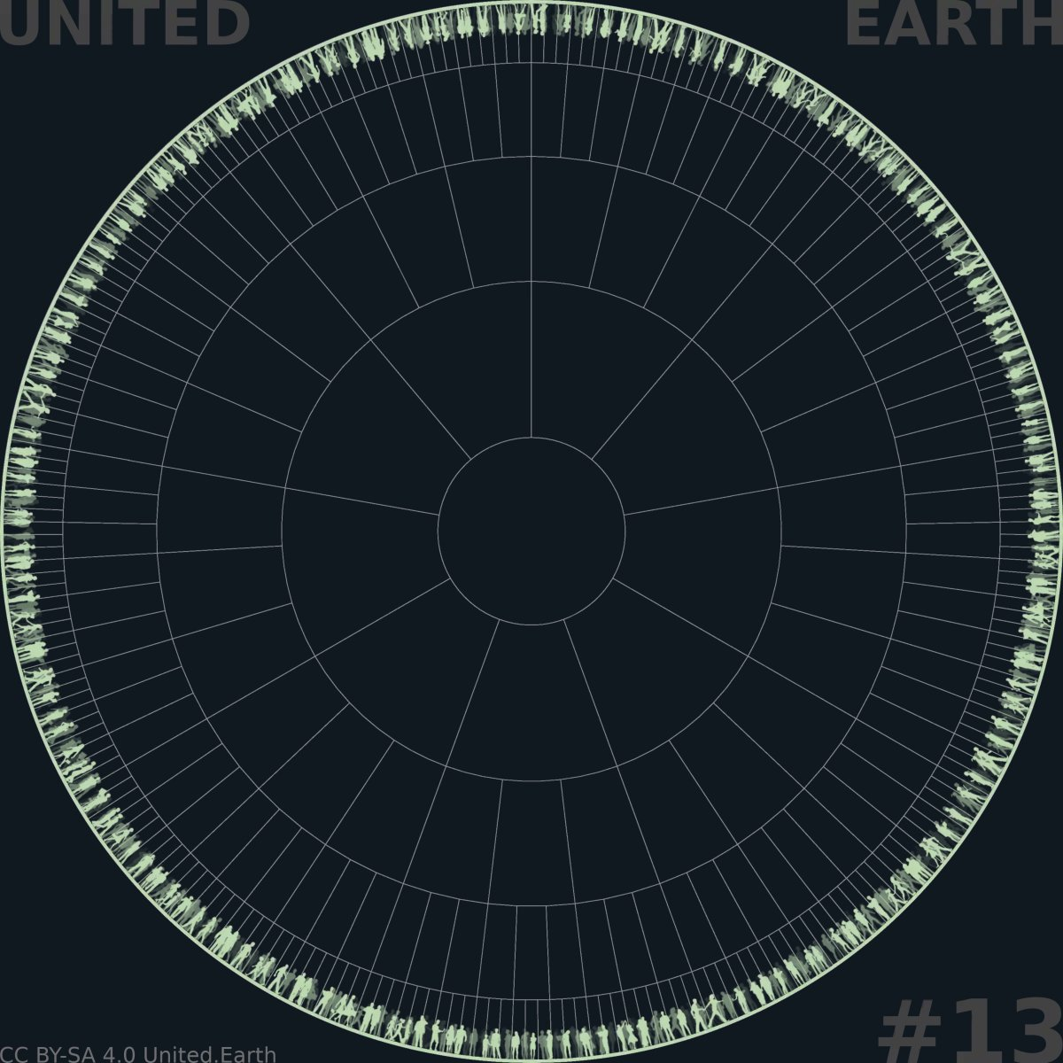
EARTHWHEEL 13

Circular hierarchy
As on the WHY and HOW pages, we use the “Earthwheel” model to visualise the political levels: the global, blocal*, sub-blocal*, regional, and local.
The model is highly abstracted, with the number of subdivisions at each level kept to a minimum to ensure readability and maintain focus on the principles rather than precise quantities.
* See below about this new form of the term ‘bloc’
Disclaimer: The estimated real-world scale and distribution of governance units discussed in the following subsections are rough estimates. Unlike the minimal 9-3-3-3 subdivision used in the illustration, they are intended to explore what a complete global structure might require.
They are not predictions, measurements, or fixed requirements. Future research, constitutional development, and democratic deliberation will be required to determine the actual number and boundaries of governance units at each level. Both may also change over time.

8.1 The global level
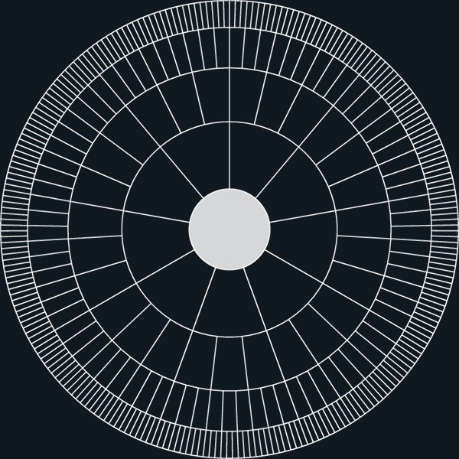

Position
The global level is the highest level of the GeoMatrix and contains one governance unit: the globe, meaning Earth as a whole. It is necessary because some systems, risks, and responsibilities are inherently planetary and cannot be governed coherently by any bloc or group of blocs acting separately.
The global level should not be confused with the global state. The global state comprises the complete constitutional order across all levels, while the globe is the single governance unit at its highest level.

Authority
Earth Parliament is the supreme legislative institution within the global constitutional order. Valid global law applies throughout the system and prevails over conflicting law at lower levels.
This legislative authority is not unlimited. Global competence is constrained by the Earth Constitution, subsidiarity, necessity, proportionality, and judicial review. The global judicial system resolves constitutional disputes concerning the distribution and legitimate exercise of authority between levels.
Earth Government exercises direct executive authority within constitutionally defined global domains, particularly the planetary commons and systems that cannot be placed under the territorial jurisdiction of any single bloc. It does not possess general territorial executive authority over the land areas governed by the blocs.

Functions
The global level maintains the shared constitutional and legal order, governs planetary commons, coordinates responses to cross-bloc and existential risks, and establishes binding global frameworks where action at lower levels is structurally insufficient.
Its responsibilities include the systems and conditions that are necessarily shared across the planet, such as the atmosphere, the open oceans, polar areas, orbital space, planetary ecological systems, globally shared digital infrastructure, systemically significant public AI systems, oversight of the bloc-based peacekeeping system, and other commons and risks whose effects cross bloc boundaries.
Global law is normally implemented on land through the blocs and their subsidiary governance units rather than through a centralised territorial administration.
The global level has no single capital or central headquarters. Its permanent institutions operate through a distributed network of global AGORA nodes located directly beside the principal institutional centres of the blocs. This keeps the global and blocal levels continuously connected while preventing any one city or bloc from becoming the physical centre of the global system.

Transition
No existing institution combines the democratic legitimacy, legislative authority, judicial system, and executive capacity required at the global level.
Existing international institutions contain substantial knowledge, experience, infrastructure, and technical capacity that should not be discarded. Relevant institutions may be transformed and integrated into the emerging global constitutional order, but the democratic authority of the global level must ultimately be established through a new constitutional process.

Name
The term international community or any other name that includes nation can no longer be used for this level due to the GOV//ID principle. The word planetary is a very probable long term winner, in line with the Solar Commons principle, however at the present stage of the project, we have stuck with globe and global. The word globe comes from the Latin globus (sphere or round mass), which entered English via Old French to describe a physical sphere before expanding in meaning to encompass planet Earth as a whole.

Scale and Distribution
The global level obviously contains one governance unit: planet Earth.
However, according to the solar commons principle, the object of governance includes all spaces and celestial objects that humanity is actively involved with: the Moon, Mars, Lagrange points, etc.

8.2 The blocal level (blocs)
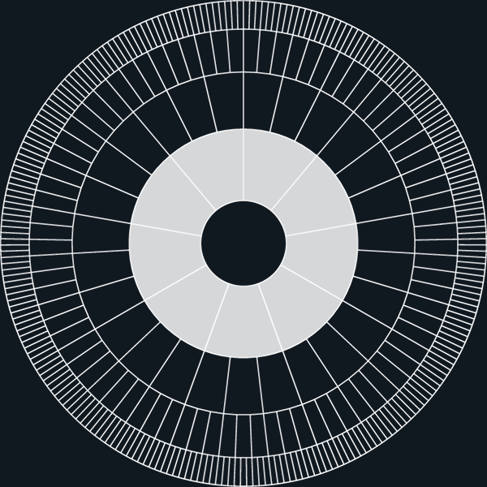

Position
The blocal level is situated immediately below the global level. Blocs are the largest territorial governance units on land. They may span continental or subcontinental territories, and each contains multiple sub-blocs, regions, and loci / local communities.
This level is necessary both to organise the planet into a workable federation and to prevent territorial executive power from becoming concentrated in one global government. The blocs create multiple large centres of power within one shared constitutional order.

Authority
The blocs have a unique position within the GeoMatrix.
De facto, they are sovereign executive governments within their respective land territories. They hold ultimate territorial control over administration, policing, emergency preparedness, territorial defence, and the monopoly on the legitimate use of force within their territories. They are not administrative departments of Earth Government, and Earth Government does not exercise general territorial command over them.
De jure, the blocs are constituent governance units within the global state. The Earth Constitution applies within their territories, and valid global law prevails in areas that fall within constitutionally legitimate global competence. Blocs cannot unilaterally invalidate such law, although they retain the full right to challenge it through the global judicial system.
Outside areas governed by valid higher-level law, the blocs retain legislative and executive authority according to subsidiarity. Their position therefore combines de facto territorial executive sovereignty with de jure membership in a binding global constitutional order.

Functions
Blocs provide the principal territorial executive capacity of the global state. They implement global law on land through their own institutions and coordinate responsibilities that exceed the capacity of sub-blocs and regions.
Their functions may include bloc-wide security, peacekeeping, macroeconomic stability framework, major infrastructure and energy systems, resource coordination, cross-territorial ecological management, and other responsibilities whose scale requires action across large populations and territories.
The blocs also form the primary territorial balance of power within the global peacekeeping system. Their control of most coercive capacity is a constitutional safeguard against absolute global tyranny.

Transition
The blocal level must be developed from a highly uneven collection of existing structures.
Some current continental or subcontinental states already operate at approximately this scale. Some existing federations, unions, and regional organisations may provide foundations for future blocs. Other areas will require the consolidation, internal federalisation, division, or creation of new structures.
Blocs do not need to become culturally homogeneous. Under GOV//ID, their populations and territories may contain many overlapping nations, languages, religions, ideologies, and other identities without any of them possessing governing ownership of the bloc.

Name
This level is already represented by several terms: union, federation, alliance, etc. Finding a general term among them doesn’t seem possible, since they are all too specific to the type of organisation, and none of them align well with the UE proposal. Therefore, bloc has been chosen, since it is already a household term in this context and since it is short and practical. The word bloc comes from the French bloc (a unified group or coalition), which developed from the Middle Dutch blok (a solid log or trunk) to describe a tightly bound collective. Today, it functions as a household term for an alliance of actors or nations with a common purpose.

Scale and Distribution
Earthwheel 13 illustrates the blocal level with nine blocs. A complete real-world structure may require approximately 20 to 40 blocs.

8.3 The sub-blocal level (sub-blocs)
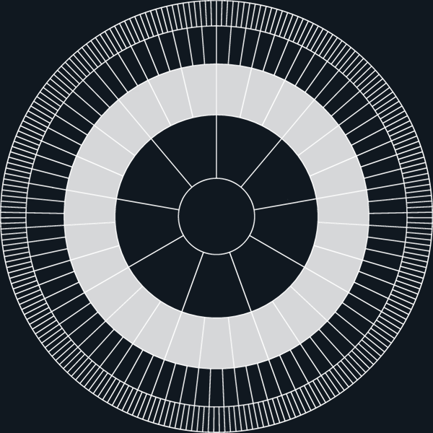

Position
The sub-blocal level is situated between the blocs and the regions. It provides an intermediate territorial and administrative scale for responsibilities that exceed the capacity of individual regions but do not require bloc-wide governance.
Its principal justification is transitional. It allows the system to preserve institutional and legal continuity while the existing geopolitical structure is reorganised.

Authority
Sub-blocs are subsidiary governance units within their respective blocs. They do not possess territorial sovereignty or an independent monopoly on legitimate force.
They exercise legislative, executive, and judicial authority within responsibilities allocated to them under the Earth Constitution, bloc law, and the principle of subsidiarity. Their authority remains subject to valid law at the global and blocal levels.
The exact extent of sub-blocal authority may vary during the transition and may diminish as functions are redistributed more coherently between blocs and regions.

Functions
Sub-blocs may coordinate multi-regional public services, infrastructure, administration, and other systems whose practical scale lies between regional and blocal governance.
They can also provide democratic representation and institutional coordination across groups of regions while maintaining continuity in legal systems, public administration, records, taxation, and service provision during the transition.
The long-term functional case for this level is weaker than for the global, blocal, regional, and local levels. Its responsibilities should therefore remain subject to continuing review under the principle of subsidiarity.

Transition
Most present-day nation-states are situated approximately at the sub-blocal scale. The same applies to many existing constituent entities within very large states, including provinces (e.g.China, Canada), states (Brazil, USA), and comparable first-order administrative divisions (e.g. oblasts in Russia, union territories in India).
Retaining these structures temporarily can reduce disruption while present-day sovereignty is reorganised within the global constitutional order and responsibilities are redistributed between the governance levels.
Over time, many sub-blocal responsibilities should move partly upward to the blocs and mainly downward to the regions. The level consequently become less important and be abolished altogether, leaving a final structure of four primary levels.

Name
The term sub-bloc derives directly from bloc. Since we’re convinced this level should become deprecated, we see no need for a unique name for it. On the contrary, sub-bloc actually underlines its temporary role.

Scale and Distribution
Earthwheel 13 illustrates three sub-blocs within each bloc. A complete transitional structure might contain as many as approximately 50 sub-blocs within a bloc and 2,000 globally.

8.4 The regional level (regions)
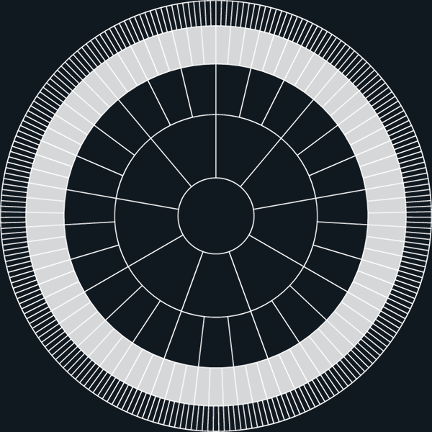

Position
The regional level is situated between the sub-blocal and local levels. At the regional level, Earth is organised through two constitutionally distinct types of governance units: societal regions and nature regions (see 11.3). Societal regions contain multiple local communities (loci), coordinate the physical systems of human society, and provide the primary functional connection between local life and governance at larger territorial scales. Nature regions protect and restore continuous ecosystems under ecosystem sovereignty and operate through dedicated regional stewardship institutions.
This level is important because many physical, ecological, economic, and public-service systems extend beyond individual local communities but remain too geographically specific to be managed effectively at bloc level.

Authority
Regions exercise substantial and constitutionally protected authority within the areas they can govern effectively. Under subsidiarity, responsibilities remain at the regional level unless their scale or consequences require coordination above it.
Regions are not sovereign entities. They remain subject to valid global, blocal, and, while that level exists, sub-blocal law. At the same time, higher levels cannot assume regional responsibilities merely because central administration would be simpler or more uniform.
Regional boundaries and authority are functional rather than cultural. A region does not belong politically to any nation, ethnicity, religion, ideology, or other collective identity.

Functions
The regional level is the primary territorial level of governance for physical and ecological coordination on land.
Its responsibilities include integrated land-use planning, transport systems, energy and water infrastructure, healthcare and educational systems, watersheds, ecosystems, settlement patterns, food systems, and other services and material networks shared by several loci.
Regions translate broader constitutional and policy frameworks into coherent territorial systems while leaving community-specific decisions to the local level.

Transition
Regions may build on existing counties, city regions, metropolitan areas, bioregions, and comparable administrative units. Existing boundaries may be retained where they function well, but others may need to be reorganised according to population, ecology, infrastructure, settlement patterns, and administrative capacity.
If the sub-blocal level later is phased out, which we recommend, regions would become the primary governance units immediately below the blocs.

Name
The word region comes from the Latin regio (direction, border, or district), which derives from the verb regere (to guide, direct, or rule), sharing a root with rex (king), while res (thing or matter) has a separate etymological root. Today, it functions as a foundational spatial concept.

Scale and Distribution
Earthwheel 13 illustrates three regions within each sub-bloc. A complete structure might contain as many as approximately 20 regions within each sub-bloc and 40,000 globally.

8.5 The local level (loci / local communities)
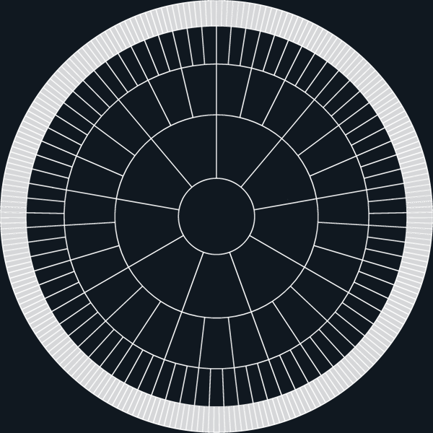

Position
The local level is the foundational level of the GeoMatrix. A locus is the governance unit closest to the physical places where people live, work, build relationships, participate in community life, and experience the consequences of political decisions.
This level is necessary because many responsibilities can be handled most responsively and democratically within the communities directly affected by them.

Authority
Loci hold a strong constitutional presumption of local autonomy. They exercise authority over all matters they can manage adequately, fairly, and sustainably without shifting significant consequences onto neighbouring communities or larger shared systems.
Their authority remains subject to constitutional rights and valid law at higher levels. Local autonomy cannot justify discrimination, identity-based domination, ecological destruction, or the externalisation of serious harms beyond the locus.
Higher levels may intervene only where local action is structurally insufficient or conflicts with legitimate higher law.

Functions
The local level handles responsibilities closely connected to everyday community life. These may include local planning, housing and settlement, public spaces, community infrastructure, primary services, local mobility, care, cultural and civic facilities, local ecological stewardship, and the practical implementation of broader frameworks.
The locus is also the primary setting for direct democratic participation, civic organisation, and continuing interaction between citizens and public institutions.

Transition
Existing municipalities, towns, rural districts, urban districts, neighbourhoods, and other local structures may provide foundations for loci. Their boundaries may need to change where existing units are too large, too small, fragmented, or poorly aligned with real communities and settlement patterns.
Large cities may contain many loci and may require additional sub-local arrangements for neighbourhood governance. Such arrangements do not necessarily constitute an additional formal level within the GeoMatrix.

Name
The words location and local come from the Latin locus (place or location), which uses the plural loci to designate specific geometric, genetic, or physical points, while local is its common derivative. Today, it serves as a foundational concept across mathematics and science, but, most relevant here, it also serves as a foundational concept in human geography and political organization, anchoring terms like localization and local government to specific geographic centers.

Scale and Distribution
Earthwheel 13 illustrates three loci within each region. A complete structure might contain 50 or more loci within each region and up to approximately two million globally.
At a global population of eight billion, two million loci would produce a mathematical average of approximately 4,000 people per locus. Actual populations would vary according to geography, settlement form, administrative needs, and the structure of larger cities.
Continues in WHAT part 2
Continued from WHAT part 1

9. The layers of governance
The levels described in section 3 define the vertical and territorial structure of governance. The layers define the recurring institutional and functional systems that operate within governance units and connect them across levels.
The proposed system consists of three governance layers: the three classical branches, the three Councils, and AGORA. Each performs a distinct role, but all operate through the shared political structure provided by the Policy Area Index.
The following sections first explain why modern governance requires a layered extension of the classical separation of powers, and then describe each layer in turn. Section 8 brings the levels and layers together within the complete unit of governance.

9.1 Extending the three branches
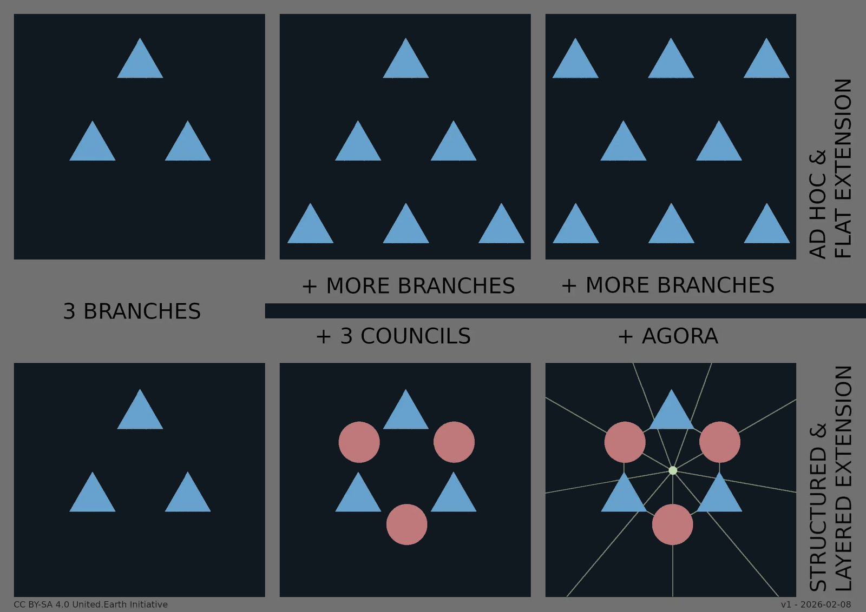
3 brances extension
The upper row illustrates a familiar historical pattern: extending the three branches by adding more institutions of the same type, resulting in ad hoc, flat expansion and growing systemic opacity and complexity.
The lower row shows an alternative response: preserving the three branches while absorbing new functions through distinct layers, advisory councils and a shared digital public square (AGORA), allowing complexity to be handled through structure rather than accumulation.

From ad hoc to structured expansion of the three branches
This infographic contrasts two fundamentally different ways of responding to increasing political complexity.
By introducing a dedicated complementary councils layer alongside the three branches, and a shared digital infrastructure that binds them together, we can repurpose functions that have historically accumulated as ad hoc extensions, allowing the core model to remain simple, legible, and true to its original purpose.
The classical separation of powers into legislative, executive, and judicial branches has proven remarkably durable. It provides a clear and widely understood mental model for how power is distributed, constrained, and legitimised within democratic systems. At the same time, modern societies have repeatedly encountered governance needs that the three-branch model alone cannot adequately absorb.
Historically, the dominant response has been to extend the model horizontally by adding new authorities, offices, or institutions alongside the three branches. This pattern can be described as ad hoc flat extension: the accumulation of additional institutions within the same constitutional layer, created to address real functional deficits but without corresponding structural differentiation.
Over time, such extensions increase institutional density and blur lines of responsibility. This is not a failure of the three branches themselves, but a mismatch between a one-layer institutional architecture and the complexity of contemporary social, technological, and global conditions.
The core insight is therefore that the problem is structural rather than numerical. What is missing is not more branches of the same kind, but additional layers with clearly differentiated roles.
Instead of continuing horizontal expansion, the proposed system proposes a layered extension of the three branches. The branches are preserved as the core institutional governance layer, maintaining their established functions and democratic legitimacy. Complexity is addressed orthogonally, through the introduction of two additional layers designed for tasks that cannot be coherently integrated into the branches themselves.
The first is a council layer, providing institutionalised capacity for ethical judgement, epistemic* grounding, and cultural safeguarding. The Councils are not merely advisory bodies, but constitutionally anchored institutions with defined responsibilities for safeguarding the ethical, scientific, and cultural foundations of governance.
The second is a digital infrastructure layer: AGORA, a secure and public digital space for information, deliberation, proposal-making, and democratic participation across all levels of governance.
Through this layered approach, new governance functions are integrated without fragmenting the core structure. The three branches remain stable and recognisable, while modern complexity is handled through functionally distinct layers.
The three layers perform different but interdependent roles. The branches provide the constitutional institutions for legislation, execution, and adjudication. The Councils safeguard the ethical, scientific, and cultural foundations of governance. AGORA provides the shared civic infrastructure through which citizens learn, deliberate, develop proposals, participate in decisions, and hold the institutional system accountable.
Sections 5 to 7 describe these three layers in turn.
Section 5 examines AGORA, section 6 the three Councils, and section 7 the three branches.

* epistemic = what concerns knowledge (Wikipedia). We use the term because it is the most efficient academic term, and explain it to promote its wider use.

10. AGORA (layer)
AGORA is the constitutional digital public sphere of the proposed system: the governance layer through which Earth Citizens form a democratic public and exercise political authority within and across every governance unit and level.
It integrates lifelong civic learning, structured deliberation, proposal development, voting, elections, public knowledge, relevant competence, and publicly governed AI within one continuous democratic infrastructure. By transforming human participation into structured collective reasoning, AGORA makes it possible to build humanity’s first intelligent geopolitical system.
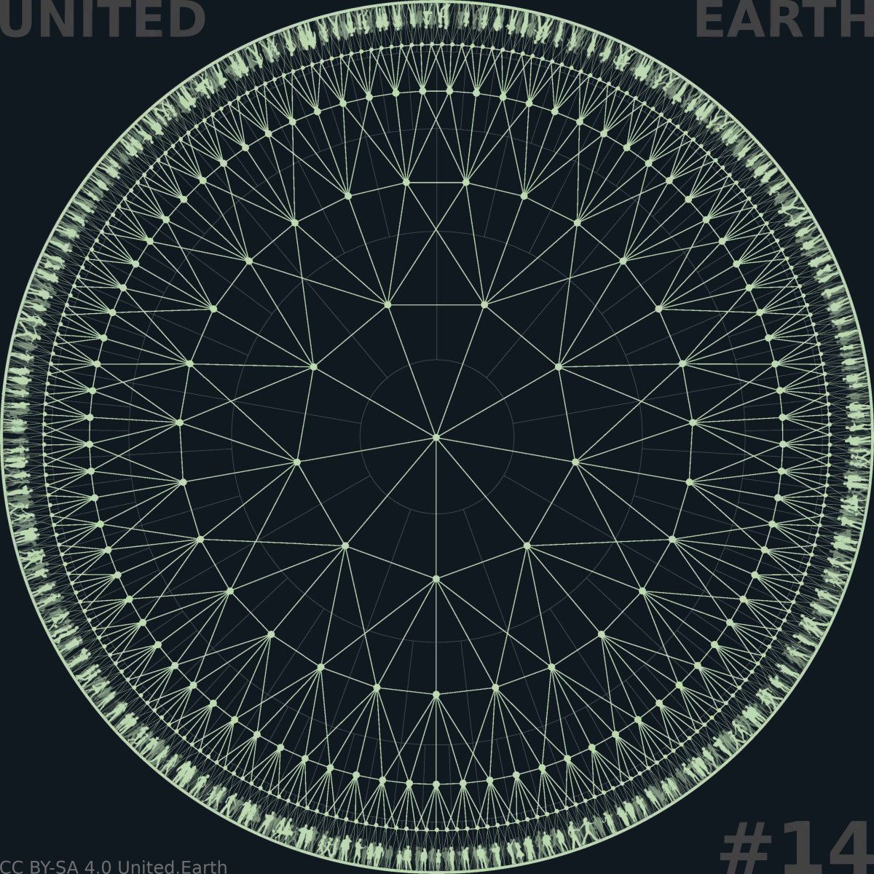
EARTHWHEEL 16/18

A networked global public square
The illustration shows AGORA as a distinct layer formed by interconnected nodes within every governance unit and at every level.
Each node connects to neighbouring nodes at the same level and to relevant nodes above and below it. These overlapping connections provide alternative routes through the system, allowing communication, knowledge, democratic processes, and institutional records to move across the network without depending on one central node or one fixed path.
Unlike the three branches and the Councils, which operate as distinct institutions within each governance unit, AGORA operates both within the unit and between units. It provides the shared infrastructure through which citizens participate in governance and through which the complete constitutional system remains connected.
The web therefore represents both civic participation within each governance unit and the federated network connecting the entire system.

10.1 What AGORA is
AGORA is the constitutional public sphere through which Earth Citizens participate in governance. It should be understood simultaneously as a governance layer, a public digital commons, a democratic infrastructure, and a continuous civic process.
It provides one coherent political environment in which citizens can access public knowledge, learn, deliberate, develop and revise proposals, vote, elect parliamentarians, scrutinise institutions, and follow decisions through formalisation and implementation.
AGORA is not a social network, a commercial platform, or a general digital environment for every aspect of social life. It is specialised political infrastructure, publicly governed and constitutionally protected. Its purpose is not to maximise attention, engagement, advertising revenue, or the circulation of opinions, but to support informed democratic judgement and legitimate collective decisions.
Nor is AGORA a fourth branch of power. It does not administer public services, issue judicial rulings, or independently convert political preferences into law. It provides the structured public process through which citizens exercise democratic authority, while the Councils clarify the basis for judgement and the three branches make valid decisions legally and institutionally operative.
Democratic authority does not originate through parties, electoral campaigns, or periodic elections. It originates continuously among Earth Citizens participating directly through AGORA.
This changes the relationship between citizens and governing institutions. Political participation is no longer concentrated into occasional choices between complete party programmes. Citizens can instead engage with particular questions, policy areas, proposals, elections, and governance levels according to their interests, knowledge, responsibilities, and available time.
AGORA operates across every governance unit and level. Through one coherent public framework, citizens can enter the processes relevant to their locus, region, sub-bloc where applicable, bloc, and the globe as a whole. The constitutional allocation of competence determines which governance unit can make a binding decision, while the Policy Area Index identifies the domains of reality involved.
AGORA is therefore not merely an interface added to an existing representative system. It is the public democratic foundation from which institutions receive their mandates and through which their exercise of authority remains visible, contestable, and accountable.

10.2 Lifelong civic participation
Earth Citizenship provides the common civic standing through which people participate in AGORA. It gives every person a defined relationship to the democratic system, including access to its public knowledge, civic processes, and constitutionally allocated forms of political participation.
AGORA distinguishes between access, civic participation, and binding political authority.
Access to public political knowledge and civic processes is a universal right. The system must provide the practical conditions required for every person to exercise it. This includes accessible technology, connectivity, language support, public access points, and assistance for people who cannot use the standard digital interface independently.
Civic participation includes learning, deliberation, proposal development, knowledge assessment, and other forms of contribution that do not themselves determine a binding political result. Binding voting rights begin at the age of 18.
Democratic participation should nevertheless begin long before formal voting age. Children and young people can use AGORA for civic learning, deliberation, proposal development, knowledge tests, simulated votes, and simulated elections. Their results can be displayed separately, allowing their political judgement to become visible without being counted as binding authority before adulthood.
This creates a continuous civic development process rather than a sudden transition from political exclusion to full voting rights on a person’s eighteenth birthday. Young people can gradually become familiar with public knowledge, disagreement, democratic responsibility, institutional procedures, and the consequences of collective decisions.
Every Earth Citizen can hold only one verified civic account. Verification must establish that the participant is one unique and eligible human being without requiring the person’s legal identity to be made public.
Public participation may therefore be pseudonymous. The identity connecting the person to the verified account remains confidential within the protected identity system, while votes and elections remain secret. Public pseudonymity protects citizens from social, professional, economic, or political retaliation without removing the internal safeguards required for democratic integrity.
Each Earth Citizen is connected to a primary locus, determined by their place of residence. This determines the territorial sequence of governance units in which the citizen holds binding democratic rights: local, regional, sub-blocal (where that level exists), blocal, and global.
The primary locus does not confine the citizen’s access to information or public discussion. AGORA remains a shared public sphere in which people can follow and learn from political processes across the system. Binding participation, however, must remain connected to the governance units in which the person is constitutionally represented and directly affected as a citizen.
Earth Citizenship consequently combines universal political equality with situated democratic responsibility. Every adult citizen enters the system with the same basic right to participate and vote.
The next question is how AGORA can recognise relevant competence within particular decisions without transferring political authority to a permanent expert class.

10.3 Scientific, ethical, and cultural competence
Political decisions require more than factual knowledge alone. They concern what is real, what responsibilities follow from that reality, and how possible decisions will be understood and experienced by different people and societies.
AGORA therefore distinguishes between three complementary forms of competence: scientific, ethical, and cultural. Together, these three dimensions form the Science, Ethics, and Culture (SEC) framework.
Their relevance varies between decisions. A technical infrastructure question may depend heavily on scientific and practical competence. A question concerning fundamental rights may require exceptional ethical understanding. A proposal affecting languages, traditions, historical conflicts, or relations between communities may depend strongly on cultural competence.
The three forms are not fixed ranks or separate political classes. They are dimensions of understanding that can contribute to a citizen’s competence profile wherever they are relevant.

Scientific competence
Scientific competence may be described as the demonstrated ability to understand and evaluate the best available knowledge relevant to a decision. This includes understanding:
- facts and evidence
- concepts and methods
- causal relationships
- uncertainty and competing explanations
- risk and probability
- direct and indirect consequences
- systemic effects
- practical feasibility
Scientific competence does not require certainty or agreement with a prevailing conclusion. It requires the ability to distinguish evidence from assertion, understand the strength and limitations of different claims, and reason transparently under conditions of uncertainty.
The term includes relevant technical, professional, practical, and research-based knowledge. Its purpose is not to privilege academic institutions as such, but to recognise demonstrated understanding of reality and how it can be investigated.
Ethical competence does not measure whether a person is morally good, nor whether the person agrees with one prescribed ethical conclusion. It measures the ability to recognise ethical conflicts, explain the principles involved, consider the positions of affected parties, and reason consistently about possible consequences.
Ethical knowledge does not guarantee ethical action. Ethical awareness, knowledge, and practice can increase the probability of better decisions.

Ethical competence
Ethical competence may be described as the demonstrated ability to identify and analyse the responsibilities involved in a political decision. This includes understanding:
- rights and duties
- who will be affected
- power and vulnerability
- necessity and proportionality
- the distribution of benefits, burdens, and risks
- consequences for future generations
- conflicts between legitimate ethical considerations
Ethical competence does not measure whether a person is morally good, nor whether the person agrees with one prescribed ethical conclusion. It measures the ability to recognise ethical conflicts, explain the principles involved, consider the positions of affected parties, and reason consistently about possible consequences.
Ethical knowledge does not guarantee ethical action. Ethical awareness, knowledge, and practice can increase the probability of better decisions.

Cultural competence
Cultural competence may be described as the demonstrated ability to understand how political questions are interpreted and experienced within different human contexts. This includes understanding:
- language and concepts
- historical experiences
- cultural meanings
- differing worldviews
- sources of trust and mistrust
- how decisions may be received in different societies
- risks of humiliation, exclusion, domination, and conflict
Cultural competence allows the system to recognise that a proposal can be technically feasible and formally equal while still carrying radically different meanings or consequences in different contexts.
Cultural identity does not itself confer political weight. Personal experience and cultural belonging may contribute to knowledge, but belonging alone does not demonstrate the breadth or depth of understanding relevant to a particular decision.
Cultural identity does not confer political weight. Cultural understanding may.
Across all three domains, competence concerns the ability to understand, evaluate, and explain. Citizens do not have to reach the same conclusion in order to demonstrate competence.
Competence requires understanding, not agreement.
The SEC framework defines the forms of competence that AGORA must make universally accessible, verifiable, and applicable to particular political questions.

10.4 Learning and competence verification
Knowledge-based democracy can only be legitimate if every citizen has a real opportunity to develop and demonstrate relevant competence. The AGORA Knowledge System (AKS) must therefore provide the default learning and verification pathway, available to everyone regardless of formal education, professional position, wealth, or institutional connections.
Structured through PAI, AKS provides access to the concepts, evidence, research, data, uncertainties, ethical dilemmas, cultural contexts, and relationships relevant to each policy area.
Citizens can develop competence through self-directed and guided learning, courses, public explanations, tests, analytical tasks, and scenario exercises. Assessment must not be limited to memorising facts. Depending on the competence involved, it may require citizens to evaluate sources, interpret uncertainty, identify consequences, analyse ethical conflicts, compare perspectives, or explain how a proposal may operate in different cultural contexts.
The results contribute to a dynamic competence profile structured by PAI. The profile shows which areas and forms of competence have been verified, their scope, how recently they were assessed, and whether they remain current.
The Councils safeguard the integrity of AKS, including its knowledge base, learning structures, assessment criteria, and verification methods.
AGORA’s internal pathway must not require people to demonstrate knowledge that has already been credibly verified elsewhere. Formal qualifications, professional experience, research, publications, authorisations, and other verifiable evidence may therefore contribute directly to the competence profile.
AKS must maintain a structured map of external systems that already verify knowledge and competence…
Where these institutions provide authenticated and interoperable interfaces, relevant records can be retrieved and added to the citizen’s profile with their consent. A citizen should also be able to use a dedicated external verification interface to identify qualifications or records that can be imported.
Where automatic retrieval is unavailable, documentation can be submitted through a structured process. AKS authenticates the source, identifies the documented content and scope, proposes connections to the relevant parts of PAI, and flags uncertainty or missing information.
These processes must be automated as far as responsibly possible. Human review should be reserved primarily for exceptional cases, disputed records, appeals, conflicting evidence, and types of documentation the system has not previously classified.
ExternaExternal institutions verify the qualification, record, or experience. AKS determines how its documented content, scope, and current validity relate to the competence profile and to particular political decisions.
The same verified profile can also support qualification for institutional candidacy, including candidacy for the Councils. Specific eligibility requirements and selection procedures are defined for each institution.
All verification criteria and procedures must be transparent, reviewable, and open to appeal. Citizens must be able to understand what has been recognised, how it has been classified, and how they can correct or challenge the result.
Competence is never treated as a permanent status. It can be developed, updated, reassessed, expanded, challenged, or lost as knowledge, circumstances, and the citizen’s own understanding change.

10.5 Knowledge-weighted direct democracy
Every adult Earth Citizen has the right to participate in binding votes through AGORA. No knowledge test is required to exercise this right, and every eligible citizen begins with a voting weight of 1.
Verified competence relevant to a particular decision can increase that voting weight, within the proposed range from 1 to 100.
The purpose is explicit: those who have demonstrated the greatest relevant competence should have the greatest influence within the matters they understand best.
Additional weight is always specific to the policy areas and forms of competence involved in the decision. A person may have substantial competence within one part of PAI and no additional voting weight within another.
Where a decision involves several policy areas or SEC dimensions, the weighting must reflect the particular combination relevant to that decision. Scientific competence may carry more significance in one question, ethical or cultural competence in another, while many decisions require all three.
No qualification creates a general or permanent political rank. A degree, profession, publication, institutional position, or body of experience contributes only within the scope it credibly documents and for as long as that competence remains relevant and current.
Wealth, fame, organisational power, popularity, and social connections confer no additional voting weight in themselves.
The rules and calculations determining voting weight must be transparent, intelligible, publicly governed, and open to challenge and appeal. Citizens must be able to understand which forms of competence affect a decision and how their own verified profile has been applied.
This is a form of knowledge-weighted epistemic democracy, not epistocracy*. Political authority does not belong to experts or to a defined class of knowledgeable people. It remains distributed among all adult citizens, while demonstrated and relevant understanding can strengthen each citizen’s own participation.
The system favours knowledge, not a class of knowers.
Nor does AGORA require liquid democracy** to introduce relevant knowledge into political decisions. Liquid democracy transfers votes to trusted people. AGORA strengthens each citizen’s own vote through demonstrated knowledge.
The knowledge effect sought through delegation can therefore be achieved without transferring political authority, accumulating delegated votes, or creating new political intermediaries. Citizens remain the direct holders of their own democratic rights.
AKS and the public AI infrastructure described in the following subsections support the learning, verification, analysis, and navigation required to make this model work at scale.

* Wikipedia on epistocracy
** Wikipedia on liquid democracy

10.6 The AGORA Knowledge System (AKS)
Knowledge-based democracy requires more than access to information. Citizens need a shared structure in which relevant knowledge can be found, understood, compared, challenged, and continuously updated.
AKS is a publicly governed system organised through PAI. For each policy area and political question, it brings together the concepts, evidence, research, data, methods, uncertainties, ethical considerations, cultural contexts, arguments, and documented consequences relevant to democratic judgement.
AKS includes the public knowledge base, learning pathways, competence verification, competence profiles, assessment methods, revision histories, and the interfaces through which public AI accesses these structures.
AKS does not present one authorised conclusion that citizens are expected to accept. It must distinguish transparently between:
- well-established knowledge
- strong but uncertain conclusions
- contested interpretations
- unresolved questions
- unknown conditions
- speculation
Sources, methods, assumptions, disagreements, revisions, and conflicts of interest must remain visible. Minority assessments and credible competing interpretations cannot be removed merely because a majority of qualified contributors supports another conclusion.
AKS must also show relationships between policy areas. A proposal concerning transport may affect land use, energy, public health, climate, economic distribution, and local communities. PAI allows these connections to be identified and followed rather than leaving each issue confined within an institutional silo.
The knowledge base is therefore not a static library. It is a continuously developing public record of what is known, what remains uncertain, where disagreement exists, and how political understanding changes over time.
The Councils safeguard the integrity, methods, structure, and public accessibility of this system. Their institutional responsibilities are described in section 6. Citizens, researchers, public institutions, civil society, and other relevant contributors can provide knowledge, criticism, and corrections through transparent procedures.
The knowledge system must remain accessible independently of the AI systems used to navigate it. Its sources, classifications, revision histories, and competing interpretations constitute public infrastructure in their own right and cannot be concealed inside proprietary models or automated outputs.
PAI identifies and connects the policy areas. SEC identifies the dimensions of understanding. AKS organises the knowledge, learning, verification, and competence through which citizens and institutions engage with them.
This separation is essential. AKS provides the public record. AI provides tools through which citizens can explore, interpret, and use that record.

10.7 Public AI as democratic infrastructure
The scale and complexity of AKS make powerful AI necessary. No individual can independently navigate all relevant sources, disciplines, languages, governance levels, and possible consequences involved in modern political decisions.
Public AI therefore forms a central part of AGORA’s democratic infrastructure. It operates between citizens and the knowledge system, helping people participate meaningfully without becoming dependent on private platforms, commercial recommendation systems, or inaccessible specialist institutions.
Publicly governed AI systems can help citizens:
- navigate PAI and the knowledge base within AKS
- search for relevant evidence and sources
- translate between languages
- explain concepts at different levels of complexity
- compare arguments and proposals
- identify assumptions and missing premises
- show uncertainty and scientific disagreement
- develop counterarguments
- trace relationships between policy areas
- explore possible consequences and trade-offs
- run transparent models and simulations
- create personalised learning pathways
- identify where additional knowledge is required
- prepare and evaluate political proposals
- understand how verified competence relates to particular decisions
AI can make complex political knowledge accessible without requiring every citizen to become a specialist in every field. It can help each person reach the level of understanding required for meaningful participation in the questions they choose to engage with.
This makes public AI a condition for substantive political equality. Formal access to AGORA is insufficient if only highly educated, technologically skilled, or institutionally connected citizens can navigate its knowledge and procedures effectively.
The AI infrastructure must therefore be available to all citizens as a public service. It must support different languages, levels of literacy, forms of disability, technical circumstances, and preferred ways of learning and interacting.
The AI systems must not function as invisible authorities. Their sources, methods, limitations, and relevant uncertainties must be inspectable. Citizens must be able to compare outputs, challenge conclusions, report distortions, and access the underlying evidence.
Personalisation must serve the citizen’s stated needs rather than covertly shape political behaviour. It must not be used for hidden persuasion, behavioural manipulation, political profiling, selective withholding of information, or the creation of individually tailored political realities.
No AI system may determine which lawful political positions a citizen is encouraged to consider, which proposals receive artificial visibility, or which interpretations become the default framing of a public question without that influence being transparent and contestable.
Nor should one AI model become the exclusive interpreter of AKS. Public AI must allow methodological plurality, independent auditing, comparison between systems, and the continued possibility of direct human access to sources and arguments.
Different publicly approved AI systems may therefore analyse the same question through different methods, provided that their sources, assumptions, and limitations remain visible. Citizens must be able to compare their outputs rather than being confined to one authorised interpretation.
Public governance does not require every underlying model or technical component to be developed by one public institution. Universities, cooperatives, public agencies, non-profit organisations, and private developers may contribute systems and components under transparent public standards.
No provider may obtain exclusive control over AGORA’s cognitive infrastructure, citizen data, competence profiles, political history, or access to the AKS.
AI may assist with competence assessment, proposal analysis, knowledge organisation, moderation, translation, modelling, simulation, and administrative processes. Constitutionally defined human institutions remain responsible for the rules governing these functions.
Where AI contributes to competence verification, moderation, agenda progression, candidate assessment, or any other process affecting democratic influence, its role must be explicitly disclosed. The affected citizen must be able to understand the basis of the result and request human review where necessary.
No AI system may decide what citizens should believe, determine political outcomes, cast votes, stand for election, hold office, or exercise independent authority within AGORA, the Councils, or the three branches.
AI systems are human-made instruments. Apparent autonomy, conversational ability, complexity, or simulated judgement does not give them civic standing, political rights, or constitutional authority.
Human control must remain unbroken throughout the system.
The purpose of public AI is not to replace human political judgement. It is to extend the capacity of citizens to understand reality, deliberate across differences, and make decisions within a complex planetary civilisation.
AI may extend human understanding and collective intelligence, but it may never become an independent source of political authority.

10.8 Deliberation, proposals, and the public agenda
AGORA turns AKS into an active democratic process. Political deliberation is organised according to the governance unit with constitutional competence, the relevant PAI domains, and the particular issue being considered.
Each public process connects:
- the condition or problem that initiated it
- the relevant documentation
- arguments and counterarguments
- uncertainty and unresolved questions
- ethical and cultural considerations
- proposals and competing alternatives
- expected consequences and risks
- revisions and amendment histories
- assessments from relevant public institutions
This structure does not eliminate informal conversation, political advocacy, disagreement, emotion, or spontaneous public mobilisation. It gives formal democratic deliberation a traceable structure that allows participants to understand what is being proposed, why it is proposed, how it has changed, and which consequences have been identified.
Earth Citizens can initiate political processes, develop proposals individually or collaboratively, support existing initiatives, propose alternatives, submit amendments, and withdraw or revise their own contributions.
A proposal does not need to emerge as a complete legal text. It may begin as the identification of a problem, a statement of intent, a policy principle, or a suggested practical solution. Through deliberation, learning, institutional input, and public revision, it can develop into a form suitable for democratic decision.
Competing alternatives should remain visible rather than being prematurely compressed into one official proposal. Where possible, citizens should be able to compare clearly defined options, including the consequences of retaining current policy.
Every formal proposal must retain a public revision history. Changes to its wording, assumptions, objectives, evidence, consequences, and institutional implications must be traceable. No actor should be able to replace the substance of a supported initiative without making the change visible to its participants.
The political agenda does not belong exclusively to parliaments, governments, parties, media organisations, wealthy interests, or platform owners.
Parliaments, executives, Councils, public agencies, and other institutions may initiate proposals within their responsibilities. They may identify urgent needs, legal inconsistencies, budgetary requirements, emerging risks, or necessary institutional reforms.
They do not, however, possess an exclusive right to decide which public questions can enter the democratic process.
Citizen initiatives must have a defined path to formal treatment when transparent requirements are met. These requirements may concern:
- sufficient public support
- identification of the competent governance unit
- constitutional admissibility
- clarity of the proposed objective
- disclosure of relevant documentation and interests
- consideration of significant consequences
- completion of required deliberative stages
The exact thresholds may vary according to the governance level, the type of decision, and the consequences involved. They must be established in advance, publicly visible, proportionate, and open to judicial review.
Procedural and informational requirements are necessary to prevent the public agenda from becoming incoherent, overloaded, or vulnerable to manipulation. They must not become concealed political vetoes.
A parliament cannot reject a qualified citizen initiative simply because its members oppose the proposal. Once the established threshold and procedural requirements have been satisfied, the responsible legislative institution has a legal duty to process it within defined time limits. The detailed institutional obligation is described in section 7.
AGORA thus combines an open public agenda with structured progression. Citizens can introduce political questions from below, while shared procedures ensure that proposals become sufficiently clear, informed, and constitutionally situated before they proceed to a binding decision.
The next stage is to distinguish the different forms of voting and election, and to explain how continuous democratic participation produces binding political authority.

10.9 Voting, elections, and continuous democracy
AGORA supports several distinct forms of democratic expression. They must not be treated as interchangeable, because they produce different kinds of political consequence.

Binding political votes
Binding political votes determine substantive questions within the constitutional competence of a governance unit.
They may concern laws, policies, priorities, public frameworks, budgets, institutional mandates, or other matters that require a collective political decision. The process must identify the responsible governance unit, the relevant PAI domains, the available alternatives, and the competence profile applied to the vote.
Once Earth Citizens have reached a constitutionally valid decision, the responsible parliament cannot replace it with another outcome, prevent its formalisation, or delay it beyond established procedural limits.
The decision remains subject to constitutional and judicial safeguards. It may be reviewed concerning:
- compatibility with the Earth Constitution
- protected rights
- the constitutional competence of the governance unit
- subsidiarity, necessity, and proportionality where applicable
- the integrity of the voting process
- material procedural failures
Judicial review concerns the validity of the decision, not whether judges prefer another political result.
A valid decision is binding within the completed process, but it is not irreversible. Citizens may later amend or replace it through a new valid democratic process.

Constitutional votes
Constitutional votes concern the foundations, allocation of authority, rights, institutions, and amendment of the constitutional order.
Because these decisions define the rules within which ordinary democracy operates, they require separate procedures, extended public deliberation, explicit constitutional review, and appropriately demanding participation and approval thresholds.
The exact rules must be established by the Earth Constitution. They cannot be altered through the ordinary procedures they are intended to govern.

Advisory votes
Advisory votes allow citizens and institutions to examine public judgement without producing an immediately binding result.
They may be used to:
- compare possible directions
- identify priorities
- test whether a proposal should be developed further
- clarify public responses to emerging conditions
- guide institutions where several lawful courses of action remain available
Their advisory status must be visible before participation begins. An institution cannot present a vote as politically binding and later reclassify it because it dislikes the outcome.

Elections of parliamentarians
Elections select the individuals responsible for the legislative institution and its stewardship of democratic processes.
Candidates stand as individuals rather than as party delegates. Their verified competence, public participation history, proposals, interests, affiliations, and previous institutional performance are made available through AGORA as the basis for electoral judgement.
Knowledge-weighted voting is specific to the policy content of a decision. It does not automatically create a general political rank that applies to elections. Competence profiles instead contribute to candidate eligibility and allow citizens to assess the qualifications relevant to the office.
The precise electoral method must be constitutionally defined. It must protect equal civic standing, secret voting, fair candidacy, meaningful choice, proportional public access, and independence from party ownership, wealth, institutional status, and algorithmic promotion.
The election gives parliamentarians an institutional mandate. It does not transfer the citizenry’s substantive political authority to them.
Elections select the individuals responsible for the legislative institution and its stewardship of democratic processes.
Candidates stand as individuals rather than as party delegates. Their verified competence, public participation history, proposals, interests, affiliations, and previous institutional performance are made available through AGORA as the basis for electoral judgement.
Knowledge-weighted voting is specific to the policy content of a decision. It does not automatically create a general political rank that applies to elections. Competence profiles instead contribute to candidate eligibility and allow citizens to assess the qualifications relevant to the office.
The precise electoral method must be constitutionally defined. It must protect equal civic standing, secret voting, fair candidacy, meaningful choice, proportional public access, and independence from party ownership, wealth, institutional status, and algorithmic promotion.
The election gives parliamentarians an institutional mandate. It does not transfer the citizenry’s substantive political authority to them.

Continuous democracy
Political authority in AGORA is exercised continuously as issues develop. Citizens do not have to wait for a general election before they can initiate proposals, participate in deliberation, or make binding decisions.
Elections nevertheless remain necessary. Institutions require identifiable people who can accept responsibility, maintain continuity, organise formal procedures, oversee administration, and answer publicly for the use of institutional authority.
The proposed system therefore combines continuous issue-based democracy with a rolling election cycle.
The proposed five-level cycle assigns one governance level to each year:
- Year 1: local elections
- Year 2: regional elections
- Year 3: sub-blocal elections
- Year 4: blocal elections
- Year 5: global elections
When the transitional sub-blocal level is no longer required, the structure becomes a four-year cycle:
- Year 1: local elections
- Year 2: regional elections
- Year 3: blocal elections
- Year 4: global elections
This arrangement creates:
- elections every year
- one governance level in primary electoral focus at a time
- regular institutional renewal
- a comprehensible rhythm across the entire system
- time for public attention, learning, candidate evaluation, and transition between levels
- a recurring democratic progression from local governance to Earth Parliament
The sequence does not make higher-level elections more important than local ones. It creates a shared rhythm in which democratic attention moves through the complete constitutional structure and returns regularly to the places where daily life is governed.
Continuous democracy therefore consists of two interlocking processes:
- citizens exercise political authority throughout the year through deliberation, proposals, and substantive decisions
- institutions are renewed through a predictable cycle of elections across the governance levels
Democracy is no longer reduced to periodic selection between political organisations. It becomes a permanent public function, while elections provide regular stewardship, responsibility, and institutional renewal.

10.10 Transparency, identity, and post-party politics
Democratic participation requires transparency about interests that may influence political judgement. It does not require citizens to expose the personal identities through which they understand themselves or live their private lives.
AGORA therefore distinguishes between relevant political interests and protected personal identity.
Relevant interests may include:
- financial interests
- employment relationships
- public offices
- paid assignments
- ownership or control of organisations
- leading organisational roles
- funding relationships
- other connections directly relevant to the matter under consideration
Disclosure requirements must be proportionate and context-specific. A relationship should be disclosed when it may reasonably affect how a person’s contribution, proposal, candidacy, institutional decision, or assessment is interpreted.
The requirements become stronger when a person seeks or holds public office, exercises institutional responsibility, evaluates other citizens’ competence, contributes authoritative knowledge, or participates in decisions involving a direct personal or organisational interest.
Disclosure must not become general surveillance. Citizens are not required to publish their ethnicity, nationality, religion, philosophy, political self-identification, sexuality, family relationships, medical history, or other protected personal characteristics merely to participate in democratic processes.
Public pseudonymity remains compatible with political transparency. A citizen can disclose a relevant interest through a verified profile without making the confidential legal identity behind that profile visible to the public.
The system must also distinguish between identity and organisation. Cultural, religious, ideological, economic, and political organisations may participate openly in public life. They may develop ideas, publish analyses, organise learning, advocate positions, mobilise support, and recommend candidates.
They do not acquire political authority as collective persons.
Political parties may therefore continue to exist, but they no longer organise the constitutional structure of democracy. They cannot:
- own political mandates
- control access to electoral candidacy
- control candidate lists
- act as obligatory intermediaries between citizens and institutions
- receive reserved political representation
- exercise collective voting rights
- require elected parliamentarians to follow binding party discipline
Candidates stand as individuals. Parliamentarians receive their mandates from Earth Citizens and exercise their responsibilities under the Constitution, not on behalf of a party that owns their position.
This does not prevent voluntary cooperation. Parliamentarians and citizens may coordinate around shared proposals, values, analyses, or temporary political objectives. The decisive distinction is that these associations do not control institutional access or acquire authority independent of the participating individuals.
Post-party politics does not mean the end of ideological disagreement. Citizens will continue to hold different values, interests, theories, priorities, and interpretations of reality. What changes is the structure through which these differences enter governance.
Rather than choosing between complete ideological packages, citizens can examine and decide particular questions through AGORA. GeoWeMe may support this process by making the relationships between Earth, society, and the individual visible without becoming an ideology, party programme, or governing authority of its own.
Parties are therefore not prohibited. They become progressively less necessary as governance no longer depends on them for political organisation, candidate selection, public deliberation, or the aggregation of complete policy programmes.
The transition is from party-mediated authority to direct, knowledge-based, and issue-specific democratic participation.

10.11 Federated architecture, integrity, and resilience
A democratic infrastructure serving humanity cannot depend on only one platform, one database, one organisation, one technical centre, or one communication route.
AGORA must be publicly governed, federated, distributed, modular, redundant, interoperable, and constitutionally protected. Its essential protocols, democratic records, identity functions, knowledge infrastructure, and public interfaces must remain part of the shared civic infrastructure.
AGORA is organised as a network of constitutional nodes.
The nodes follow compatible constitutional and technical standards while retaining the capacity to operate within the responsibilities of their own governance units.
Each node connects to neighbouring nodes at the same level and to relevant nodes above and below it.
These connections form a network rather than a simple hierarchical tree. Communication and democratic processes should be able to follow several routes through neighbouring and cross-level connections. A node must not depend exclusively on one superior node, one provider, or one communication path in order to remain connected to the constitutional system.
Not every node must connect directly to every other node. The network must instead provide sufficient neighbouring connections, alternative routes, replication, and interoperability for information and authorised processes to reach their destinations even when parts of the system are unavailable.
The architecture is functionally self-similar. The scale and institutional form change between levels, but the basic relationships between citizens, knowledge, deliberation, decisions, Councils, Branches, and the AGORA node remain recognisable throughout the system.
Each node must retain sufficient local capacity to preserve essential democratic and institutional functions during temporary isolation or wider network failure. Civic identity, public records, constitutional procedures, authorised decisions, and institutional continuity must remain protected even when full functionality cannot be maintained.
The global level follows the same network principles, but not the ordinary one-unit, one-node physical form. Its governance functions are distributed between a network of global top-level nodes associated with the blocs. The distributed global structure is described in section 3.1, while its physical and constitutional relationship with each bloc is described in section 8.6.
The general physical and institutional form of a governance-unit headquarters and AGORA node is described in section 8.5.
The internet provides a useful analogy. Individual nodes, connections, and services may fail or be attacked without causing the entire network to cease functioning. Information and democratic processes can be replicated, routed, restored, and verified across multiple parts of the system.
The analogy has limits. AGORA cannot inherit the internet’s dependence on private platforms, opaque algorithms, concentrated cloud infrastructure, commercially controlled identity systems, or a small number of dominant network providers. Its constitutional functions require stronger public standards, accountability, distribution, and continuity.
Public governance does not mean that every component must be produced by one public institution. Universities, cooperatives, public agencies, non-profit organisations, and private developers may provide technology and services under open, interoperable, and democratically governed standards.
No provider may obtain exclusive control over:
- civic identity
- access to participation
- competence profiles
- AKS
- proposal visibility
- voting infrastructure
- election administration
- democratic records
- communication between governance units
- the system’s continued operation
The architecture must preserve one verified civic account for each human participant while separating confidential identity verification from public profiles, political activity, and secret voting.
No single institution should be able to combine these data layers into a complete system of political surveillance. Access must be limited by function, legally controlled, independently audited, and technically separated wherever possible.
AGORA requires protection against:
- identity fraud
- multiple civic accounts
- account theft
- vote buying
- coercion
- false automated participants
- manipulation of competence profiles
- coordinated disinformation
- concealed algorithmic control
- unauthorised surveillance
- sabotage
- central shutdown
- deletion or alteration of democratic history
The exact technologies used to provide these protections will change. The constitutional requirements must remain stable: verifiable human participation, secret voting, public procedural transparency, limited access to identity data, distributed control, independent auditing, and the ability to challenge consequential system decisions.
Integrity mechanisms must not themselves become instruments of domination. Systems designed to detect manipulation cannot be permitted to suppress lawful dissent, enforce political conformity, or classify disagreement as a security threat.
Automated detection may identify anomalies and initiate review. It cannot silently remove civic rights, alter votes, invalidate competence, or exclude citizens from political participation without a transparent process and access to appeal.
Democratic history must be durable. Proposals, revisions, assessments, procedures, aggregated results, formal decisions, institutional actions, and later corrections must remain traceable over time.
This does not require every personal contribution to remain permanently public. Privacy rights, lawful deletion, protected deliberation, and public pseudonymity must coexist with an immutable record of the validity and institutional progression of democratic decisions.
Redundancy also has a political function. When control is distributed across levels and institutions, no government, corporation, technical provider, or temporary majority can unilaterally silence the entire democratic public sphere.
AGORA must remain capable of operating during political conflict, infrastructure failure, cyberattack, natural disaster, and institutional crisis. Different parts of the system may enter degraded modes, but constitutional continuity and the capacity for legitimate democratic recovery must be preserved.
Technical architecture alone cannot secure this integrity. The system also requires permanent institutions capable of maintaining knowledge standards, evaluating methods, clarifying ethical responsibility, identifying cultural consequences, and publicly challenging failures without taking over the political decision.
These functions belong to the three Councils.

11. The three Councils (layer)
The three Councils form the permanent scientific, ethical, and cultural integrity layer of the proposed system. They clarify the reality, responsibilities, and human meanings involved in democratic decisions, and safeguard the knowledge, competence, and methodological structures through which Earth Citizens participate in AGORA.
The Councils do not govern instead of citizens, parliaments, executives, or courts. They make evidence, uncertainty, ethical conflicts, cultural consequences, and long-term risks visible before and throughout democratic decision-making. Their purpose is not to guarantee good decisions, but to increase their probability.
Science clarifies reality. Ethics clarifies responsibility. Culture clarifies human meaning. Citizens decide.

11.1 What the Councils are
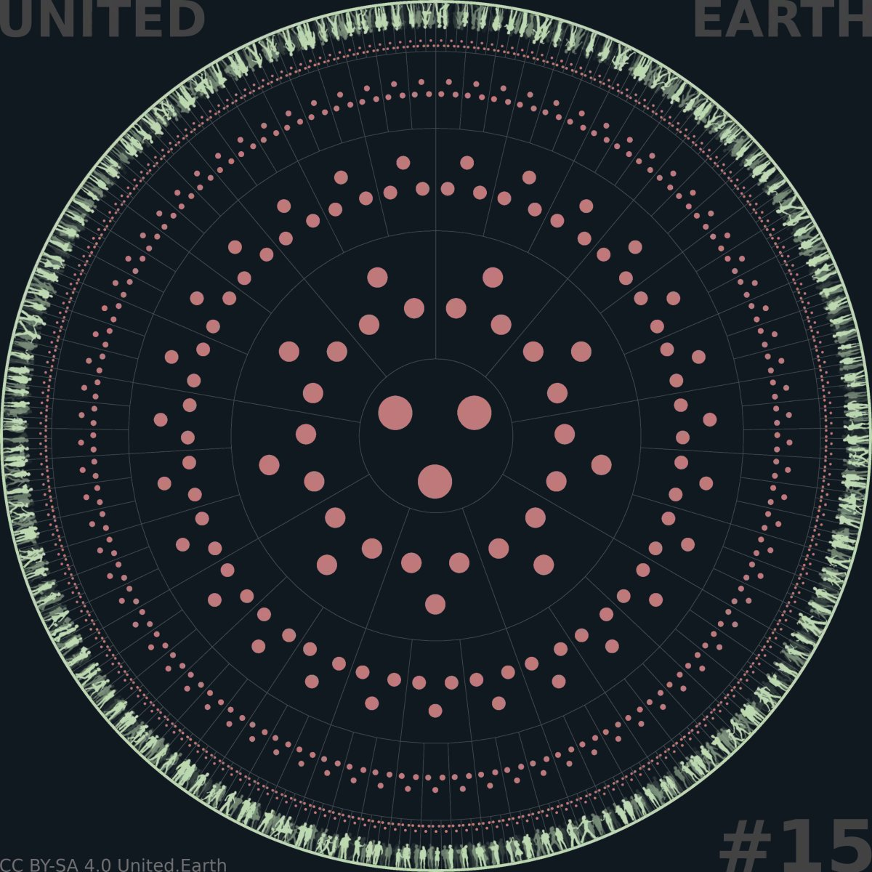
EARTHWHEEL 15/18

The democratic integrity layer
The illustration shows the Council of Science, the Council of Ethics, and the Council of Culture as a distinct governance layer operating within every governance unit and across all levels. They provide complementary perspectives on the same political processes rather than corresponding to separate branches or areas of political authority.
The Councils are permanent constitutional institutions, not temporary committees, extensions of individual branches, or parallel political decision-makers. They operate within governance units and connect federatively across levels, allowing knowledge, methods, assessments, warnings, and institutional learning to circulate throughout the system.
The pink network represents an integrity structure embedded throughout the governance system. AGORA is where citizens learn, deliberate, develop proposals, vote, and elect parliamentarians. The Councils clarify and safeguard the basis for judgement. The three branches formalise, implement, and judicially review valid democratic decisions.
The three Councils form a distinct governance layer consisting of permanent constitutional institutions for science, ethics, and culture (SEC). They operate within governance units at every level and connect federatively across the system.
The Councils are the permanent institutional guardians of the SEC framework.
Their purpose is to maintain the conditions required for informed and responsible democratic judgement. They clarify the realities, responsibilities, uncertainties, consequences, and human contexts involved in political decisions, while citizens retain the authority to decide.
The Councils are not merely advisory committees. They hold defined responsibility for essential system functions, including the integrity of AKS, competence development and verification, methodological standards, public evaluation of proposals, and the transparent treatment of uncertainty and disagreement.
These responsibilities give the Councils substantive institutional authority within their own domain. They may establish and administer transparent standards for knowledge, assessment, verification, documentation, and public evaluation where the Constitution assigns those functions to them.
They do not possess sovereign political authority. They cannot enact laws, administer public policy, issue judicial rulings, replace a valid democratic decision with their preferred outcome, or acquire a general veto over political processes.
Their authority concerns the integrity of the basis for judgement, not the political conclusion drawn from it.
The Councils must remain institutionally independent of the three branches, political parties, private interests, knowledge providers, and the organisations whose work they evaluate. Their assessments, standards, methods, sources, disagreements, and conflicts of interest must be publicly visible and open to criticism, revision, and appeal.
Independence does not mean separation from democratic legitimacy. The Councils exercise public functions within a constitutional democracy and must therefore be constituted through procedures that combine documented competence with democratic accountability.
Their federated structure allows each Council to work at the governance level and within the policy areas relevant to a particular question. Local and regional knowledge can enter higher-level processes, while global knowledge, standards, and warnings can remain accessible throughout the system.
The Councils must also preserve internal pluralism. Scientific, ethical, and cultural questions frequently contain legitimate disagreement. The purpose of the Councils is not to conceal this disagreement behind an institutional voice, but to make its substance, evidential basis, and consequences publicly understandable.
The Councils cannot guarantee good political decisions. They are designed to increase their probability.

11.2 Council of Science
The Council of Science safeguards the scientific and epistemic integrity of the governance system. Its primary task is to clarify what is known, how it is known, how certain that knowledge is, and what consequences can reasonably be expected from different courses of action.
Its responsibilities include standards for:
- evidence and verification
- scientific and analytical methods
- data quality and integrity
- causal reasoning
- risk and probability
- uncertainty
- systems analysis
- modelling and simulation
- practical feasibility
- long-term observation
- transparent scientific disagreement
The Council does not treat scientific knowledge as a collection of unquestionable conclusions. It maintains procedures through which claims, methods, data, assumptions, models, limitations, and competing explanations can be examined and challenged.
AKS must distinguish clearly between well-established knowledge, strong but uncertain conclusions, contested interpretations, unresolved questions, unknown conditions, and speculation.
These distinctions must be preserved when the Council assesses political proposals. A proposal may depend on reliable evidence in one area while containing major uncertainty in another. The purpose of the assessment is to make both conditions visible rather than compressing them into one simplified institutional judgement.
The Council evaluates factual plausibility, expected consequences, systemic relationships, risks, uncertainties, and feasibility. It may identify missing evidence, methodological weaknesses, unsupported assumptions, or consequences that have not been considered.
Where credible scientific disagreement exists, majority and minority assessments must remain accessible. Institutional agreement cannot be used to erase relevant uncertainty or suppress a methodologically credible alternative interpretation.
The Council also supports long-term monitoring. Many political consequences emerge gradually, interact across policy areas, or become visible only after implementation. Scientific assessment must therefore continue after a decision has been made, allowing policies and knowledge structures to be revised as reality changes.
The Council develops and safeguards scientific learning pathways, assessments, scenario exercises, and methods for verifying relevant scientific, technical, professional, and practical competence within AGORA.
Scientific understanding can clarify reality and probable consequences. It cannot alone determine which consequences should be accepted, which rights should prevail, or what citizens ultimately ought to decide.

11.3 Council of Ethics
The Council of Ethics safeguards the ethical integrity of the governance system. Its primary task is to clarify the responsibilities, boundaries, conflicts, and human consequences involved in political decisions.
Its work is grounded in the constitutional premise that life has intrinsic value. From this starting point, it examines questions involving:
- rights and duties
- necessity and proportionality
- power and vulnerability
- non-domination
- affected persons and communities
- the distribution of benefits, burdens, and risks
- future generations
- ecological responsibility
- conflicts between legitimate ethical considerations
- long-term moral consequences
The Council does not determine whether a person is morally good, nor does it establish one complete ethical doctrine that citizens must accept. It identifies the ethical dimensions of a question and makes the reasoning behind competing positions visible.
A proposal may protect one right while restricting another, reduce one form of harm while transferring risk elsewhere, or benefit present populations while imposing costs on future generations. The Council’s role is to expose such relationships and clarify the principles and responsibilities involved.
The Council may identify actions or proposals that conflict with constitutionally protected rights, the intrinsic value of life, non-domination, or other binding ethical foundations. The judicial branch retains responsibility for issuing legally binding interpretations of the Constitution.
The Council supports the continued development and public understanding of foundational documents such as the Declaration of the Rights of Life and the ethical principles embedded in the Earth Constitution. It does not replace the democratic and constitutional procedures through which those documents are established or amended.
It also develops learning pathways, ethical scenarios, reflection exercises, and assessments through which citizens can demonstrate the ability to recognise ethical conflicts, understand affected perspectives, evaluate consequences, and reason consistently.
Ethical competence does not require agreement with the Council or with one prescribed conclusion. What can be assessed is the ability to understand and explain the ethical conflict.
Ethical knowledge does not guarantee ethical action. Ethical awareness, knowledge, and practice can increase the probability of better decisions.

11.4 Council of Culture
The Council of Culture safeguards cultural understanding, dignity, plurality, and interpretive fairness within the governance system. Its primary task is to clarify how language, history, worldview, identity, and social context affect the meaning and consequences of political decisions.
Its responsibilities include:
- language and concepts
- historical experiences
- cultural meanings
- differing worldviews
- cultural continuity
- minority and Indigenous perspectives
- communication between societies
- sources of trust and mistrust
- risks of humiliation and exclusion
- risks of cultural domination
- cultural effects of laws and policies
- mutual understanding and conflict prevention
A policy that appears neutral in abstract legal or technical terms may be experienced very differently between societies. The same concept may carry different historical associations, and the same institutional arrangement may create trust in one context and fear or humiliation in another.
The Council makes these differences visible before they become unintended political consequences or sources of conflict. It helps citizens and institutions understand how proposals may be interpreted, implemented, and experienced across diverse human contexts.
The Council of Culture does not represent nations, religions, ethnicities, ideologies, or other identities as collective political persons. Nor does it assign public authority according to cultural belonging.
It must not become an institution that decides which identities are authentic, who belongs to them, or which version of a culture is correct. Cultural knowledge must remain open to internal diversity, disagreement, historical change, and criticism.
People with relevant cultural knowledge and experience may contribute to assessments, learning systems, and public deliberation. Personal belonging can provide valuable situated knowledge, but belonging alone does not establish complete cultural competence or political authority.
The Council develops learning pathways, contextual resources, translation standards, and assessments that enable citizens to understand cultural meanings and consequences beyond their own immediate experience.
It also helps ensure that AKS and public AI remain accessible across languages and contexts without reducing cultural differences to simplified categories or forcing all societies into one interpretive framework.
Cultural neutrality does not mean the removal of culture from public life. It means that governance does not belong to any culture and that all citizens and identities meet within institutions that protect their equal standing.
The Council makes cultural knowledge accessible and contestable without converting cultural identity into governing authority.
Together, the three Councils clarify the scientific, ethical, and cultural dimensions of political judgement. Their shared responsibility for PAI, AKS, and the SEC is developed in the following subsection.

11.5 Shared responsibilities and stewardship
The three Councils contribute distinct but complementary forms of oversight across the same governance structures and political processes. The table below summarises their principal responsibilities before the following sections explain how these functions are organised and exercised.
The three Councils jointly safeguard the structures through which knowledge and competence become usable within democratic governance.
Their shared responsibilities include:
- the Policy Area Index (PAI)
- the AGORA Knowledge System (AKS)
- learning pathways and courses
- tests, analytical tasks, and scenario exercises
- competence verification methods
- competence profiles
- methodological standards
- revision and appeal procedures
- standards governing public AI within AKS
Each Council contributes through its own domain.
The Council of Science safeguards conceptual clarity, evidence, methods, data, uncertainty, and empirical coherence.
The Council of Ethics safeguards rights, responsibilities, non-domination, the distribution of consequences, and the ethical boundaries within which knowledge and political action are interpreted.
The Council of Culture safeguards linguistic accessibility, contextual understanding, interpretive plurality, and protection against cultural bias or domination.

Stewardship of the PAI
The Policy Area Index provides the shared classification through which political issues and institutional responsibilities are organised, and to which knowledge and competence within AKS are connected. Because changes to PAI can affect how political reality is framed, its stewardship cannot belong to one discipline, institution, political majority, or technical provider.
The Councils jointly maintain its definitions, relationships, scope, and internal coherence. Proposed changes must be publicly documented and open to participation, criticism, and revision through AGORA.
The Councils cannot use stewardship of PAI to determine political priorities. PAI identifies and structures the domains of governance. It does not decide which problems citizens should address or which solutions they should prefer.

Stewardship of AKS
AKS encompasses the public knowledge base, learning pathways, competence verification, competence profiles, assessment methods, revision histories, and the interfaces through which public AI accesses these structures. The Councils jointly safeguard its integrity, while AGORA remains the civic environment through which citizens use it.
The Councils maintain the standards through which citizens can develop and demonstrate scientific, ethical, and cultural competence.
This includes ensuring that learning systems remain:
- publicly accessible
- relevant to the PAI domains involved
- transparent in their objectives and methods
- open to different learning pathways
- capable of recognising verified external competence
- protected against ideological conformity
- continuously updated as knowledge and conditions change
- open to correction and appeal
Competence assessments must evaluate understanding rather than agreement. No citizen should lose recognition merely for reaching a different political conclusion when the person can demonstrate a sound understanding of the relevant evidence, uncertainty, ethical conflict, and cultural context.
Competence requires understanding, not agreement.

Competence profiles for political decisions
Each political question may require a particular combination of competence within the SEC framework. This combination forms the competence profile applied to that decision.
The profile must identify:
- the relevant PAI domains
- the forms of competence involved
- the relative significance of those forms
- the scope and currency of recognised competence
- the method used to calculate any additional voting weight
The profile must be established before the binding vote, explained publicly, and open to challenge and judicial review.
It cannot be altered to favour a preferred proposal, group of citizens, predicted majority, or political result. Where the appropriate profile is disputed, the disagreement and alternative assessments must remain visible.
The same general competence infrastructure can support qualification for institutional candidacy. The Councils may help define the competence requirements associated with their functions, but they cannot control who is recognised as eligible to challenge or replace their current members.
AKS must remain institutionally capable of qualifying new candidates independently of the Councils they may later join.

Stewardship of public AI
The Councils also safeguard the scientific, ethical, and cultural standards governing public AI within AGORA.
The Councils do not receive political authority through this role, nor should they control one exclusive AI system. Their task is to maintain the public standards through which competing systems can be evaluated, approved, challenged, and removed.
They assess whether AI systems:
- use sources and methods transparently
- communicate uncertainty accurately
- remain open to independent auditing
- avoid concealed political persuasion
- respect rights and privacy
- function across languages and cultural contexts
- allow comparison between methods and models
- preserve direct access to underlying knowledge
- remain subordinate to human and constitutional authority

11.6 Evaluation, warnings, and public knowledge
The Councils apply their combined competence to political proposals, draft laws, existing policies, institutional practices, and emerging conditions.
Their evaluations may address:
- factual foundations
- methodological quality
- feasibility
- uncertainty and risk
- direct and systemic consequences
- rights and responsibilities
- distribution of benefits and burdens
- long-term and intergenerational effects
- cultural interpretation and impact
- risks of exclusion, humiliation, or domination
- relationships with other PAI domains
- assumptions that remain unsupported or unexamined
The purpose is not to produce one Council-approved political answer. It is to make the relevant basis for judgement visible before citizens and institutions act.
Public assessments
Council assessments must state:
- what has been evaluated
- which evidence and methods were used
- which assumptions were made
- what is known
- what remains uncertain
- where relevant disagreement exists
- which consequences have been identified
- which perspectives or information may still be missing
- which members or contributors have relevant conflicts of interest
Assessments must be publicly accessible through AGORA and connected directly to the proposals, laws, policies, or conditions they concern.
Where the Councils disagree internally, majority and minority assessments must remain visible. A formal majority may determine the institution’s principal statement, but it cannot erase a credible alternative analysis.
The Councils may also publish joint assessments where a question requires integrated scientific, ethical, and cultural judgement.

Warnings
A Council may issue a public warning when it identifies a serious threat, major uncertainty, constitutional concern, neglected consequence, or substantial failure in the basis for a political decision.
Warnings may concern:
- immediate danger
- accumulating systemic risk
- violation of ethical boundaries
- foreseeable harm to vulnerable groups
- long-term ecological or social consequences
- cultural domination or conflict
- unreliable evidence or modelling
- institutional capture
- failures in knowledge, competence, or AI systems
Warnings must state their grounds, urgency, limitations, and the conditions under which they should be revised or withdrawn.
A strong warning may create a constitutional duty for the responsible institutions to respond publicly, provide further documentation, or complete additional review. It does not allow the Council to impose its preferred political solution.

Evaluation after implementation
Council evaluation continues after a decision has been formalised and implemented.
The Councils help compare:
- expected and observed consequences
- predicted and actual risks
- intended and experienced cultural effects
- the original ethical assessment and the distribution of real outcomes
- the knowledge available at the time and what has since been learned
This allows errors, changing conditions, and unintended consequences to enter a new democratic process.
AKS must preserve this history. Assessments, disagreements, warnings, later evidence, and revisions should remain connected, allowing citizens to see not only what institutions currently conclude, but how understanding developed over time.
All Council work must therefore be:
- public
- reasoned
- traceable
- criticisable
- revisable
The Councils can warn with the full weight of their constitutional responsibility. They cannot make their preferred political conclusion binding.

11.7 Composition, independence, and democratic legitimacy
The Councils cannot protect democratic integrity unless their own composition is competent, plural, independent, and democratically legitimate.
Membership must be based on documented competence relevant to the Council and the responsibilities involved. Eligibility may draw on verified education, research, professional and practical experience, publications, demonstrated public reasoning, and competence developed directly through AGORA.
No single qualification, profession, institution, or academic tradition should control access.
Candidate eligibility must be determined through transparent, reviewable criteria and an independent verification process. Existing Council members cannot possess exclusive authority to approve the candidates who may replace or challenge them.

Democratic legitimacy
Council members must be selected through democratic election or another constitutionally defined process that provides genuine democratic legitimacy.
The detailed model may vary between Councils, governance levels, and types of responsibility. It may combine:
- verified eligibility requirements
- direct election by Earth Citizens within the relevant governance unit
- selection for defined specialist functions
- transparent nomination
- public candidate assessment
- limited use of sortition among qualified candidates
- institutional confirmation where constitutionally appropriate
Whatever model is chosen, the final structure cannot be a closed academy, a party-appointed committee, or a self-perpetuating professional corporation.
Citizens must be able to examine candidates through AGORA, including their:
- verified competence
- relevant experience
- public reasoning and participation history
- methodological positions
- institutional affiliations
- financial and organisational interests
- previous Council work where applicable
Democratic selection does not mean that all citizens are automatically eligible for every Council function. Competence requirements protect the integrity of the institution. Democratic legitimacy determines who among the qualified candidates receives the public mandate.

Independence
Council members must act independently of:
- the three branches
- political parties
- governments
- private funders
- commercial knowledge providers
- professional organisations
- religious or ideological institutions
- the institutions and systems they evaluate
Independence does not prohibit experience or affiliation. It requires relevant relationships to be transparent and prevents outside actors from directing Council conclusions or controlling membership.
Rules for recusal, conflicting interests, incompatible positions, funding, gifts, external assignments, and post-service employment must be publicly defined and enforceable.

Renewal and accountability
Council mandates must be time-limited. Terms, rotation, staggered renewal, and limits on repeated service should prevent permanent institutional ownership while preserving continuity and accumulated knowledge.
Members must be removable through transparent procedures for causes such as:
- serious misconduct
- corruption
- concealed conflicts of interest
- systematic methodological failure
- abuse of institutional authority
- incapacity to perform the assigned function
- deliberate falsification or suppression of relevant knowledge
Removal cannot depend merely on political disagreement or an unpopular assessment. The process must protect both institutional independence and public accountability.
The Councils must also remain internally plural. Their composition should reflect relevant differences in discipline, method, experience, geography, language, and cultural context without converting identity groups into holders of collective political mandates.
No permanent Council elite should emerge.
The Councils are competence-based institutions in a democracy, not institutions through which competent people acquire sovereignty over it.

11.8 Relationship to AGORA and the branches
AGORA, the Councils, and the three branches perform separate but interdependent functions.
AGORA is the constitutional public sphere through which Earth Citizens learn, deliberate, develop proposals, vote, elect officeholders, and scrutinise the governance system.
The Councils develop and safeguard the scientific, ethical, cultural, and methodological foundations required for informed democratic judgement.
The three branches make valid democratic authority legally and institutionally operative through legislation, execution, and adjudication.
The Councils contribute throughout the democratic process.
Before a decision, they develop knowledge, learning, competence standards, assessments, and warnings.
During deliberation, they clarify evidence, uncertainty, responsibilities, cultural consequences, and competing interpretations.
After a decision, they monitor consequences, update AKS, and identify conditions that may justify reconsideration.
They do not initiate executive action, issue judicial rulings, or formalise political preferences as law.
AGORA allows citizens to challenge Council knowledge and assessments, propose corrections, compare interpretations, examine institutional interests, and participate in the selection and accountability of Council members.
The branches must consider Council assessments where constitutionally required and respond publicly to serious warnings. They cannot compel the Councils to alter scientific, ethical, or cultural conclusions for political convenience.
The Councils, in turn, cannot use their responsibility for knowledge and integrity to obstruct a constitutionally valid democratic decision merely because they oppose it.
The judicial branch resolves legal disputes concerning Council authority, procedural integrity, rights, constitutional competence, and the lawful application of competence systems. It does not decide which scientific, ethical, or cultural conclusion must prevail as political judgement.
The three layers therefore correct different forms of systemic failure:
- AGORA prevents political authority from being enclosed within institutions and parties.
- The Councils prevent democratic participation from becoming detached from knowledge, responsibility, and human context.
- The branches prevent political decisions from remaining informal, unenforceable, or unprotected by law.
None can replace the others.
AGORA is the public sphere in which knowledge is used, challenged, and transformed into democratic decisions. The Councils develop and safeguard PAI, AKS, and the SEC framework. The three branches formalise, implement, and judicially review valid decisions.
The following section describes how the classical branches are retained, transformed, and integrated within this democratic and knowledge-based foundation.

12. The three branches (layer)
The proposed system retains the classical separation of powers into legislative, executive, and judicial branches. Their essential functions remain necessary: democratic decisions must be formalised as law, implemented through capable institutions, and interpreted and reviewed by independent courts.
What changes is the source and flow of political authority. AGORA establishes the democratic public through which Earth Citizens exercise political authority. The Councils safeguard the scientific, ethical, cultural, and methodological basis for judgement. The three branches then make valid democratic authority legally and institutionally operative.
The branches are therefore retained, transformed, and integrated within a new democratic and knowledge-based foundation. They do not replace the political authority of Earth Citizens or become alternative sources of sovereignty.
Citizens decide. The legislative branch formalises. The executive branch implements. The judicial branch adjudicates.

12.1 The transformed role of the branches
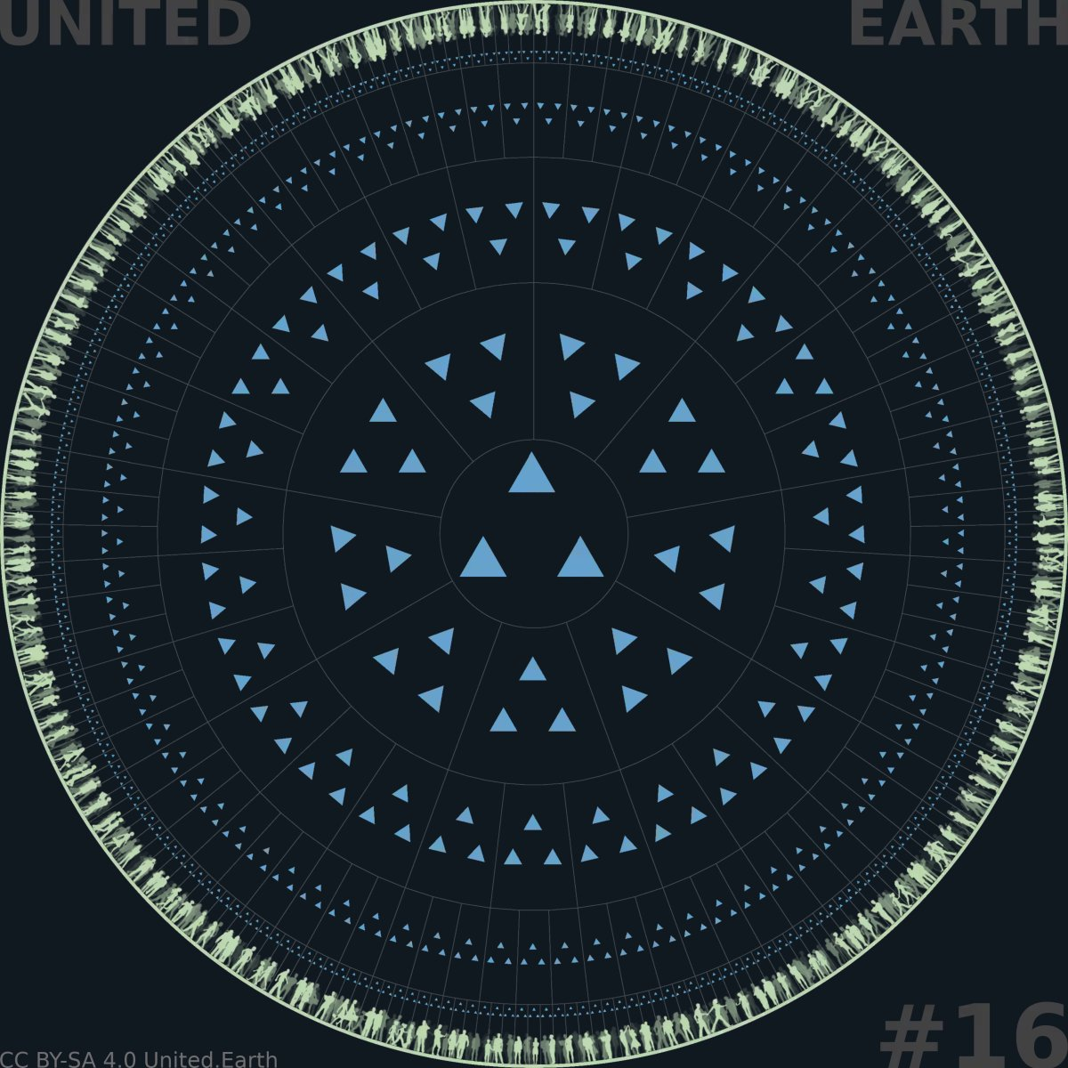
EARTHWHEEL 14/18

The classical branches, transformed
The illustration shows the legislative, executive, and judicial branches as a distinct governance layer operating within every governance unit and across all levels.
Together, the branches transform valid democratic authority into law, implementation, and constitutional adjudication.
The blue structure represents the formal institutional layer through which democratic authority becomes legally binding, operationally effective, and constitutionally controlled. The three branches remain separate from one another and from AGORA and the Councils. None may absorb the functions or authority of the others.
The three branches retain the institutional functions of legislation, execution, and adjudication. What changes is their position within the democratic system and the source from which their authority is derived.
In conventional representative systems, political authority is commonly concentrated within parties, elections, parliaments, governments, and courts. Citizens periodically select representatives, after which the institutional system exercises much of the substantive political authority until the next election.
In the proposed system, democratic authority originates continuously among Earth Citizens participating through AGORA. The Councils clarify the scientific, ethical, and cultural basis for judgement through PAI, AKS, assessments, and public warnings. The branches make constitutionally valid democratic authority legally and institutionally operative.
The branches therefore perform necessary public functions without becoming alternative sources of sovereignty.
Their responsibilities include:
- organising formal institutional processes
- translating valid democratic decisions into law
- implementing law and public policy
- exercising constitutionally delegated discretion
- interpreting law and the Earth Constitution
- protecting rights and procedures
- maintaining institutional continuity
- preserving public records
- controlling and constraining one another
This transformation does not reduce the branches to passive machinery. Laws require precise drafting, implementation requires practical judgement, and judicial interpretation requires independent legal reasoning.
The branches retain authority within these defined functions. What they do not possess is an independent right to replace the democratic will, determine their own constitutional competence, or treat public authority as the property of the institution.
Officeholders receive mandates to perform constitutional functions. They do not receive ownership of the political authority from which those mandates arise.
AGORA and the Councils consequently transform both the recruitment and the operation of the branches. Candidates can be evaluated through verified competence, public reasoning, participation history, interests, and institutional performance rather than primarily through party affiliation, campaign resources, or closed appointment systems.
Once constituted, the branches remain separate from AGORA and the Councils. Citizens decide through the democratic processes provided by AGORA. The Councils clarify the basis for judgement. The branches formalise, implement, interpret, and control the valid exercise of authority.

12.2 The legislative branch
The legislative branch organises the formal law-making process and ensures that valid democratic decisions become coherent, applicable, and publicly accessible law.
Its central institution is the parliament operating within each governance unit. Parliamentarians are elected as individuals and receive their mandates from the Earth Citizens of the relevant unit. Their mandates do not belong to political parties, electoral organisations, or other collective intermediaries.
The legislative branch is responsible for:
- developing legally precise proposals
- clarifying the alternatives submitted for democratic decision
- identifying the relevant PAI domains
- confirming which governance unit holds constitutional competence
- initiating and validating formal AGORA processes
- formalising valid democratic results as law
- coordinating new law with the existing legal framework
- establishing budgets and necessary legal authorisations
- overseeing the executive branch
- preserving legislative continuity and institutional memory

Legislative stewardship
Parliamentarians remain active participants in political development. They may identify problems, initiate proposals, develop alternatives, commission assessments, examine Council warnings, and contribute publicly to deliberation through AGORA.
They do not possess a monopoly over the political agenda.
Citizen initiatives that satisfy constitutionally defined requirements must enter a predictable path toward formal treatment. Parliament cannot suppress a qualified initiative because its members oppose its purpose or expect an unfavourable outcome.
The legislative process must therefore include:
- public procedural thresholds
- defined time limits
- visible case status
- mandatory treatment of qualified initiatives
- documented reasons for procedural decisions
- complete proposal and amendment histories
- judicially reviewable procedures
Committees may investigate, clarify, and improve proposals. They cannot conceal qualified initiatives indefinitely, alter their substance without a visible revision process, or use procedural control as a disguised political veto.

From political decision to law
A democratic decision may express a principle, objective, prohibition, priority, or defined policy choice without already being written as complete legislation.
The legislative branch must convert the valid substance of that decision into legally coherent form. This may require precise definitions, transitional provisions, institutional responsibilities, enforcement rules, budgetary frameworks, and coordination with existing law.
Legal clarification must not become political substitution.
Where several formulations could implement the same valid decision, parliament may exercise legal and institutional judgement. It cannot change the objective, reverse the result, remove its essential effect, or introduce provisions that contradict what citizens decided.
Material changes must return to the appropriate public process.
When a decision has been constitutionally and procedurally validated, parliament has a legal duty to formalise it within established time limits.
The result is final in relation to the parliament within that completed process. Its relationship to constitutional review and later democratic revision is clarified in section 7.5.

Budgets and oversight
The legislative branch establishes budgets and general legal frameworks within the priorities and obligations created through democratic decisions.
Budgetary authority cannot be used to nullify a valid decision indirectly. If implementation requires resources, parliament must either provide them, demonstrate a genuine constitutional or material impossibility, or initiate a transparent democratic process to reconsider the decision.
Parliament also oversees the executive branch. It can require documentation, question executive officeholders, investigate failures, review delegated authority, and establish accountability for the use of public resources and institutional power.
This oversight does not permit parliament to take over day-to-day administration. Its purpose is to ensure that implementation remains lawful, faithful to the democratic mandate, and publicly accountable.

12.3 The executive branch
The executive branch transforms law and valid democratic decisions into organised public action.
Its responsibilities include:
- public administration
- operational planning
- implementation
- public services
- allocation and management of authorised resources
- coordination between institutions and policy areas
- civil crisis response
- monitoring
- reporting
- maintenance of operational capacity
The executive does not merely follow mechanical instructions. Democratic decisions and laws cannot anticipate every practical condition. Implementation requires professional judgement, prioritisation, coordination, adaptation, and the selection of workable means.
The executive therefore needs sufficient discretion to act effectively within:
- the law
- authorised budgets
- delegated authority
- the constitutional competence of the governance unit
- transparent procedures
- democratic oversight
- judicial review
This discretion concerns how valid objectives are achieved. It does not allow the executive to replace those objectives with an independent political agenda.

Administration structured by PAI
Executive organisation follows the policy structure provided by PAI. This creates continuity between democratic deliberation, Council knowledge, legislation, administration, monitoring, and later evaluation.
PAI provides a stable reference for ministries, agencies, professional functions, budgets, data, and cooperation across governance units.
This does not mean that every governance unit must have an identical administrative organisation. Institutional forms can vary according to level, size, capacity, and local conditions.
The shared policy structure nevertheless prevents the administration from being continually reorganised to reflect temporary political branding, changing party coalitions, or short-term institutional priorities. Major structural changes should follow transparent revisions of PAI and the constitutional allocation of responsibilities.

Coordination across the system
Many political decisions involve several policy areas and governance levels. The executive must therefore coordinate:
- horizontally across PAI domains
- vertically between governance levels
- territorially between neighbouring governance units
- operationally between public institutions
Coordination does not remove the constitutional distinctions between these responsibilities. A higher executive institution cannot assume lower-level authority merely because coordination would be administratively convenient.
Nor can a lower unit disregard valid higher law when its actions create consequences beyond its constitutional competence.

Civil crisis response
Under peacetime and ordinary constitutional conditions, acute emergencies may require executive action before a complete democratic process can be concluded. This may include:
- natural disasters
- pandemics and other public health emergencies
- major infrastructure failure
- ecological emergencies
- severe economic or supply disruption
- other immediate threats requiring coordinated civil action
Emergency authority must be:
- constitutionally defined
- limited in scope
- limited in duration
- necessary and proportionate
- fully documented
- subject to immediate legislative and judicial control
- open to later public evaluation
Temporary executive necessity cannot become a permanent independent source of political authority.
Actions taken during a crisis must enter AGORA’s public record as soon as legitimate security and privacy requirements permit. Their assumptions, consequences, legal basis, and continued necessity must remain reviewable.
The executive is accountable not only for whether it acted, but for how faithfully, effectively, and lawfully it transformed democratic authority into practical results.

Military capacity
Military capacity exists only at the global and blocal levels.
Blocs hold territorial military authority within their land territories and a narrowly defined adjacent coastal zone. They control territorial defence and the principal concentration of coercive capacity within the global state.
The global level holds a separate and constitutionally limited military capacity within global domains that are not subject to bloc territorial sovereignty, including the open oceans, polar regions, and near-Earth space. It has no general authority to exercise military control over land territory.
Armed conflict between governance units, military action beyond bloc territory, and intervention by the global level are governed by the special constitutional procedures of the bloc-based global peacekeeping system described in section 9.

12.4 The judicial branch
The judicial branch protects the constitutional and legal integrity of the governance system.
Independent courts interpret and apply the Earth Constitution and valid law, resolve disputes, protect rights, review procedures, and determine whether institutions and governance units have remained within their lawful authority.
Its responsibilities include:
- interpreting the Earth Constitution and legislation
- protecting constitutional rights
- reviewing governance competence
- enforcing subsidiarity
- reviewing necessity and proportionality
- controlling the legality of public action
- resolving conflicts between governance units and levels
- reviewing the validity of democratic procedures and votes
- protecting AGORA and the Councils against unlawful capture
- providing remedies when institutions or public systems violate protected rights

Constitutional competence
The judicial branch determines whether a political question has been decided by the governance unit constitutionally authorised to decide it.
A decision may be invalid even when supported by a democratic majority if the unit lacked competence over the matter. A local majority cannot lawfully decide a matter reserved for a higher level, and a higher-level institution cannot take over a matter constitutionally protected as local.
Courts must also review whether upward allocation of authority satisfies subsidiarity, necessity, and proportionality. Administrative convenience or political preference is not sufficient justification for centralisation.

Review of democratic decisions
A court may invalidate a vote or its formal result when it:
- conflicts with the Earth Constitution
- violates protected rights
- lies outside the competence of the governance unit
- fails applicable requirements of necessity or proportionality
- results from material procedural violations
- is affected by corruption, coercion, manipulation, or failure of electoral integrity
Judicial review protects the conditions under which democratic authority is valid. It does not give judges a superior political vote.
Courts cannot invalidate a constitutionally valid decision because they consider it unwise, scientifically mistaken, ethically objectionable, culturally harmful, economically inefficient, or politically undesirable.
Council assessments may inform judicial understanding where evidence, ethical foundations, cultural context, or institutional methods are relevant. They do not dictate the legal judgement.
Likewise, courts may review whether PAI, AKS, competence profiles, public AI, and AGORA procedures have been applied lawfully. They do not take over the scientific, ethical, cultural, or technical stewardship assigned to the Councils.

Institutional protection
The judicial branch protects the separation between the governance layers and branches.
It may intervene when:
- a branch attempts to absorb the authority of another
- an executive institution obstructs judicial independence
- a parliament refuses a legally mandatory democratic process
- a Council exceeds its constitutional function
- AGORA is manipulated to exclude lawful participation
- identity systems, competence systems, or AI processes violate protected rights
- a governance unit attempts to detach itself from valid constitutional authority
Judicial independence is therefore indispensable. Courts must be protected from government direction, parliamentary retaliation, party control, private influence, public intimidation, and capture by the institutions they review.
At the same time, judicial power must itself remain transparent, reasoned, appealable, and constitutionally limited.
The courts protect the validity of democratic authority. They do not become its source.

12.5 Democratic finality and constitutional revision
A constitutionally valid democratic decision is binding on the legislative and executive branches.
Parliament must formalise the decision faithfully, and the executive must implement it within the law, the authorised budget, and its delegated authority. Neither branch may reopen the political outcome merely because its officeholders disagree with it.
The decision is final within the democratic process through which it was made.
Finality does not mean that the decision stands above the constitutional order. Every exercise of democratic authority remains subject to:
- the Earth Constitution
- protected rights
- the constitutional competence of the governance unit
- applicable requirements of subsidiarity, necessity, and proportionality
- procedural integrity
- judicial review
A court may invalidate a decision when one of these constitutional conditions has not been met. It cannot invalidate the decision because it prefers another lawful political outcome.
Nor does finality mean permanence. Political knowledge develops, circumstances change, consequences become visible, and citizens may revise their judgement.
A valid decision can therefore be amended or replaced through a new valid democratic process. The new process must meet the same constitutional and procedural standards as the original one.
This allows democratic authority to remain both decisive and capable of learning. Decisions must be implemented when valid, but the political community is not imprisoned by its previous conclusions.

Constitutional revision
Changes to the Earth Constitution require procedures distinct from ordinary political decisions.
Constitutional decisions may alter:
- protected rights
- the allocation of authority
- governance levels and units
- the functions of AGORA, the Councils, and the branches
- the procedures through which democratic authority is exercised
- the safeguards controlling institutional power
Because these decisions define the rules governing ordinary democracy, they require extended public deliberation, explicit constitutional review, and appropriately demanding participation and approval thresholds.
The exact procedures must be defined by the Constitution itself. Ordinary institutions cannot change constitutional limits merely by using the powers those limits regulate.
The constitutional order must therefore be stable enough to protect rights, institutional boundaries, and democratic continuity, while remaining amendable through a legitimate constituent process.
Democratic finality and constitutional revision together combine:
- democratic sovereignty
- constitutional limitation
- judicial protection
- institutional implementation
- political learning
- peaceful revision
A valid democratic decision must have consequences. A democratic system must also retain the capacity to recognise error and change direction.

12.6 Transparency, accountability, and institutional memory
Public authority must remain visible to the people from whom it originates.
The three branches must therefore document how they receive, interpret, delegate, and exercise their authority. Citizens must be able to follow the institutional progression from democratic decision to law, implementation, adjudication, evaluation, and later revision.
This requires:
- public documentation
- visible procedures
- reasoned decisions
- transparent delegations of authority
- disclosure of relevant interests
- accessible laws, regulations, and judicial rulings
- financial and administrative auditing
- complaint and appeal procedures
- personal and institutional accountability
- complete decision histories
- evaluation after implementation
Transparency does not require the publication of information whose disclosure would violate protected privacy, compromise legitimate security, expose confidential identity data, or undermine a fair judicial process.
Any limitation must have a defined legal basis, remain proportionate to its purpose, and be subject to independent review. Secrecy cannot be used merely to protect institutions from criticism, embarrassment, or political responsibility.

Reasoned authority
Consequential institutional actions must be accompanied by reasons.
The relevant branch must explain:
- the legal authority under which it acted
- the democratic decision or delegated mandate involved
- the evidence and assumptions used
- the alternatives considered where relevant
- the consequences and risks identified
- the institutional actors responsible
- the procedures available for challenge or appeal
A public institution cannot demonstrate accountability merely by publishing its final action. The reasoning and authority behind the action must also be traceable.
AGORA provides the civic interface through which citizens can access this documentation, scrutinise institutional conduct, identify responsibility, submit challenges, and initiate democratic reconsideration.
The Councils contribute evaluations of knowledge, methods, responsibilities, cultural consequences, risks, and observed outcomes. Their assessments supplement institutional accountability without replacing the legal responsibility of the branches.

Delegation and responsibility
Authority may be delegated within and between public institutions where the Constitution and the law permit it.
Every delegation must identify:
- who delegates the authority
- who receives it
- the exact scope of the authority
- its legal basis
- its duration
- its reporting requirements
- the conditions for review, withdrawal, or renewal
Delegation transfers the authority to perform a defined function. It does not erase the responsibility of the institution that authorised it.
Officeholders and institutions must answer for unlawful action, failure to perform mandatory duties, misuse of public resources, concealment of relevant interests, and abuse of delegated authority.
Accountability must distinguish between political disagreement, reasonable error, negligence, misconduct, and deliberate abuse. Institutions cannot function if every unsuccessful decision is treated as wrongdoing. They cannot remain legitimate if serious failure has no consequence.

Institutional memory
The governance system must preserve a durable institutional record.
This includes:
- proposals and amendments
- Council assessments and warnings
- democratic deliberation and aggregated results
- legislative drafting and formalisation
- executive plans and implementation records
- judicial interpretation and review
- delegated authority
- observed consequences
- audits, complaints, and appeals
- later corrections and revisions
Institutional memory allows citizens and officeholders to understand not only what was decided, but why it was decided, how it was implemented, what followed, and what the system learned.
Records must remain connected across AGORA, PAI, AKS, the Councils, and the branches. Changes to terminology, institutional organisation, or technology cannot be allowed to sever the history of public authority.
This continuity protects the system against repeated error, institutional amnesia, manipulation of political history, and the disappearance of responsibility between successive officeholders.

12.7 Separation and mutual constraint
The separation of powers remains a foundational constitutional safeguard.
The legislative, executive, and judicial branches possess different functions because the concentration of these functions within one institution would allow public authority to become self-authorising, self-executing, and self-judging.
The legislative branch cannot control judicial outcomes, direct individual court decisions, or remove judicial independence because it dislikes a legal interpretation.
The executive branch cannot suspend the law, control the courts, obstruct legislative oversight, or convert temporary administrative necessity into permanent political authority.
The judicial branch cannot take over the political agenda, administer public policy, or replace constitutionally valid political decisions with judicial preferences.
The branches must also remain separate from the other governance layers.
The Councils cannot enact law, administer policy, issue judicial rulings, or make their scientific, ethical, or cultural conclusions politically binding.
AGORA cannot function as a public administration, legislative drafting authority, executive command structure, or court. It is the constitutional public sphere through which citizens exercise democratic authority.
Conversely, the branches cannot take control of AGORA, PAI, AKS, the SEC framework, competence verification, or Council assessments to shape public participation and knowledge around their institutional interests.

Mutual constraint
Separation does not mean isolation.
The institutions are connected through:
- the Earth Constitution
- democratic authority exercised through AGORA
- the allocation of competence through governance levels and units
- PAI
- AKS
- the SEC framework
- Council assessments and warnings
- public documentation
- legislative oversight
- judicial review
- democratic accountability
Parliament oversees the executive without administering it.
Courts review parliament and the executive without governing in their place.
The executive implements law while remaining accountable to parliament, the courts, and Earth Citizens.
The Councils evaluate the foundations and consequences of public action without deciding the political outcome.
Earth Citizens exercise political authority without personally administering every institution or adjudicating every dispute.
Each part of the system therefore possesses enough authority to perform its function, but not enough to absorb the functions of the whole.
The purpose of institutional separation is not to create permanent conflict between institutions. It is to prevent any temporary majority, officeholder, profession, organisation, governance level, or technical system from converting a limited mandate into uncontrolled power.
No branch owns the authority it exercises. No Council owns the knowledge it safeguards. No platform owns the democratic public sphere.
All derive their legitimacy and limits from the shared constitutional order.
The following section brings AGORA, the Councils, and the three branches together within the complete architecture of a governance unit.

13. The units of governance
The preceding sections have described the levels and the three governance layers separately. A governance unit is where these dimensions meet: a constitutionally defined territorial unit at one level in which Earth Citizens, the Councils, and the three branches operate through one connected democratic process.
Every locus, region, sub-bloc, bloc, and the globe follows the same basic architecture. PAI identifies and connects the policy areas involved. AKS organises the relevant knowledge, learning, verification, and competence. SEC clarifies the scientific, ethical, and cultural dimensions of understanding. AGORA enables democratic participation, the Councils safeguard the basis for judgement, and the branches make valid decisions legally and institutionally operative.
The architecture is self-similar, not identical. The relationships between its components remain consistent, while constitutional competence, institutional scale, administrative capacity, and executive authority vary between levels.
One constitutional architecture operates across all levels, differentiated by competence and scale.

13.1 One governance unit
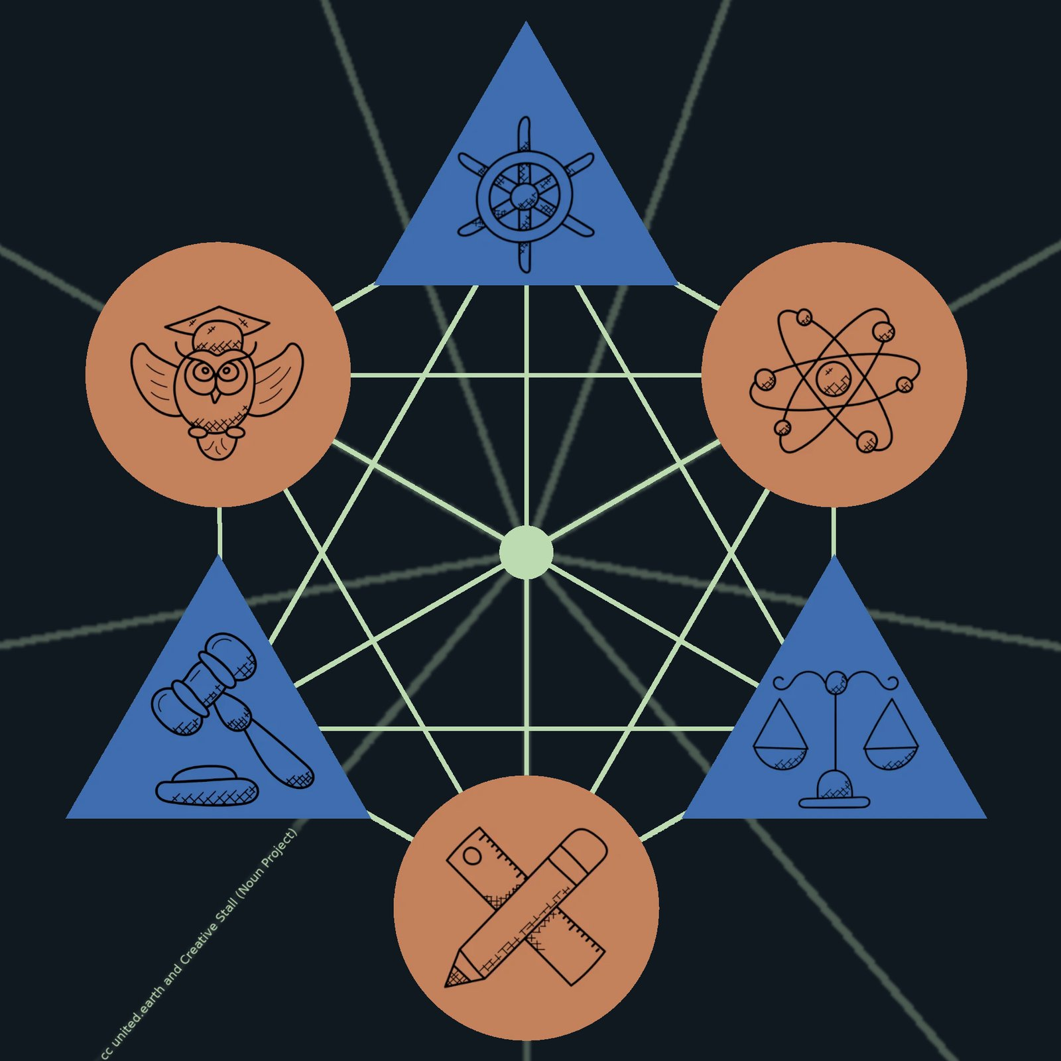
UE Unit of governance

Three layers in one governance unit
The illustration shows the three governance layers operating together within one governance unit at any level.
I: The three branches of power (blue triangles)
- The legislative (gavel)
- The executive (ship’s helm)
- The judiciary (scales)
II: The three Councils (orange spheres)
- Council of Ethics (wise owl)
- Council of Science (atom)
- Council of Culture (pencil and ruler)
III: The AGORA connection (green web)
A governance unit is one territorially defined political unit situated at a particular governance level and assigned constitutionally defined responsibilities.
A locus (local community), region, sub-bloc, bloc, and the globe are therefore different kinds of governance units. Each has its own territory, population (except for nature regions), democratic processes, institutions, and field of constitutional competence.
The common internal architecture described in this section applies to populated governance units. Nature regions are governance units at the regional level with a specialised institutional architecture under ecosystem sovereignty. Their stewardship authorities remain constitutionally accountable and connected to AGORA and the wider governance system, but they do not necessarily reproduce the ordinary populated-unit architecture described below.
A governance unit is not merely a territory, an administration, or a collection of public institutions. It brings together:
- Earth Citizens participating within the unit
- constitutionally allocated authority
- AGORA and the unit’s constitutional node (or node network in case of the global level)
- the three Councils
- the legislative, executive, and judicial branches
- PAI
- AKS
- the SEC framework
- public records and institutional memory
- relationships with other units and levels
The governance level identifies the unit’s position within the constitutional scale. The Earth Constitution determines which decisions the unit can make. PAI identifies the policy areas involved. AKS organises the knowledge, learning, verification, and competence relevant to them.
The three governance layers determine how authority operates within the unit.
AGORA provides the constitutional public sphere through which citizens learn, deliberate, develop proposals, vote, elect officeholders, and scrutinise institutions.
The Councils safeguard the scientific, ethical, cultural, and methodological basis for judgement.
The branches formalise valid democratic decisions, implement them, interpret the law, and protect the constitutional order.
A unit is therefore complete only when democratic participation, knowledge, constitutional competence, institutional capacity, and functioning AGORA infrastructure operate together.
The same Earth Citizen participates in several governance units simultaneously. Through the citizen’s primary locus, the person is connected to a local unit, a region, a sub-bloc where applicable, a bloc, and the globe.
Participation is not identical at every level. Citizens take binding decisions within the units in which they hold democratic rights and according to where the relevant constitutional competence lies.
A local political question should be decided locally. A planetary question requiring binding global coordination must be decided at the global level. Many questions involve several policy areas and institutions, but the constitutional allocation of authority must remain clear.
A governance unit is where territory, democratic participation, constitutional competence, and institutional capacity become operational.

13.2 The common internal architecture
Every governance unit contains the same three basic governance layers.
This does not mean that every unit has identical institutions, staffing, administrative capacity, or technical organisation. It means that the fundamental democratic and constitutional relationships remain recognisable throughout the system.

AGORA within the unit
Through AGORA, citizens can access the unit’s:
- political questions
- relevant knowledge
- learning pathways
- deliberative processes
- citizen initiatives
- institutional proposals
- votes and elections
- budgets and public plans
- Council assessments
- laws and judicial decisions
- implementation records
- evaluations and revision histories
AGORA does not exist as a separate, isolated platform for every unit. Each governance unit maintains its own constitutional AGORA node, or at the global level a distributed network of top-level nodes, as part of one federated public infrastructure through which citizens move between the units and levels relevant to them.
The node is integrated with the unit’s principal governance functions. Its physical, digital, and constitutional form is described in section 8.5.
A citizen can therefore enter one coherent democratic environment while clearly seeing which governance unit is responsible for each process.

The Councils within the unit
The unit’s three Councils safeguard the scientific, ethical, and cultural foundations required for democratic judgement.
They:
- contribute to PAI and AKS
- organise relevant knowledge and competence
- develop learning and verification structures
- assess political proposals and existing policies
- identify uncertainty, consequences, and conflicts
- publish warnings and competing interpretations
- monitor results over time
- connect with corresponding Councils in other units and levels
Council functions must remain proportionate to the unit. A local Council structure need not reproduce the full organisational scale of a global Council. It must nevertheless provide the relevant scientific, ethical, and cultural capacities or have reliable federated access to them.

The branches within the unit
The legislative, executive, and judicial branches make valid democratic authority institutionally operative.
The legislative branch organises and formalises the law-making process.
The executive branch implements law, provides public services, and administers the unit’s responsibilities.
The judicial branch protects rights, procedures, constitutional competence, and the lawful exercise of authority.
Their exact institutional form varies. A small locus may require compact institutions and shared administrative services, while a bloc or the globe requires extensive parliaments, courts, administrations, and specialised agencies.
The functions themselves must remain distinct even where organisational arrangements are small or shared.
The basic division can be stated simply:
Citizens decide. Councils clarify. Branches formalise, implement, and adjudicate.
None of these layers can create a complete democratic governance unit alone.
AGORA without Councils can become poorly informed, reactive, and vulnerable to manipulation.
Councils without AGORA can become an expert system detached from democratic authority.
AGORA and the Councils without the branches cannot make political decisions legally binding, operationally effective, or judicially protected.
Branches without AGORA and the Councils revert toward institution-centred governance in which citizens, knowledge, and public accountability remain structurally secondary.
The complete governance unit integrates all three without allowing any one of them to absorb the others.
The common architecture does not require identical institutional scale. Global and blocal governance units require extensive parliaments, Councils, courts, administrations, and specialised agencies, while regional and local units may use smaller institutions, shared services, or federated access to specialised capacity.
These variations do not change the constitutional relationships between AGORA, the Councils, and the branches. The architecture remains consistent while institutional scale and form adapt to the responsibilities and capacity of each governance level.

13.3 The democratic decision cycle
A governance unit must be understood as an operating process, not only as a set of institutions.
A political question can enter the system through citizens, Councils, branches, public agencies, changing conditions, observed consequences, or developments in another governance unit.
A typical democratic decision cycle may proceed as follows:
- A condition, need, risk, or opportunity is identified. The issue enters AGORA with its source, initial documentation, and known institutional context.
- PAI identifies the relevant policy areas. This reveals which domains of reality are involved and which relationships with other policy areas must be considered.
- The Earth Constitution identifies the competent governance unit. The question is placed at the lowest level capable of addressing it effectively, subject to subsidiarity and the constitutional allocation of authority.
- AKS develops the relevant knowledge foundation. Evidence, concepts, methods, uncertainty, disagreement, ethical implications, cultural contexts, and existing experience become accessible.
- Citizens learn and deliberate through AGORA. They examine the issue, challenge assumptions, compare arguments, identify consequences, and develop proposals and alternatives.
- The Councils publish assessments. Scientific, ethical, and cultural evaluations clarify reality, responsibility, uncertainty, feasibility, and human meaning. Majority and minority interpretations remain visible where relevant.
- Proposals pass transparent procedural requirements. The system verifies constitutional admissibility, governance competence, clarity, documentation, relevant interests, and any required thresholds.
- Earth Citizens make the substantive democratic decision. The vote takes place within the competent governance unit and according to the applicable democratic and competence rules.
- The legislative branch formalises the valid result. Parliament converts the decision into coherent law, budgets, mandates, and institutional frameworks without replacing its political substance.
- The executive branch implements it. Public institutions translate the law and democratic objective into practical action within their delegated authority.
- The judicial branch reviews legality where required. Courts resolve disputes, protect rights, and determine whether the process and the exercise of authority comply with the Constitution and the law.
- Consequences are monitored and made public. Institutions and Councils compare expected and observed results, identify new knowledge, and register unintended effects.
- Citizens and institutions evaluate the outcome. The results return to AGORA and AKS, where they become part of future learning and deliberation.
- The decision may be corrected or revised. A new democratic process can amend or replace the decision when knowledge, circumstances, or political judgement change.
The cycle is not always linear. New information may require a proposal to return to deliberation. A judicial decision may reveal a constitutional defect. An executive feasibility assessment may require clarification. A Council warning may trigger further investigation.
The system must make these movements visible rather than allowing them to occur through concealed institutional negotiation.
Democracy therefore does not end when a vote is completed. The complete process includes:
- perception
- learning
- deliberation
- judgement
- decision
- formalisation
- implementation
- adjudication
- observation
- correction
This is where collective intelligence becomes institutionally concrete.
Collective intelligence does not mean merely that many people communicate or contribute information. It means that the political system can perceive conditions, organise relevant knowledge, compare alternatives, make decisions, observe consequences, preserve what it learns, and correct its own errors.

13.4 Relations between units and levels
No governance unit functions in isolation.
Each unit forms part of a wider constitutional structure and maintains vertical relationships with units above and below it, as well as horizontal relationships with units at the same level.
These institutional relationships are supported by the AGORA network. Each governance-unit node connects with relevant nodes above and below it and with neighbouring nodes at the same level, allowing democratic processes, knowledge, records, communication, and institutional coordination to move through multiple routes across the system.
The general network architecture is described in section 5.11. Sections 8.5 and 8.6 describe how these connections are physically and constitutionally anchored within governance units.

Vertical relationships
Vertical relationships connect the local, regional, sub-blocal, blocal, and global levels.
They are governed by:
- the Earth Constitution
- subsidiarity
- constitutional competence
- valid higher-level law
- delegated implementation
- institutional cooperation
- judicial review
- rights of constitutional challenge
A higher governance unit can exercise authority only within the responsibilities constitutionally allocated to its level.
Valid higher-level law prevails within that competence. A lower unit cannot nullify it unilaterally because its institutions or citizens disagree with the decision.
Lower units must nevertheless be able to challenge higher-level action before the judicial system. Courts determine whether the higher unit acted within its competence and complied with subsidiarity, necessity, proportionality, rights, and required procedures.
The existence of higher authority therefore does not create unrestricted central authority.
Nor does local autonomy permit units to ignore consequences that extend beyond their boundaries. A unit cannot claim exclusive competence over actions whose significant effects fall constitutionally within the responsibility of another level.
PAI identifies the policy areas and their relationships. The Constitution determines where binding authority lies.
Implementation may still be distributed. Global or blocal law can be implemented through regional and local institutions where this is more effective and consistent with subsidiarity.
Delegated implementation does not transfer the source of the legal mandate or erase accountability between levels.

Horizontal relationships
Governance units at the same level may:
- cooperate
- coordinate services
- share infrastructure
- exchange knowledge and data
- establish joint institutions where constitutionally permitted
- develop common proposals
- coordinate across boundaries
- address shared ecosystems, labour markets, transport systems, or other connected conditions
- bring unresolved problems to the level above
Horizontal cooperation should be preferred when units can resolve a shared problem effectively without transferring binding authority upward.
It cannot substitute for higher governance where voluntary cooperation is structurally insufficient.
If a problem requires every affected unit to comply with a common decision, and no unit or voluntary agreement can provide legitimate binding coordination, the matter may belong at a higher level.
This creates a dynamic but controlled relationship:
- authority remains as low as possible
- cooperation occurs horizontally where sufficient
- authority moves upward only where structurally necessary
- higher authority remains constitutionally limited
- implementation returns downward where appropriate
The purpose is neither centralisation nor fragmentation. It is to place each responsibility where it can be exercised effectively, democratically, and accountably.

13.5 The governance-unit headquarters and AGORA node
Every governance unit below the global level has a principal institutional centre where its democratic, Council, legislative, executive, judicial, and administrative functions are coordinated.
This governance-unit headquarters does not necessarily consist of one building or enclosed complex. It may include several connected institutions, facilities, public spaces, and technical installations. What defines it is its function as the principal physical and institutional centre of the governance unit.
Each headquarters contains or is directly integrated with the unit’s constitutional AGORA node.
An AGORA node is the physical, digital, and constitutional interface through which a governance unit connects its citizens, institutions, knowledge infrastructure, democratic processes, and public records to the wider AGORA network.
The node may include:
- one or more data centres
- secure civic identity and voting infrastructure
- authoritative institutional records
- relevant parts of AKS
- public AI infrastructure
- secure communication systems
- facilities for Council and branch functions
- public meeting and deliberation spaces
- accessible public participation points
- replicated archives and continuity systems
The node is therefore not identical to a data centre. Data centres provide essential technical capacity, but the complete node also includes its constitutional functions, institutional relationships, public interfaces, and physical accessibility.
One logical and constitutional node may be supported by several physical installations. Large governance units may require multiple data centres, public facilities, and redundant systems distributed across their territory. These remain parts of the same governance-unit node when they operate under one constitutional responsibility and institutional framework.
The form and capacity of the node vary with the governance level and the size and responsibilities of the unit.
A local node may consist of a modest technical installation integrated with municipal institutions, public meeting facilities, libraries, schools, or other accessible civic infrastructure.
Regional, sub-blocal, and blocal nodes require progressively greater capacity for data processing, secure communication, institutional coordination, knowledge systems, and continuity of public administration.
The underlying constitutional relationship remains the same at every level.
Earth Citizens connect to AGORA through their verified civic accounts. They may participate through personal devices or through publicly available access points connected to their governance-unit node.
Access to democratic participation cannot depend on private ownership of technology, commercial platforms, or reliable personal connectivity. Every governance unit must provide the physical and technical conditions required for its citizens to exercise their rights.
Each node connects with neighbouring nodes at the same level and with relevant nodes above and below it.
These connections allow democratic processes, knowledge, institutional communication, public records, and administrative coordination to move through multiple routes. A node must not depend on one superior node or one exclusive communication path in order to remain connected to the constitutional system.
The detailed architecture for neighbouring connections, alternative routes, replication, and continued operation during technical failure is described in section 5.11.
A governance-unit node must retain sufficient capacity to preserve essential democratic and institutional functions when parts of the wider network become temporarily unavailable. The unit may enter a limited or degraded operating mode, but its civic identity functions, public records, constitutional procedures, and institutional continuity must remain protected.
As a general rule, the node and headquarters belong exclusively to the governance unit they serve. A higher governance level is connected through the federated network, but it is not physically or territorially embedded within the headquarters of every lower unit.
A regional headquarters therefore contains the region’s institutions and node, not a permanent physical representation of the bloc. A locus contains its own local institutions and node, not a permanent regional authority.
The relationship between the global and blocal levels constitutes a specific exception to this general rule.
Every governance unit below the global level has its own institutional centre and constitutional AGORA node as part of one federated democratic network. The global unit follows the distributed form described in section 8.6.

13.6 The global-blocal node interface
The relationship between the global and blocal levels is structurally different from the relationships between the levels below them.
Together, the global unit and the blocs form the operational federation.
The global level provides the shared constitutional order, global legislation, the global judiciary, and direct executive authority within constitutionally defined global domains.
The blocs provide the principal territorial executive capacity on land. They implement global law through their own institutions, maintain the principal concentration of territorial military capacity, and form the operational foundation of the global peacekeeping system.
This relationship requires a closer physical, digital, and institutional connection than exists between other governance levels.
At every bloc headquarters, the ordinary blocal structure described in section 8.5 is therefore joined by a second, constitutionally separate structure: a global constitutional precinct containing one of AGORA’s global top-level nodes.
The global precinct must be located directly beside and functionally integrated with the bloc’s principal institutional centre. The global and blocal nodes remain constitutionally distinct, but their proximity enables continuous cooperation between the institutions responsible for global authority and the institutions responsible for territorial execution on land.
The precinct is not a facility temporarily provided or leased by the surrounding bloc. It is a small, clearly delimited area held under the limited sovereignty and jurisdiction of the global governance unit through the Earth Constitution.
Global sovereignty within the precinct applies only to its defined territory and institutional functions. It does not give Earth Government general territorial authority over the surrounding bloc or over land outside the precinct.
Each global precinct contains a global top-level AGORA node and may also provide:
- facilities for Earth Parliament
- global Council functions
- global judicial facilities
- Earth Government representation
- secure connections to the bloc’s political and administrative leadership
- peacekeeping coordination functions
- public hearings and participation facilities
- replicated global archives and democratic records
- secure communication and continuity systems
The global and blocal nodes form a closely connected node pair.
The blocal node serves the bloc’s citizens, institutions, knowledge systems, democratic processes, and territorial responsibilities.
The global node connects these functions to Earth Parliament, the global Councils, the global judiciary, Earth Government, and the corresponding global nodes located in the other blocs.
Neither node is subordinate to the other as technical infrastructure. Their constitutional responsibilities differ, and their systems must remain capable of independent operation where necessary. Their connection reflects interdependence without institutional merger.
The complete network of global precincts allows the global governance unit to operate as a distributed institution rather than from one capital or central headquarters.
Earth Parliament, the global Councils, the global judiciary, Earth Government, and specialised global institutions are permanent functions, but their physical activities can be distributed across the precincts.
Earth Parliament may hold plenary sessions on a rotating basis between blocs. Parliamentary committees, Council bodies, judicial proceedings, executive meetings, and public hearings may take place at the locations most closely connected to the matters and governance units involved.
A global judicial case primarily concerning one bloc may be heard at the global precinct located there. A dispute between two blocs may involve proceedings in both affected precincts, with additional participation from another location where required for impartiality, access, or security.
Where Earth Government must respond to a conflict or constitutional crisis involving blocs, its work should take place in direct institutional contact with the affected blocal governments, Councils, judiciaries, administrations, and peacekeeping capacities.
The precincts therefore provide more than meeting facilities. They create a permanent physical connection between global constitutional authority and the territorial institutions through which global law and peacekeeping operate on land.
This presence becomes particularly important if a bloc attempts to obstruct global law, withdraw unilaterally from the federation, capture shared institutions, or sever its citizens and institutions from the global constitutional order.
The global precinct must be protected against:
- closure
- seizure
- surveillance by the surrounding bloc
- disruption of communication
- obstruction of access
- unilateral alteration of its status
- takeover of its records, systems, or institutions
During a conflict, the precinct preserves global constitutional presence, secure communication, authoritative records, institutional continuity, and a direct point of access for the bloc’s citizens and lawful institutions.
An attempt by a bloc to occupy, close, or take control of the precinct constitutes a direct breach of the Earth Constitution and an attack on the shared federal order.
All blocs must contain constitutionally equivalent global precincts. Their size and physical design may vary according to local conditions, but their status, protections, institutional role, and network access must remain equal.
No individual precinct becomes the global capital or headquarters. No bloc receives privileged control over global meetings, records, administration, communications, or political access merely because global institutions operate within its territory.
Global neutrality is therefore created through symmetrical presence in every bloc rather than through concentration in one supposedly neutral city, isolated territory, offshore installation, or orbital facility.
The global level is physically present within every bloc, while remaining territorially dominant in none of them.
The global and blocal nodes form the constitutional and operational interface through which one global federation governs without one governing city.
This integrated description of governance units provides the necessary foundation for understanding the bloc‑based global peacekeeping system described in the next section, as well as the economic architecture outlined thereafter.
Continues in WHAT part 3
Continued from WHAT part 2

14. The bloc-based peacekeeping system
The proposed model for a global civilisation includes a peacekeeping system designed to intervene immediately when conflicts arise, prevent escalation and damage to society and nature, and reduce the chance of war to near zero. Since conflict can never be fully ruled out, the system establishes clear procedures for the ten structurally distinct escalation paths that can arise within the transitional five-level geopolitical structure. This makes the system predictable, accountable, and a powerful deterrent against any leadership at any level acting aggressively.
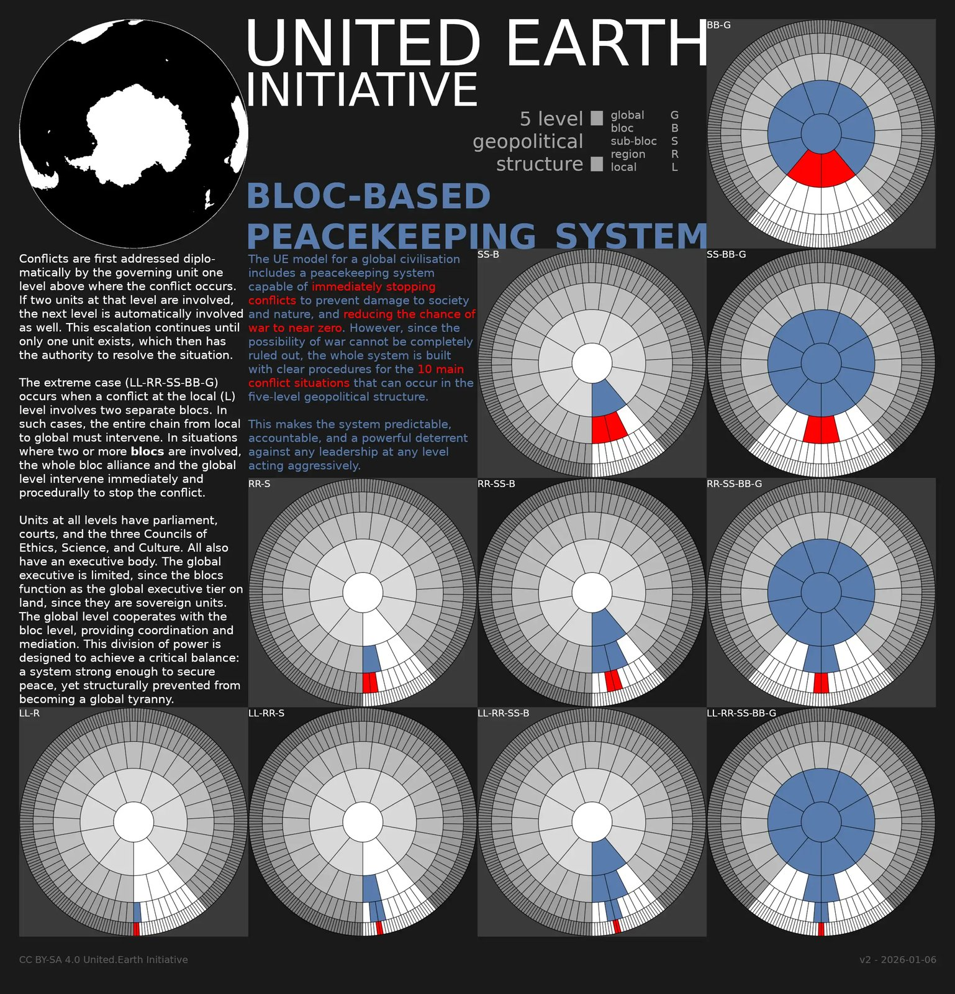
UE peacekeeping system

14.1 One global state, distributed control of military force
The proposed system constitutes a single global democratic state. Within this state, the monopoly on the legitimate use of force is not concentrated in a single hierarchical command, but deliberately distributed to prevent the emergence of global tyranny.
Territorial military authority over land is constitutionally vested in the blocs. Each bloc holds ultimate territorial control over military force within its land territory and a narrow adjacent coastal zone. This ensures that no global authority can directly dominate populations through territorial force.
At the same time, a global military authority exists as an integral part of the global state. This authority operates in global domains that are not subject to bloc territorial sovereignty, including the open oceans, polar regions, and near-Earth space. Antarctica and the high Arctic are treated as explicit global governance zones due to their planetary ecological and climatic significance.
The result is a single state with constitutionally divided military authority as a structural safeguard.

14.2 Global authority without global domination
The global level possesses independent military initiative and enforcement capacity within global domains. It is capable of acting decisively where no territorial authority can legitimately operate.
However, the global level is constitutionally constrained in three decisive ways:
- It has no general right to project force into land territory.
- It may intervene on land only under formally defined peacekeeping conditions requiring coordinated bloc participation.
- Its own standing military capacity may never exceed 50% of the combined military capacity of all blocs.
This 50% rule constitutes a core anti-tyranny mechanism. The global level can coordinate action to prevent escalation and terminate conflicts, but it cannot dominate the system on its own. On land, it can act only through and in relation to bloc forces, never above them.
Global military authority is therefore relational rather than absolute. It stabilises the system without becoming a territorially dominant source of coercive power.

14.3 Procedural escalation and democratic control
All military action beyond a bloc’s own territory, together with all use of global military force, is governed by explicit constitutional procedures. Decisions involving escalation to the global level require authorisation under procedures involving Earth Parliament and Earth Government.
Operational coordination between the global and blocal levels takes place through the global-blocal node interfaces described in section 8.6.
These decisions inevitably involve human judgement. The system does not attempt to eliminate discretion, but to bind it institutionally. Judgement is exercised within defined thresholds, responsibilities, and accountability mechanisms, rather than through unilateral or opaque decision-making.
Interventions are always:
- purpose-limited,
- scope-limited,
- time-limited,
- and subject to post-hoc democratic and legal review.
The global peacekeeping system functions as an escalation firewall rather than as an autonomous military actor.

14.4 Predictable conflict typology
Because the geopolitical structure is formally defined, the territorial pathways through which conflicts can escalate are finite and known in advance.
Within the transitional five-level structure, conflicts between units at the same level produce ten structurally distinct escalation paths. The number falls to six in the final four-level structure. Which path applies depends on how far upward the system must move before reaching a governance unit that encompasses all parties to the conflict.
Each path follows predefined responsibilities, authority transitions, and intervention thresholds. No conflict is treated as institutionally exceptional or left to improvised coalitions. This predictability is itself a central deterrent, as it removes strategic uncertainty and limits the ability of any actor to test boundaries through force.

14.5 Collective security without veto or imperial logic
The bloc-based peacekeeping system constitutes collective global security, but it differs fundamentally from existing models.
Security is not voluntary, veto-based, or dependent on ad hoc coalitions. It is procedurally enforced and constitutionally embedded. No bloc can opt out, block a lawfully authorised intervention, or redefine threats unilaterally.
At the same time, the system avoids imperial concentration of force. The global state has sufficient collective capacity to act against large-scale war, while global military authority remains structurally constrained against becoming a military empire.

14.6 No guarantees, but greatly reduced risk
The peacekeeping system offers no guarantee against catastrophe, tyranny, or ultimate failure. Human misjudgement, political error, institutional failure, or technical malfunction remain possible.
What the system provides is a structural reduction of risk: fewer incentives for aggression, fewer pathways to escalation, and fewer opportunities for concentrated abuse of force. It aims to make the worst outcomes less likely, while enabling a stable, just, and livable global civilisation under conditions of uncertainty.

15. A sustainable and just economic system
The proposed system establishes an economic architecture designed to support life, maintain social stability, and prevent systemic coercion across all levels of governance. As with peacekeeping, we know that no economic system can eliminate risk or conflict, but it should prevent economic power from being used to destabilise societies, dominate territories, or undermine democratic self-government.
Economic order is treated as a core component of global security. The system is therefore designed as a federated, multi-level structure that follows the same general logic as the bloc-based global peacekeeping system, while remaining grounded in ecological limits and glocal subsidiarity. Local resilience is a primary design constraint, and higher-level optimisation must not undermine it.
This section drafts the constitutional principles and distribution of authority within the economic system, not a complete economic model. The specific design of monetary systems, taxation, ownership, trade, labour, welfare, resource accounting, and other economic arrangements must be developed and continuously revised through AGORA and the democratic institutions of the relevant governance levels.
Local economy: Citizens selling and buying food at the Siti Khatijah Market, Kelantan, Malaysia. Photo by Alex Hudson on Unsplash
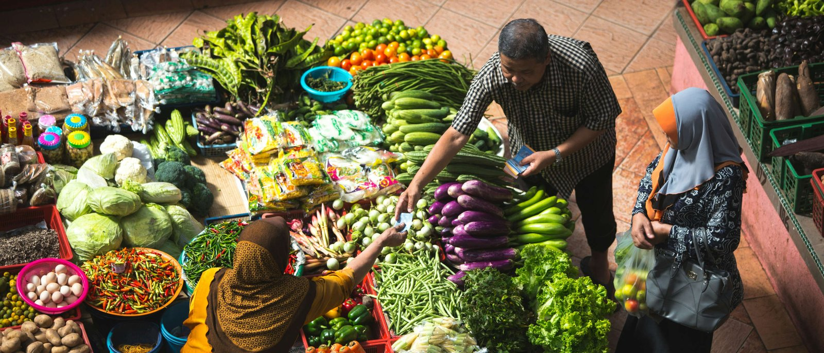
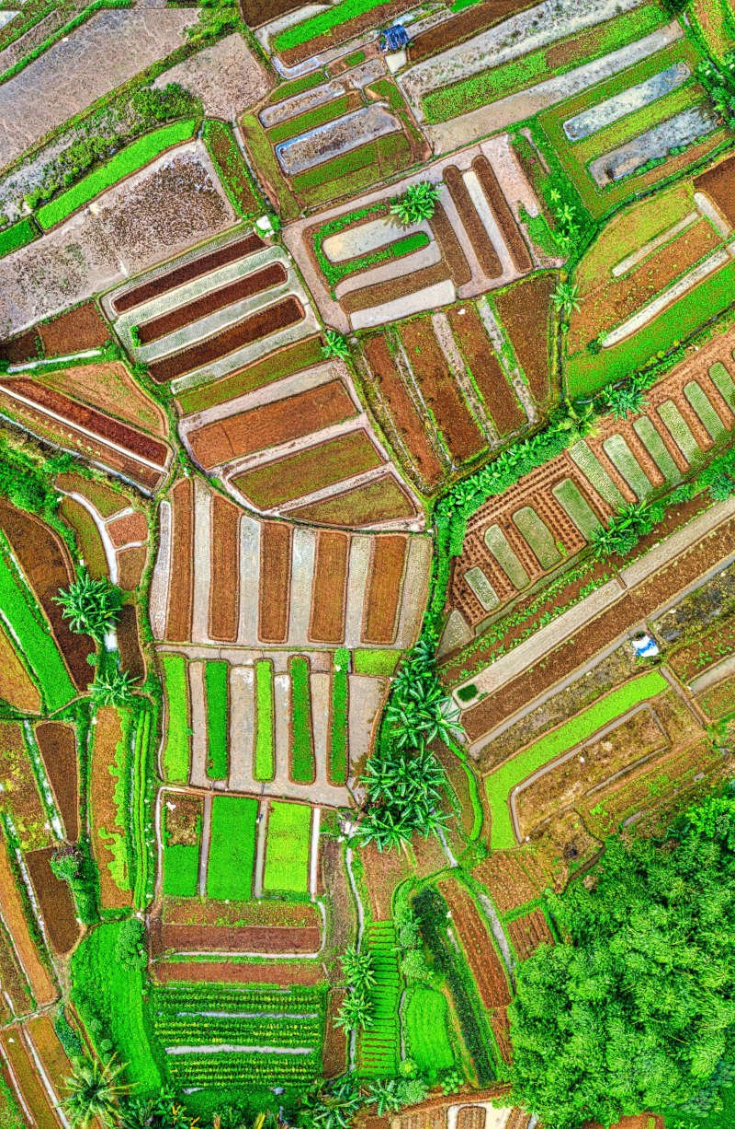
Local food production: Aerial snapshot showcasing the lush, patchwork farmland of Banten, Indonesia. Image by Tom Fisk from Pexels

The real economy is local
All human life is lived locally. Food is grown, work is done, care is given, and communities endure in physical places, shaped by climate, land, and social relations.
Any global economic system that does not protect the capacity of local economic life to continue during severe disruption at higher levels is structurally unsound, regardless of how sophisticated it appears at those levels.
Local resilience does not mean isolation or that everything must be produced locally. It means that essential economic life must remain functional, and that exchange with higher levels strengthens rather than replaces local productive capacity.

15.1 The economy as a tool of society
Human society exists as part of the biosphere. Economic systems are created within society to organise production, exchange, distribution, investment, provisioning, and other aspects of material life.
The economy is therefore neither an autonomous force nor an end in itself. It is a practical tool through which society pursues democratically defined political, ethical, social, and ecological goals within the Rights of Life and the biophysical boundaries of the living planet.
This reverses the relationship established under capitalism, where societies and ecosystems are repeatedly required to adapt to the demands of capital accumulation, profitability, and economic growth.
In the proposed order, democratic politics defines the goals and boundaries of economic activity. Economic institutions and mechanisms are selected according to how well they serve people, society, and the living planet.
Economic success is therefore measured through human well-being, social justice, ecological regeneration, and systemic resilience rather than through unlimited material growth or capital accumulation.

15.2 A post-ideological economic order
In accordance with GOV//ID, capitalism, socialism, communism, and other comprehensive economic ideologies do not serve as constitutional templates for society. They remain protected as bodies of thought, political identities, and sources of analysis, but none possesses governing status or permanent authority over the organisation of the economy.
Post-ideological does not mean without political disagreement, economic alternatives, or competing values. It means that economic mechanisms are evaluated pragmatically according to knowledge, context, governance level, and democratically defined purpose rather than derived from a predetermined doctrine.

Capitalism
Capitalism is treated as a completed historical paradigm rather than the default condition of economic life.
Its defining principles, including the primacy of capital accumulation, the systemic pursuit of private profit, and the conversion of economic ownership into political and social power, cannot remain the organising principles of society.
This does not mean the rejection of markets, investment, enterprise, innovation, or personal ownership. Market economy and capitalism are not synonymous. Markets are mechanisms of communication, exchange, and coordination that existed before capitalism and can continue within a post-capitalist order.

Socialism and communism
Socialism and communism are treated as related but distinct historical paradigms, not as replacement constitutional ideologies.
Public ownership, redistribution, universal social provision, democratic control of essential infrastructure, economic planning, commons, cooperatives, shared stewardship, economic equality, and collective responsibility may all serve legitimate purposes within the proposed order.
The system does not presume, however, that the state should own or centrally direct all productive activity, or that markets, personal ownership, plural forms of enterprise, and political diversity should be abolished.
Public, cooperative, communal, and other collective forms of organisation are evaluated by the same standard as private forms: whether they serve the Rights of Life, democratic goals, ecological integrity, social justice, and the practical needs of the communities involved.

Markets and democratic planning
Markets and planning are complementary instruments rather than opposing ideological systems.
Markets organise much decentralised production, exchange, innovation, and distribution. Democratic planning coordinates the material systems that cannot be governed coherently through fragmented market decisions alone, including land use, settlement patterns, infrastructure, transport, energy, food systems, resource flows, and ecosystem restoration.
Neither markets nor planning possess autonomous authority. Their roles are determined democratically according to the scale, purpose, and consequences of the activity involved.

15.3 One economic order, distributed authority
The global civilisation operates within one economic order governed by a shared constitutional and legal framework. This provides common rights, responsibilities, ecological boundaries, standards, and procedures for economic activity across all governance levels.
One economic order does not mean one currency, one ownership model, or one centrally administered economy. Economic authority is distributed according to subsidiarity, with different levels responsible for the functions that correspond to their scale, capacity, and consequences.
The shared framework provides interoperability between economic systems, including common principles for accounting, payments, clearing, cross-bloc exchange, public economic data, and the resolution of disputes. Governance units may develop different institutions and mechanisms within this framework, provided that they respect constitutional rights, the commons, and the legitimate authority of other levels.
The global level can establish binding rules for activities that cross blocs, affect the planetary commons, or threaten the stability of the system as a whole. This authority must not become unrestricted economic dominance or allow shared financial infrastructure to be used for arbitrary political coercion.
No global institution may:
- suspend essential economic activity within a bloc or territory outside constitutionally defined legal procedures
- use payment systems, transaction costs, or access barriers as instruments of political coercion
- monopolise payment, settlement, credit, or other essential financial infrastructure
- override the authority of lower governance levels outside constitutionally allocated global competence
Essential economic systems must therefore remain distributed, interoperable, and sufficiently redundant. No currency, financial centre, payment network, institution, bloc, or governance level can become an unavoidable point of control over the economic life of the whole.
Economic unity is created through constitutional coherence, not central command.

15.4 Glocal subsidiarity and local resilience
Local communities form the smallest economic cells of the global system. They should retain the greatest possible capacity to organise and sustain their own economic life, including food, shelter, energy, care, basic services, local production, and exchange.
Economic authority remains at the lowest governance level capable of exercising it effectively. Local communities determine their own priorities and economic arrangements within constitutional rights, ecological boundaries, and the responsibilities assigned to their governance level.
Regional, blocal, and global institutions support local economies where wider coordination, infrastructure, redistribution, or protection is required. Their role is to strengthen local agency, protect communities against external extraction and concentrated economic power, and address conditions that cannot be handled locally.
Trade and wider economic integration expand access to knowledge, resources, goods, and services. They must operate in ways that preserve local productive capacity rather than hollow it out or make essential economic life dependent on distant corporations, financial institutions, or fragile supply chains.
Local currencies, mutual credit systems, cooperatives, public services, private enterprise, community provisioning, and other locally appropriate mechanisms can operate within the shared economic order.
This structure allows communities to remain open and connected while retaining the capacity to act, adapt, and provide for essential needs through their own institutions and resources.
Higher governance levels exist to protect and enable local economic agency, and thus increase the resilience of the system as a whole.

15.5 The regional level as the primary physical‑ecological coordination layer
The regional level connects local economic life with the wider physical and ecological systems on which communities depend. It provides the principal scale for coordinating land use, settlement patterns, food systems, water, energy, transport, infrastructure, material flows, waste systems, and ecosystem restoration.
These systems form connected landscapes and networks that extend beyond individual properties and local boundaries. Their cumulative development therefore requires coherent democratic planning based on ecological knowledge, social needs, and long-term regional capacity.
Regional planning establishes the shared spatial and infrastructural framework within which local communities, public institutions, cooperatives, enterprises, and markets operate. It protects productive land and ecosystems, coordinates essential networks, and ensures that separate economic decisions contribute to a viable regional whole.
This planning does not direct every activity or exchange. It defines the physical, ecological, and social conditions within which decentralised initiative can flourish without allowing fragmented property interests or short-term market incentives to determine the future of the region.
The regional level should strengthen the distinct character, productive capacity, and resilience of its local communities while coordinating the systems they cannot manage separately.
The region provides the coherent physical and ecological framework within which local economic agency can thrive.

15.6 Blocal and global economic coordination

Macro-cells of economic stability
Blocs provide the principal scale for monetary coordination, fiscal capacity, redistribution, strategic investment, major infrastructure, and economic stabilisation across large territories.
Each bloc should retain sufficient diversity and productive capacity to maintain essential economic functions during severe disruption of cross-bloc trade or global financial systems. This includes the capacity to support its regions and local communities without making them permanently dependent on one external currency, financial centre, production system, or supply network.
Blocal economic authority also protects regions and communities against transnational monopolies, speculative disruption, resource extraction, and other concentrations of economic power that exceed the capacity of lower governance levels.
The blocs remain economically interconnected. Shared standards and predictable rules support trade, knowledge exchange, specialisation, and cooperation while reducing the ability of any bloc to use economic dependence as a weapon against another.

Global coordination as stabilisation
The global level coordinates economic conditions and actors whose effects extend across blocs or affect humanity and the planetary commons as a whole.
Its responsibilities include global financial interoperability, transnational economic power, systemic crises, cross-bloc shocks, global resource constraints, and collective objectives that cannot be achieved through separate bloc action.
Global economic authority may establish binding rights, obligations, ecological limits, and common standards within these areas. Its interventions must be democratically authorised, procedurally defined, transparent, subject to review, and implemented through blocal and lower governance levels wherever possible.
The global level does not direct ordinary production, exchange, enterprise, or local economic life. It protects the constitutional framework within which diverse economies operate and coordinates collective action when fragmentation would threaten the wider system.
The purpose of global economic coordination is to preserve coherence, prevent domination, and maintain the conditions under which blocs, regions, and local communities can govern their own economic lives.
Higher-level coordination protects the whole so that economic agency can remain distributed throughout it.

16. Earth civilisation
Earth civilisation refers to the systemic condition that becomes possible when governance, economy, security, and ecology are designed to function together at planetary scale. It is not defined by ideology, culture, or technological ambition, but by the capacity of human societies to organise themselves within the limits of the biosphere while sustaining democratic agency at all levels.
The preceding sections of this WHAT page have described the structural components of such a system: a multi-level democratic architecture, a bloc-based peacekeeping system, and a federated economic order grounded in glocal subsidiarity. This section does not introduce new mechanisms. It describes the civilisational coherence that emerges when these structures operate as an integrated whole.
Green Field and Trees Under Cloudy Sky, Hà Giang, Vietnam. Image by @qhung999 from Pexels


16.1 A global democratic civilisation
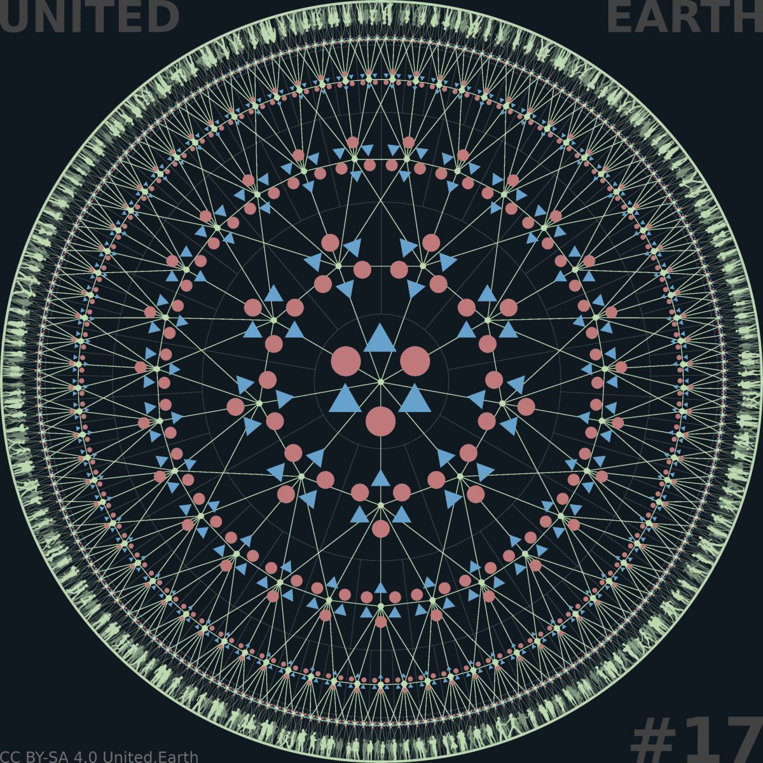
EARTHWHEEL 13

The complete structure
The Earthwheel shows the full institutional architecture of Earth civilisation:
levels of governance, functional units, and systemic layers integrated into a single, coherent democratic framework.
Earth civilisation is democratic by necessity rather than by doctrine. Decisions with planetary consequences require institutions capable of operating at planetary scale, while remaining anchored in local and regional self-government.
The proposed system is a single global democratic state composed of multiple levels of governance, functional units, and institutional layers. Power is distributed rather than concentrated, ensuring that no level can dominate the whole, while all levels remain structurally connected.
Democracy in this context is not limited to representation at the top, but embedded throughout the system: from local communities to regional coordination, bloc-level governance, and global institutions. Political legitimacy flows in both directions, enabling collective action without erasing local autonomy.

16.2 Governing the planetary commons
Earth civilisation requires explicit governance of shared planetary systems that no local, regional, or bloc authority can manage alone. These include the atmosphere, the oceans, polar regions, and near-Earth space.
The scope and different forms of the commons principle are defined in section 1.2. At the global level, the planetary commons receive explicit constitutional status, clearly allocated responsibilities, and enforceable democratic governance.
They are not ungoverned frontiers available for unilateral national or private appropriation. Research, access, resource use, infrastructure, and economic activity can take place within them, but only under common rules that protect their integrity, peaceful use, fair access, and long-term continuity.
The global level coordinates their protection, restoration, monitoring, use, and security. Implementation remains distributed through blocs and lower governance levels wherever planetary responsibilities intersect with territorial administration, infrastructure, economic activity, or local communities.
Their governance must connect climate stability, biodiversity, ecological restoration, security, scientific knowledge, and economic coordination rather than treating them as separate policy fields. Through continuous democratic stewardship, the global system replaces fragmented agreements and geopolitical competition with one coherent constitutional responsibility.
The wider Solar Commons extends the same principle beyond the immediate planetary domain, as described in section 1.2.

16.3 Nature/humanity: 50/50
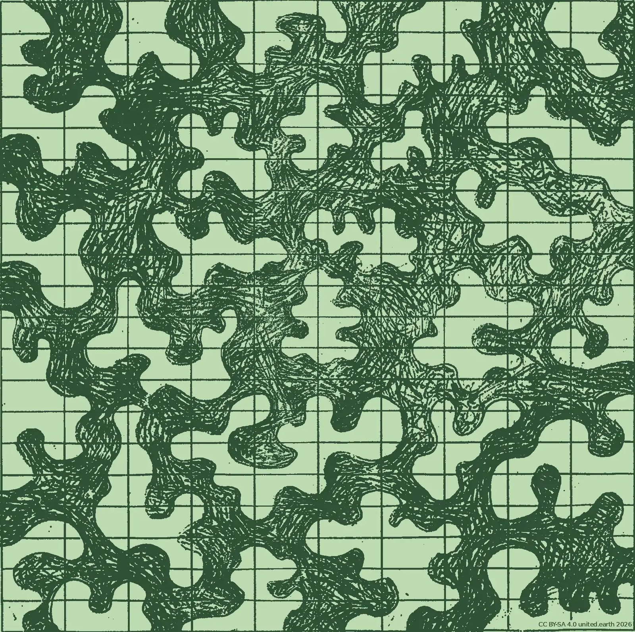

Regional level
This image presents the 50/50 principle as a regional pattern. The dark field represents continuous nature regions where ecosystem sovereignty takes priority and human intervention is limited, regulated, and constitutionally constrained. The light field represents societal regions organised for settlement, food production, forestry, infrastructure, mobility, culture, and economic life.
Both are regions in their own right at the same governance level. Together, they form the regional structure of each bloc and connect humanity’s civic footprint with a continuous natural commons.
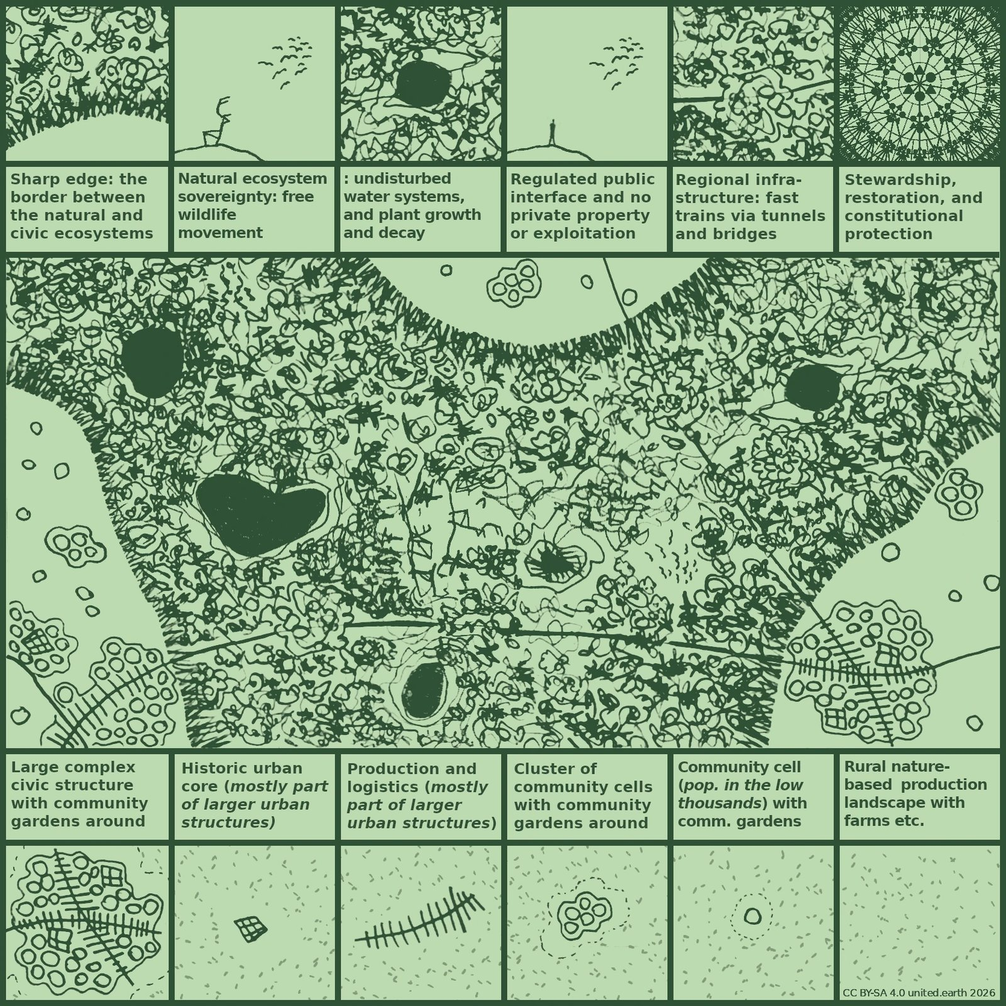

Local level
This image shows how the two regional regimes meet at the local scale. The upper legend defines the internal logic of nature regions: sharp edges, ecosystem sovereignty, free wildlife movement, undisturbed water systems, natural plant growth and decay, regulated access, light-touch crossings, and constitutional stewardship.
The lower legend defines the societal region as a managed ecosystem for human life: community cells, clusters, historic urban cores, production and logistics structures, larger civic formations, and rural landscapes for food and forestry.
The central field shows how these two regimes meet through a legible territorial structure linking commons protection, land use, infrastructure, and everyday habitation.

Half of the land and half of the oceans
The 50/50 principle proposes that roughly half of Earth’s land area and half of its ocean area should be secured under ecosystem sovereignty. The two categories are assessed separately, so extensive protection of the oceans cannot compensate for continued fragmentation of the land, or the other way around.
The principle is inspired by E. O. Wilson’s Half-Earth proposal, but develops it into a territorial and constitutional model for Earth civilisation. It seeks to provide the large, connected spaces required for biodiversity, ecological adaptation, migration, reproduction, and the free continuity of life processes.
The remaining half constitutes humanity’s civic footprint. It includes the territories and marine areas primarily organised for settlement, food production, forestry, transport, energy, economic activity, culture, and other human purposes.
Both halves remain parts of the same living Earth system. The distinction concerns what they are primarily organised to serve. Ecosystem sovereignty has priority within one half, while the other is organised to support human civilisation within the Rights of Life, the commons principle, and ecological limits.

Two parallel types of regions
On land, the 50/50 principle becomes part of the regional structure itself. Each bloc is organised through two parallel types of regions:
societal regions and nature regions
Societal regions organise human settlement, civic life, infrastructure, agriculture, production forestry, industry, energy, transport, and economic activity. They follow the ordinary democratic architecture of populated governance units.
Nature regions organise the protection and restoration of continuous ecosystems under ecosystem sovereignty. They have their own regional stewardship authorities, constitutionally accountable for ecological integrity, access, restoration, monitoring, and the regulation of permitted human activity.
Both are constitutionally recognised regional units at the same governance level. Nature regions are therefore not reserves contained within societal regions, residual spaces between them, or territories administered for their benefit. They are regions in their own right with a fundamentally different purpose and institutional form.
Within each bloc, the two region types together realise the 50/50 principle. The exact boundaries are established and revised by the bloc in consultation with the affected regions, guided by ecological knowledge, democratic deliberation, and the need to create coherent natural systems across regional and bloc borders.

Ecosystem sovereignty
Ecosystem sovereignty means that the continuity and integrity of ecological processes possess constitutional priority within nature regions.
Wildlife must be able to move freely. Water systems must flow with minimal interruption. Plant life must be able to grow, reproduce, die, decay, and regenerate according to its own dynamics. Ecosystems must retain the space and connectivity required to adapt over time.
Human institutions remain responsible for protecting, restoring, monitoring, and administering nature regions. Their governing authority is limited, however, by the ecological purpose of the territory. Nature regions cannot be reorganised as ordinary areas for settlement, private property, production, or resource extraction.
Human institutions govern the protection of nature regions, but they do not govern their ecosystems for human purposes.
Nature regions contain no permanent private property.Existing private titles are gradually transited into collective stewardship through the processes described in section 1.2. Land, buildings, facilities, and rights of use within these regions are held collectively and remain conditional upon their compatibility with ecosystem sovereignty.

Humanity’s civic footprint
Humanity’s civic footprint comprises the societal regions and other areas primarily organised for human life and activity. It is not a zone of uncontrolled development, but a carefully designed and managed ecosystem for settlement, food production, forestry, mobility, culture, and economic life.
Societal regions gradually form more coherent systems of settlements, infrastructure, production landscapes, and civic environments. Agriculture, forestry, transport, energy, logistics, and urban development are coordinated regionally so that human activity occupies a clear and disciplined territorial structure.
This reverses the dominant contemporary pattern. Nature currently survives largely as fragmented islands within an almost continuous human landscape. In the proposed pattern, nature regions form the continuous system, while societal regions become clearly bounded islands, peninsulas, corridors, and defined extensions within it.
Humanity remains part of nature within the civic footprint. Settlements, farms, forests, gardens, parks, waterways, and infrastructure all form living ecological environments. The difference is that these landscapes are organised primarily to support human society, while remaining subject to ecological limits and the Rights of Life.
The civic footprint must therefore become more spatially disciplined, productive, resilient, and beautiful. Its purpose is to provide good conditions for human life without continuously expanding into the territories required for the free continuity of other life.

Sharp edges and light-touch crossings
A sharp edge is a concrete legal, administrative, and spatial boundary between a societal region and a nature region.
The boundary identifies where ordinary rights of settlement, construction, ownership, agriculture, forestry, production, and infrastructure development end. It prevents gradual encroachment, speculative expansion, endless sprawl, and the continued fragmentation of natural habitats.
The edge is sharp as a matter of governance and land-use authority. Ecological transition zones, floodplains, shorelines, buffer habitats, and other natural gradients can extend across it where required by the ecosystem.
Blocs determine the overall boundaries in consultation with the regions because the pattern must remain coherent across large territories. Global coordination ensures continuity where ecosystems, watersheds, migratory routes, and nature regions cross bloc borders.
Infrastructure connecting societal regions can pass through nature regions where necessary. These connections must be designed as light-touch crossings, primarily through tunnels, bridges, and other solutions that preserve wildlife movement, water systems, vegetation, and ecological continuity.
Ordinary development cannot follow these crossings into the surrounding nature region. A transport connection remains a limited passage through the natural commons rather than a corridor for settlement and commercial expansion.

The marine pattern
The same 50/50 principle applies separately to the oceans. Roughly half of the ocean area forms a continuous marine natural commons under ecosystem sovereignty, while the remaining half accommodates regulated human activity such as shipping, fishing, energy production, cables, research, aquaculture, and other maritime uses.
Marine nature areas must protect migration routes, breeding grounds, food webs, seafloor ecosystems, coastal connections, and the movement of species across climatic zones. Their boundaries and internal connections must be based on ecological systems rather than existing territorial claims or the immediate economic interests of individual actors.
Necessary transport, research, monitoring, and infrastructure can pass through or operate within marine nature areas under clearly defined conditions. The integrity and continuity of the ecosystem remain the governing purpose.
The global level establishes the constitutional framework and overall marine pattern because the open oceans form part of the planetary commons. Blocs, coastal regions, and local communities participate in implementation wherever marine systems connect with territorial waters, coastlines, fisheries, infrastructure, and local livelihoods.
The 50/50 principle (see 11.3) reorganises humanity’s physical presence within the Earth system. Earth’s natural systems receive large, connected room to live, while humanity develops a more disciplined, beautiful, and sustainable footprint within the half we shape primarily for ourselves.
The 50/50 principle adapts the foundational concept proposed by biologist E. O. Wilson in his ‘Half-Earth’ thesis into a binding territorial and constitutional model for Earth civilization. See E. O. Wilson’s “Half-Earth” concept on its website, and Wikipedia

16.4 Permanent peace as a structural condition
Peace in Earth civilisation is an actively maintained structural condition. Conflict remains an inherent feature of complex societies, but institutions are designed to identify, mediate, contain, and resolve it before it develops into uncontrolled escalation. War is treated as a systemic failure.
The global and blocal peacekeeping system makes peace substantially more robust by constraining the pathways through which conflict can intensify. Distributed military authority, shared situational awareness, transparent procedures, early intervention, and coordinated escalation control reduce both the probability of large-scale violence and the probability that limited violence develops into wider war.
Peace therefore becomes a substantially more durable outcome of institutional design. It remains vulnerable to human error and institutional failure, but is far more likely to endure than under a system dependent on unstable balances of power, deterrence, and improvised crisis diplomacy.

16.5 Prosperity and justice within ecological limits
Economic life begins in local communities, where people provide for their needs, care for one another, work, produce, exchange, and build shared life. The purpose of economic policy is to strengthen their capacity to sustain themselves, shape their own development, and create the conditions for good, free, meaningful, and materially secure lives.
Regional planning coordinates the physical and ecological systems on which local economic life depends, including land, food, water, energy, infrastructure, transport, production, and ecosystem restoration. Blocal and global institutions provide redistribution, stabilisation, interoperability, and protection against concentrated economic power where the required action exceeds the capacity of lower levels.
Reliable life-supporting systems form the material foundation of prosperity, but prosperity extends beyond survival and stability. It includes health, freedom, meaningful activity, social participation, cultural life, security, and real opportunities to flourish. Economic institutions remain practical tools for achieving these conditions rather than ends in themselves.
Justice requires the fair distribution of risks, benefits, opportunities, and obligations. The economic system must not depend upon structural exploitation, and present prosperity must not destroy the capacity of future generations to live well within planetary boundaries.

16.6 A civilisation designed for uncertainty
Earth civilisation is designed for a dangerous and uncertain world. Human error, conflict, natural hazards, technological failure, and unforeseen events remain unavoidable parts of existence.
The task of governance is to prevent humanity from amplifying these risks into avoidable civilisational catastrophe. Institutions are designed to detect danger early, absorb shocks, correct mistakes, and contain escalation before nuclear war, ecological breakdown, uncontrolled technological races, or other systemic failures place life on Earth at unnecessary risk.
The same institutions should increase humanity’s collective capacity to reduce suffering, protect the conditions for life, and expand the possibilities for health, freedom, meaning, security, and well-being.
The proposed system offers no guarantee of survival or success. Its more modest and fundamental purpose is to make humanity less likely to destroy what sustains us, and more capable of improving life together.

17. Earth Citizenship
Earth Citizenship describes how the structures outlined on this WHAT page are lived and experienced by individual people. It is more than a legal status or symbolic identity. It is the practical form of political belonging through which every person belongs to the shared constitutional order and can participate in it.
Where Earth civilisation describes the coherence of the system as a whole, Earth Citizenship describes the position of the individual within it: the rights, responsibilities, protections, and opportunities that arise when governance, economy, security, and ecological responsibility are organised across all levels while remaining anchored in local society.
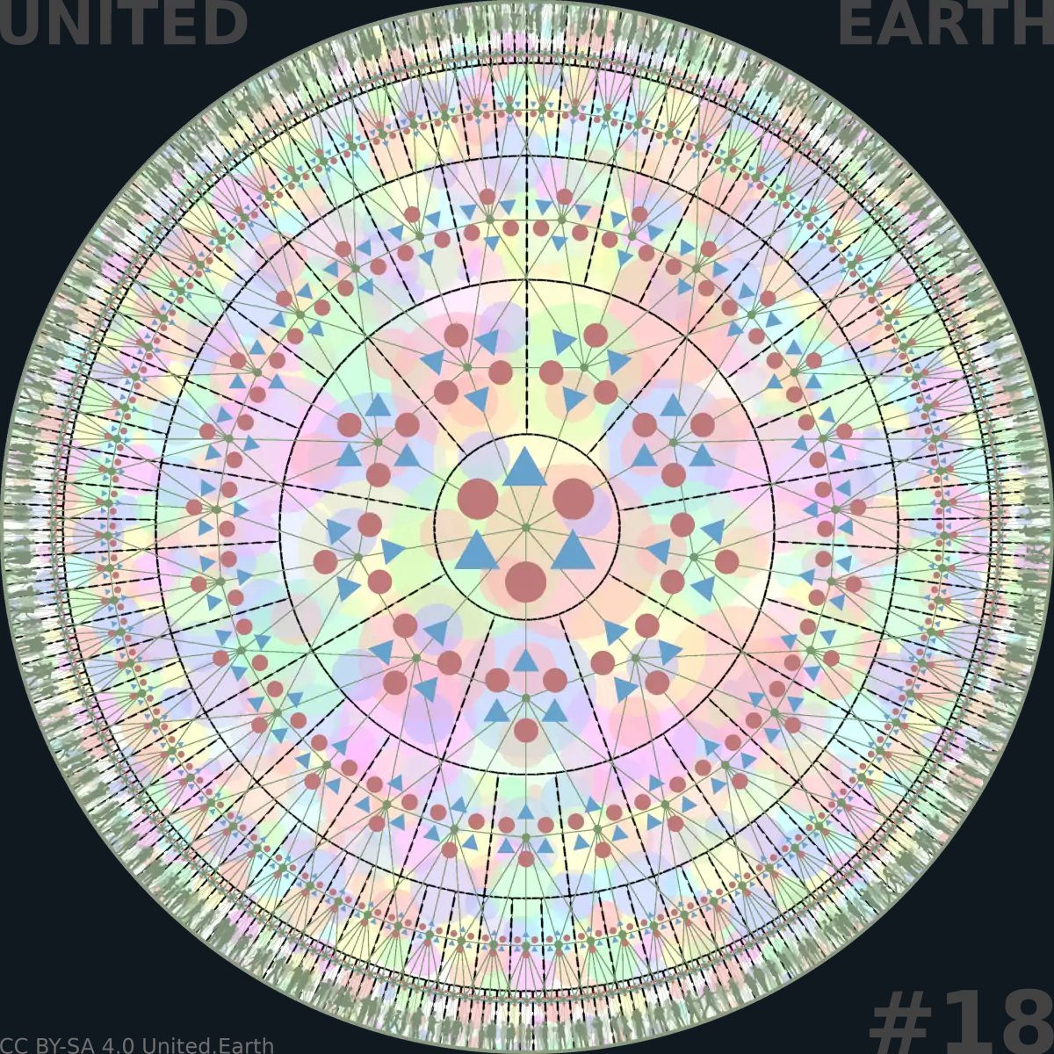

We, our identities, and the structure
This Earthwheel shows the complete institutional structure described in the previous section, together with the overlapping cultural patterns of human life: languages, traditions, beliefs, communities, and ways of belonging.
Under GOV//ID, these identities cross territorial boundaries and coexist within the same constitutional framework without defining, owning, or receiving institutional dominance over governance.
Earth Citizenship provides the shared political status through which individuals belong to and can participate in this structure while remaining free to belong to diverse cultural identities.

17.1 Citizenship beyond identity
Earth Citizenship does not replace cultural, linguistic, national, religious, ideological, or local identities. It provides a shared political status and constitutional framework within which these identities can coexist freely without defining or owning the institutions of governance.
Political belonging is layered rather than exclusive. Each person belongs politically to the governance units at every level connected to their primary locus, reflecting the fact that human lives are embedded in several communities and systems at once.
Earth Citizenship provides equal political standing across this layered structure. Under GOV//ID, no cultural identity can claim ownership of the state or institutional dominance over others, while every individual retains the freedom to form, express, and participate in diverse identities and communities.

17.2 Rights as conditions for participation
Earth Citizenship carries a common constitutional foundation of rights across the whole global state. These include equal standing before the law, freedom of expression and association, access to public information and democratic processes, and the freedom to move, reside, and work throughout the system, subject only to constitutionally justified limitations.
These rights are fundamental in their own right. They are also practical conditions for meaningful democratic participation, personal agency, and the ability to build a life within the shared political order.
Political rights cannot be exercised fairly where people lack access to knowledge, communication, education, physical security, or the basic material conditions required for independent participation. The constitutional protection of rights must therefore be supported by institutions capable of making those rights practically accessible.
Rights are protected both as expressions of human dignity and as structural prerequisites for democracy itself.

17.3 Responsibilities and fair obligations
Earth Citizenship also entails reciprocal responsibilities. Participation in a shared political, economic, and ecological system requires contributions to the institutions and commons that make shared freedom possible.
These obligations may include taxation and other clearly defined civic duties. They must be established democratically, allocated through the appropriate governance level, and distributed according to capacity and context.
Every obligation must be proportionate, transparent, legally defined, and open to democratic scrutiny and judicial review. This prevents both coercive uniformity and unchecked free-riding while recognising that people live under different material and personal conditions.
Democratic participation remains voluntary. Taking part in public life is a civic opportunity and responsibility, but citizens cannot be compelled to maintain a particular level of political activity, knowledge, or engagement.
Responsibility is therefore understood as reciprocal contribution rather than moral conformity. Citizens support the shared conditions that protect their own freedom and the equal freedom of others.

17.4 Democratic participation on fair premises
Democratic participation in Earth civilisation is continuously available rather than confined to periodic elections. Through AGORA, citizens can learn, deliberate, develop proposals, participate in elections and votes, and follow how democratic decisions are formalised and implemented.
Participation is voluntary, and people can engage at the governance levels and within the policy areas that correspond to their interests, knowledge, responsibilities, available time, and the consequences that affect them.
The conditions for participation are actively maintained as public goods. These include access to reliable knowledge, accessible technology and public interfaces, language support, transparent procedures, opportunities for civic learning, and effective protection against exclusion or retaliation.
Every adult Earth Citizen begins with the same basic political standing and right to participate. Where influence within a specific decision varies according to relevant verified competence, the criteria must be public, attainable, context-specific, and open to review. Wealth, popularity, social status, cultural identity, and political affiliation provide no automatic democratic advantage.
This structure supports broad and informed participation without expecting uniform political interest, expertise, or continuous engagement from every citizen.

17.5 Living locally in a global civilisation
Earth Citizenship is lived locally. People work, care, create, exchange, participate, and belong within physical places and social relationships.
A person’s primary locus connects this everyday life to the wider constitutional structure. It anchors democratic participation in the governance units directly connected to where the person lives, while Earth Citizenship provides access, rights, and political belonging throughout the global state.
Local communities retain authority over the matters they are capable of governing themselves. Regional, blocal, and global institutions support and protect this agency by coordinating the systems that exceed local capacity and by limiting external political, economic, technological, and ecological pressures that communities cannot control alone.
The shared global framework protects cultural and local diversity rather than replacing it. Its purpose is to establish the peaceful, stable, just, and ecologically viable conditions within which different communities can shape their own development.
Earth Citizenship therefore connects universal political equality with concrete local belonging. It stabilises the larger systems so that people and communities can exercise real agency where life actually takes place.

How can we build it in time?
How can we create the first real geopolitical system — from below?
How can it be built and tested before it holds any formal authority?
How can today’s states and institutions become part of it, rather than obstacles to it?
What can each of us do to help build it?

Summary
We must build the democratic global system before the world is forced to choose the wrong geopolitical system out of panic. The WHY page established why we need democratic global governance. The WHAT page described what this may look like. This page shows how we can achieve it in time to avoid both global collapse and global tyranny.
We must build a real global political community, develop the future system in proto-form, democratically transform today’s political structures, and activate the new constitutional order only when the necessary human and institutional legitimacy has been achieved.
Each part of this method does specific work. A political community has to exist before it can govern itself: Earth Parliament Day, Earth Citizenship, proto-AGORA and a growing network of nodes begin to build it. Separating governance from cultural identity is a parallel process that can begin with limited material resources and run alongside everything else from the start, because a global system built on the same fusion of territory and identity that produces today’s conflicts would only relocate the problem it exists to solve.
A system built and tested in proto-form, before it holds any authority, can be used, criticised and corrected before its decisions carry the full consequences of binding public authority. Transformation of today’s states and institutions is crucial, because they still hold the sovereignty, law and force the new order will need. It can only happen through voluntary and constitutionally valid change within each political system, while protected participation and democratic organisation prepare future openings where such channels do not yet exist.
The referendum can proceed only once both thresholds have been independently confirmed: a verified global supermajority, and a constitutional order that has already been built, tested and independently validated, not merely promised. Authority is activated only after that order has been ratified and the ratified activation conditions have been met.
This is not a naive plan. It is built to resist capture by its own founders, to survive setbacks and uneven progress across the world, and to hand real power to the very people it claims to serve. Succession out of United Earth’s hands is not a later promise; it is designed in from the start, in the ownership and licensing of the software and infrastructure, in the mandates of the transitional organisations, and in the constitution and activation rules themselves.
HOW is not a forecast or a fixed timetable. What follows identifies the capacities, relationships and thresholds the transition requires, and traces one possible path from where humanity stands today to the system described in WHAT, and to the work that system finally makes possible: turning knowledge into coordinated action, and protecting the conditions life on this planet depends on.
Eight billion people already share this planet. What has been missing is not the capacity to build a shared future, but a shared analysis, a common goal and a workable method. Together, WHY, WHAT and HOW set out to provide all three.

18. Build before the crisis
Democratic global authority cannot be improvised at the moment it becomes unavoidable. The political community, democratic practice and institutional capacity needed to exercise it legitimately must begin to exist first.

18.1 From alarm to alertness
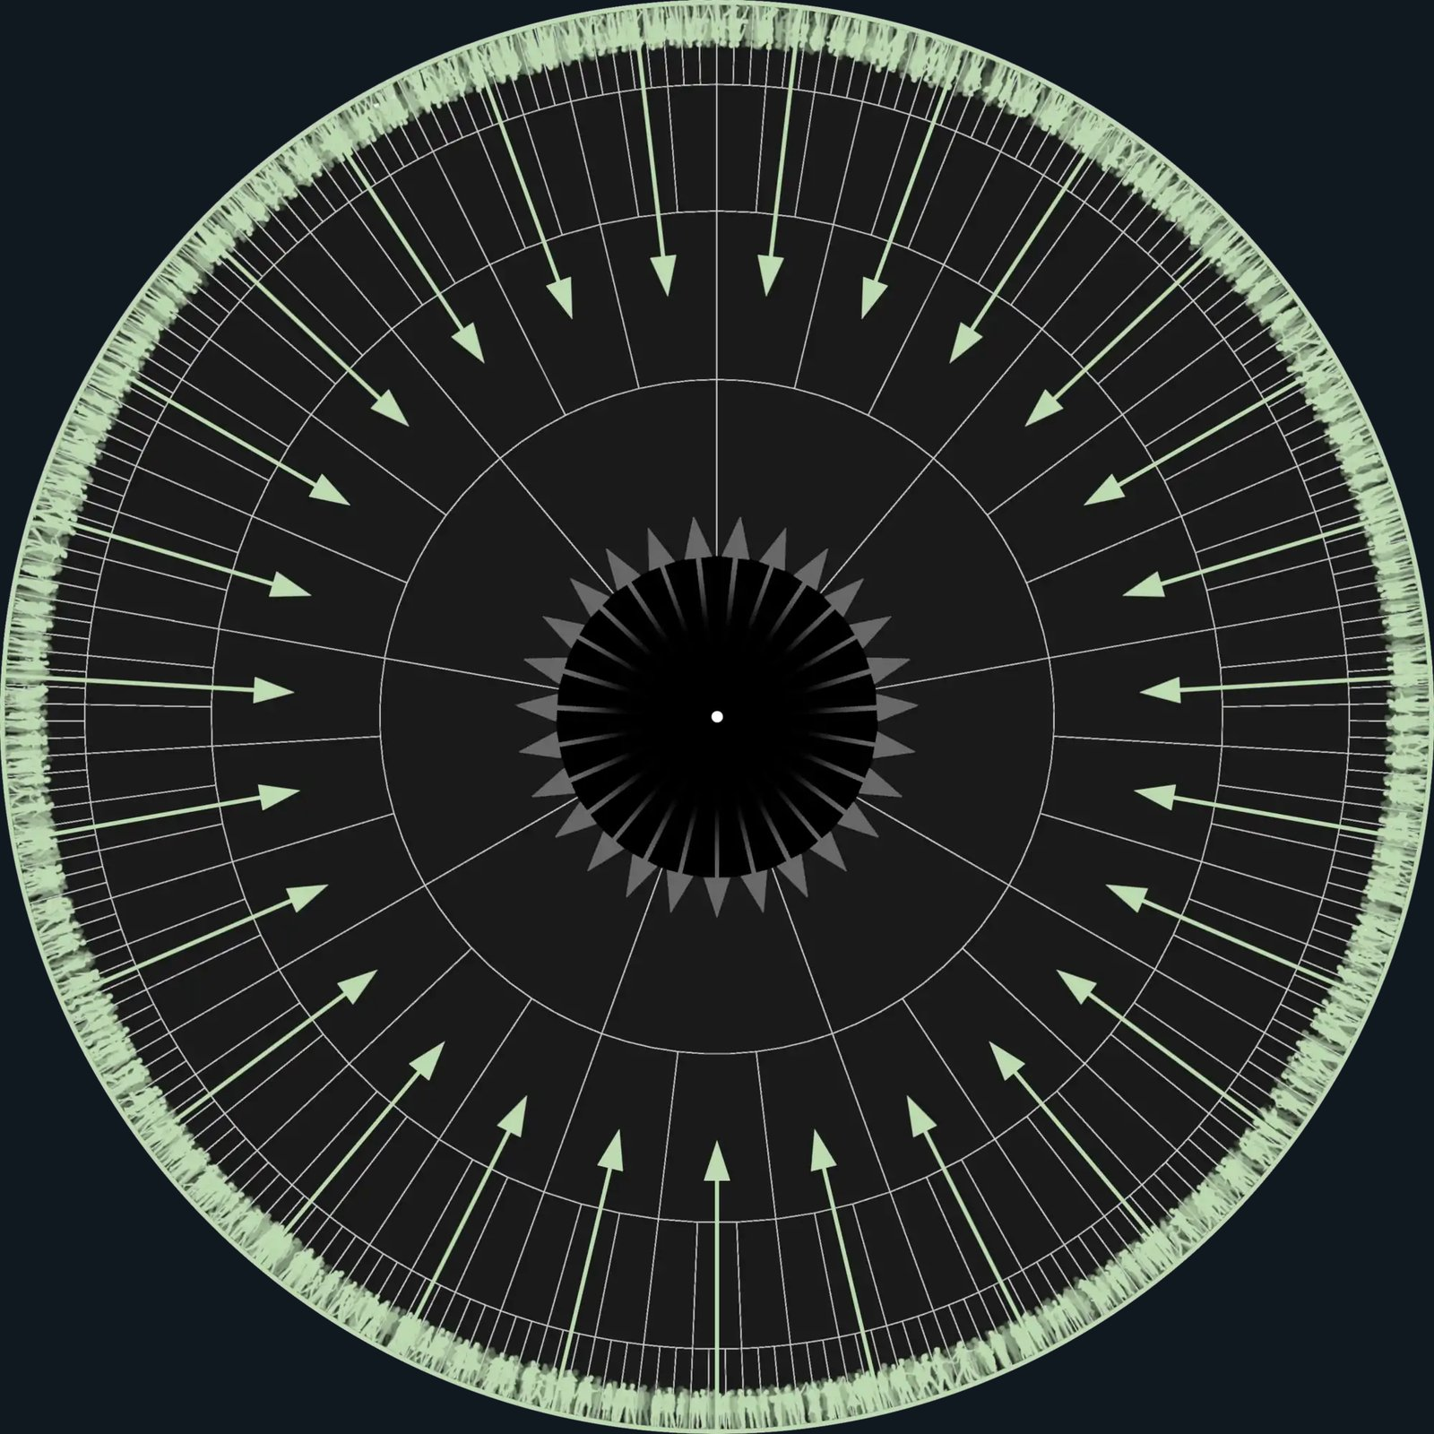
Hope enabled by focus on the commons and global democracy

A beacon of hope
Here, the same Earthwheel model that showed collective paralysis in WHY shows its opposite. Humanity is no longer a passive grey mass; it appears as a connected, alert citizenry.
At the empty centre, previously shown as a “black hole”, a single point of light now marks a declared beacon of hope: the annual countdown to Earth Parliament Day 23 April and the hope that the institution becomes real by 2035.
Hey, we are 8 billion! Come on, we can do this!
CC BY-SA 4.0 United.Earth Initiative
WHY described political paralysis as a structural condition, not a personal failure of understanding, morality or effort. Millions of individual actions can be sincere and valuable without adding up to binding global coordination, because no legitimate political system exists at the scale the problem requires. The task in front of humanity is therefore not to issue another appeal to existing leaders. It is to begin organising the missing actor itself: a global democratic political community capable of acting democratically at the global level, where no legitimate democratic actor currently exists.
This organisation does not move directly from concern to a global state. It moves through a political community, democratic practice, working institutions, accumulated legitimacy, and only then constitutional authority. Each of these is a distinct achievement, and each is the subject of a later section of this page.
Existing work is not replaced by this process. Scientific communities, movements, local governments, professional networks and civil society organisations already carry real expertise and real capacity. What has been missing is a shared democratic structure through which this work can be connected at the scale on which the underlying problems actually operate, without requiring these communities and organisations to abandon their own purpose or organisational identity.

18.2 Build before authority
The system described in WHAT cannot simply be completed in the abstract and then imposed from above. It must be developed through practical use before it is activated. This is United Earth’s prefigurative strategy.
A prefigurative strategy means that the system begins practising the democratic form through which it may one day exercise formal authority. Earth Citizens take part in shaping its procedures and institutions as they are built, not only after they are complete. Proposals, learning, deliberation, votes and elections are tried before their results carry the full consequences of binding public authority. Mistakes can therefore be found and corrected while the cost of a mistake is a revision, not a constitutional crisis. Legitimacy accumulates the way any working democracy earns trust: through open development, visible correction, and experience that anyone can test for themselves.
The new order should not be activated before it has been built, used, tested and democratically shaped.
This has a firm limit. A system built this way can produce advice, working models, voting results and real institutional experience. It cannot, by itself, turn its own decisions into binding law before a legitimate global constituent process has ratified the constitutional order. The shift from influence to authority is not something protoform practice can achieve on its own; it requires a separate, explicit constituent act.

18.3 A strategy, not a prediction
Building this system requires several distinct kinds of capacity: a global political community that people can actually join; a working democratic practice of learning, deliberation, proposal and vote; a shared knowledge infrastructure capable of supporting judgement at planetary scale; constitutional institutions developed and tested before they hold power; and an operational infrastructure robust enough to carry all of this without depending on any single organisation, provider or individual. Later sections of this page take up each of these in turn.
What cannot be specified in advance is the order in which they mature, or how long each takes. No one can say today which places will move first, which alliances will form, which setbacks will occur, or how quickly any particular part of this will develop. That uncertainty is not a weakness in the strategy; it is simply the truth about a process this large.
The sections that follow are organised thematically rather than chronologically, but read together they trace one broad progression from where humanity stands today toward the system described in WHAT. The concluding phase synthesis draws these parallel tracks back together into a single illustrative sequence, not a predicted one.
The path cannot be predicted in detail. The capacities it requires can still be identified and deliberately built.

19. The global political community
Global democracy needs more than a constitution and a set of institutions. It needs a global political community capable of learning, acting, taking responsibility and building legitimacy together. That community does not yet exist in finished form. United Earth therefore begins by gathering people as Earth Citizens and connecting them through proto-AGORA and a growing network of nodes. Earth Parliament Day gives this process a shared public starting point and a recurring global rhythm.

19.1 Earth Parliament Day
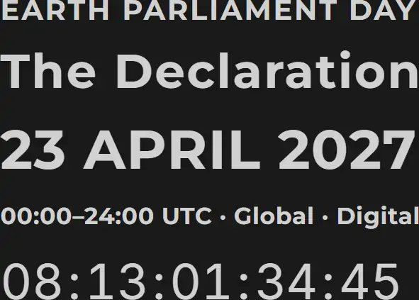
WE* propose Earth Parliament Day as a new annual focal point for global civic mobilisation. All fellow Earth Citizens are invited to take part in a coordinated effort to build support for a global parliament and the broader transition to global democracy.
* Worried Earthlings
The transition needs a clear, recurring global gathering point. Earth Parliament Day, held every year on 23 April, exists to make the demand for an Earth Parliament visible and to give that demand a shared political rhythm rather than a single moment of attention.
In its earliest form, the day is mainly a mobilisation: a public launch, a point of entry for new Earth Citizens, and a moment that turns diffuse concern toward one concrete, missing structure. As the movement grows, the same day can carry coordinated learning, deliberation and early global votes.
Later still, it can mark elections, constitutional milestones and progress toward the threshold. Held every year, it can gradually make Earth Parliament a known and expected public institution long before it formally exists.
Earth Parliament Day is not the day United Earth unilaterally declares that a parliament exists. It builds the public demand, participation and protoinstitutional experience from which Earth Parliament can later be constitutionally established through the constituent process.

19.2 Earth Citizenship introduction
Earth Citizenship establishes the membership that can grow into a global political community and later carry a legitimate constituent process. In this phase, it is a verified membership in United Earth’s democratic transition process, an entry point to proto-AGORA, and the foundation for learning, deliberation, voting and elections within it. It is also the measurable membership behind the threshold described here.
It is not yet formal citizenship of an existing global state, and it does not replace or require the surrender of any national or local citizenship a person already holds. It does not by itself confer constituent authority, and it does not require anyone to make their legal identity public.
That membership must be verifiable without becoming publicly identifying. The system must be able to establish that each Earth Citizen is one unique person while allowing public pseudonymity, minimising identity data and developing alternative verification paths for people without standard identity documents. Without this balance, Earth Citizenship cannot become either fully inclusive or democratically credible.
The significance of this membership is more than administrative. It turns the abstract idea of “humanity” into a defined and verifiable democratic body. Each person joins as an individual, not as a representative of a state, nation, religion or ideology, but keeps every identity they want, and the current legal nation-state citizenship they already hold. Earth Citizenship begins to build a global democratic identity without turning that identity into a new homogenising culture of its own, because it is tied directly to a democratic system rather than derived from any dominant cultural identity. GOV//ID, the subject of the next main section, begins here as a working principle, not only as a future rule.

19.3 AGORA and the node network
Membership alone does not make a political community. Proto-AGORA is what turns Earth Citizenship into something people can actually do together: a shared public space where principles and goals are presented, where members get a profile and a way in, where information and public conversation are organised, where learning material is made available, and where proposals, questions and criticism can be collected and openly documented.
“Proto” signals something specific here. It does not mean an early, limited version of a piece of software, though in practice it will mean that too, since the tech solutions will have to be developed incrementally in parallel with their use. But most importantly, it means that the political system built through AGORA does not yet hold formal constitutional authority, even once its functions become extensive and socially significant. Proto-AGORA will later carry the Policy Area Index, the AGORA Knowledge System, Council processes, competence verification, structured deliberation, elections to protoinstitutions, and the constitutional drafting and voting described in later sections. This generative role does not mean that AGORA stands above the Councils or the branches in the eventual constitutional order. The sequence in which institutions are developed is not the same as the balance of power between them once established.
A global digital public sphere still needs to be anchored in actual people, places and fields of work. Local nodes gather Earth Citizens in particular areas, make physical meetings possible, help people who need support to participate digitally, and connect local experience to global questions. Thematic nodes gather people around fields of knowledge, professions and shared interests, can cross geographic borders freely, and can grow into the recruitment and learning grounds the Councils and other proto-institutions will later draw on.
Neither kind of node is a public governance unit. They are structures for organisation and participation, and they should not present themselves as local, regional or national authorities. Proto-AGORA should nevertheless aim to build most of the node capacity that the future constitutional AGORA will need by the time the four-billion threshold is reached. Many nodes should therefore be designed from the outset for eventual succession into the permanent AGORA infrastructure, while remaining adaptable as the final territorial structure develops.
Existing states and institutions may later contribute facilities, personnel, technology and funding, greatly accelerating this process. The strategy cannot depend on that support arriving. The node network must be capable of growing through the Earth Citizen community itself, while remaining open to the integration and transformation of existing institutional capacity.
The shape of the proto-node network should not be read as a fixed map of the future governance structure. Nodes may later be expanded, combined, divided, relocated or assigned different functions. What matters from the outset is that they can cooperate directly, connect into broader distributed networks and develop without any single node becoming a permanent command centre for the rest.

19.4 Growth as shared capacity
Growth in this community is not only a matter of numbers. Each stage of growth should increase the system’s actual democratic, epistemic and institutional capacity, not simply its membership count. New Earth Citizens bring languages, cultural perspectives, expertise, node organisers, and economic and technical capacity. Each addition should increase the capacity to establish working Councils, test procedures more broadly, and carry real weight in today’s political systems. Growth of this kind is self-reinforcing: more Earth Citizens build more knowledge and capacity, which makes proto-AGORA more capable, which makes participation more meaningful, which strengthens recruitment and political influence in turn.
Growth must not be allowed to concentrate power in the people who happened to start the process. As the community and its capacity grow, its decision-making structure must open and democratise with it; resources and institutions must remain tied to open mandates and the succession described in later sections, so that the organisation can scale without producing an administrative elite that cannot be removed.
Nor can growth be allowed to inflate its own significance. United Earth cannot claim to represent people who have not joined it. Earth Citizenship is voluntary and explicit, and the results of any proto-vote must be presented as exactly what they are — the outcome among participating Earth Citizens, not a decision made on behalf of humanity. Legitimacy accumulates gradually through this process, but formal global authority arises only through the constituent process described later on this page.
The global political community does not become complete in this section. It continues to grow and change throughout the rest of the transition. What is established here is the foundation that makes everything that follows possible.

20. GOV//ID as the principle of transition
WHY identified the structural problem: across much of today’s political order, governing authority is tied to a dominant cultural identity, ID=GOV, and this tie makes territorial and constitutional change feel like an existential threat rather than an administrative one. WHAT described the alternative: GOV//ID, a governance system in which cultural identities are protected but none of them owns the state.
ID=GOV principle
->
GOV//ID principle
This section describes the steps that the transition itself requires: recognising the problem, working out what separation demands in law and constitutional design, tracing what it means for culture and belonging in practice, carrying the principle into the proto-version of the new system, and building the political momentum needed for voluntary constitutional transformation.
Unlike the institution-building processes that dominate later sections, the conceptual and early legal work can begin with limited material resources. It can therefore proceed alongside the heavier work of building institutions, transforming states and forming blocs, rather than waiting for any of it to be completed first.

20.1 From recognised diagnosis to a transition premise
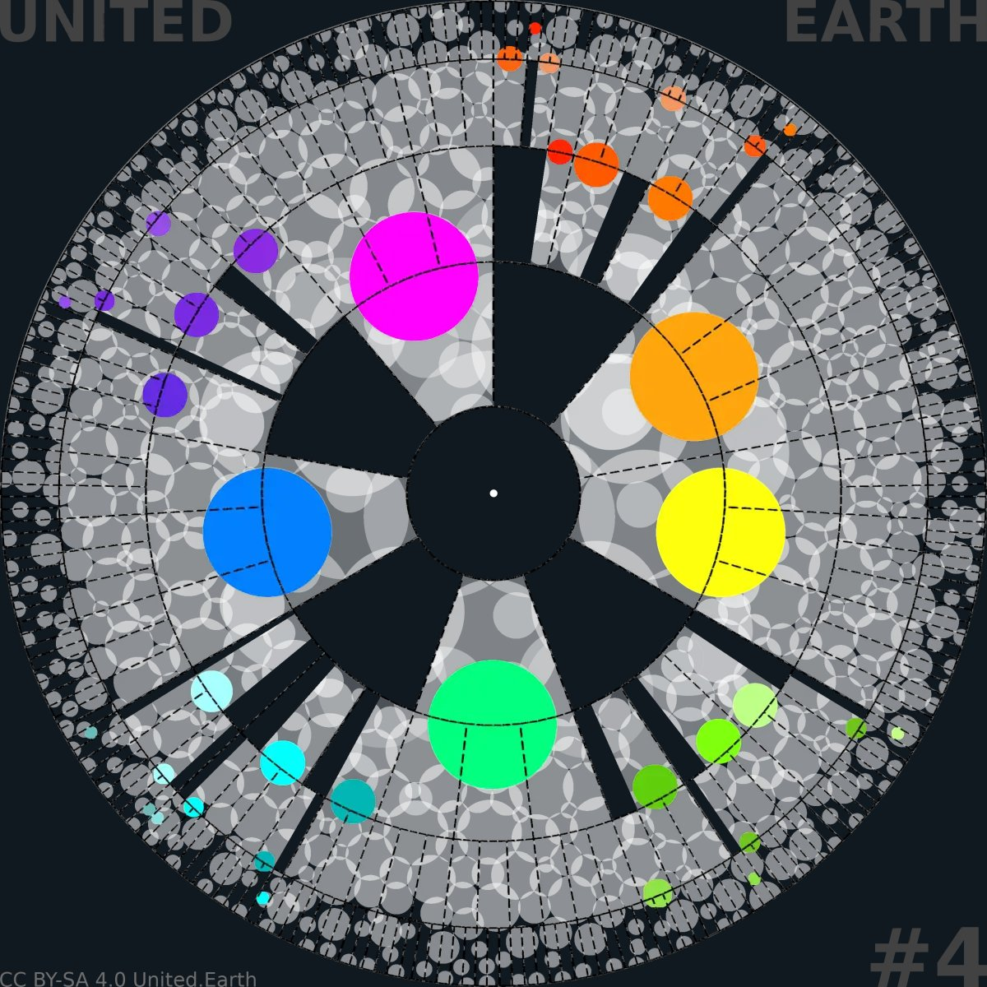
EARTHWHEEL 4/18

Decoupling cultural identities from defining governance
The separation begins with the circles retaining the same colours they had when they still filled the territorial space in the WHY illustrations. The identities remain visually distinct, but no longer coincide with the boundaries of governance.
Read more about the earthwheels here.
CC BY-SA 4.0 United.Earth Initiative
Many people have already made, individually, the mental shift that the WHY chapter describes: they no longer take it for granted that a nation needs its own state, or that governing a shared territory requires one dominant identity to own it. This insight is not new, and it does not need to be argued for again here. What has been missing is not the idea, but a decision to build on it: to treat it as a working premise for the transition itself rather than as a private conviction held by people who happen to agree.
Some might argue that many countries are already operating based on the GOV//ID-principle, since church and state are separated, or more broadly, all religions and the state. Or they argue that they are multi-cultural, multi-ethnic, etc. Yes, many countries are, but this is not enough to qualify as true govid-based governing units, because they are still all operating under the most idgov-based premise of all: the nation-state.
That shift, from private insight to shared working premise, is itself a political act. It commits everyone involved in building the proto-system to a design constraint: Earth Citizenship, the nodes, the Councils, the future blocs and the Earth Constitution must not be owned, defined or governed by any single national, ethnic, religious or ideological identity. It does not require anyone to change what they believe about their own culture or nation. It requires accepting that governing authority and cultural identity can, and from this point on should, be treated as two separate things.
Today, only a small minority of cultural identities are associated with a sovereign state of their own. Most are not, and many of the peoples organised around them live with varying degrees of minority status, political subordination, pressure to assimilate or direct suppression.
GOV//ID does not attempt to correct this inequality by giving every remaining identity a state of its own. It removes the category of identity-owned governance itself. In the completed order, every unit of governance at every level is constitutionally a subsidiary unit within one multicultural global state. No unit belongs to a nation, ethnicity, religion, ideology or other cultural identity.
Historical settlement patterns will still mean that one identity forms a demographic majority in many places. That presence may remain culturally visible and politically relevant, but it does not restore a claim to exclusive ownership of governance. A demographic majority is not a sovereign identity.

20.2 Map what separation requires constitutionally and legally
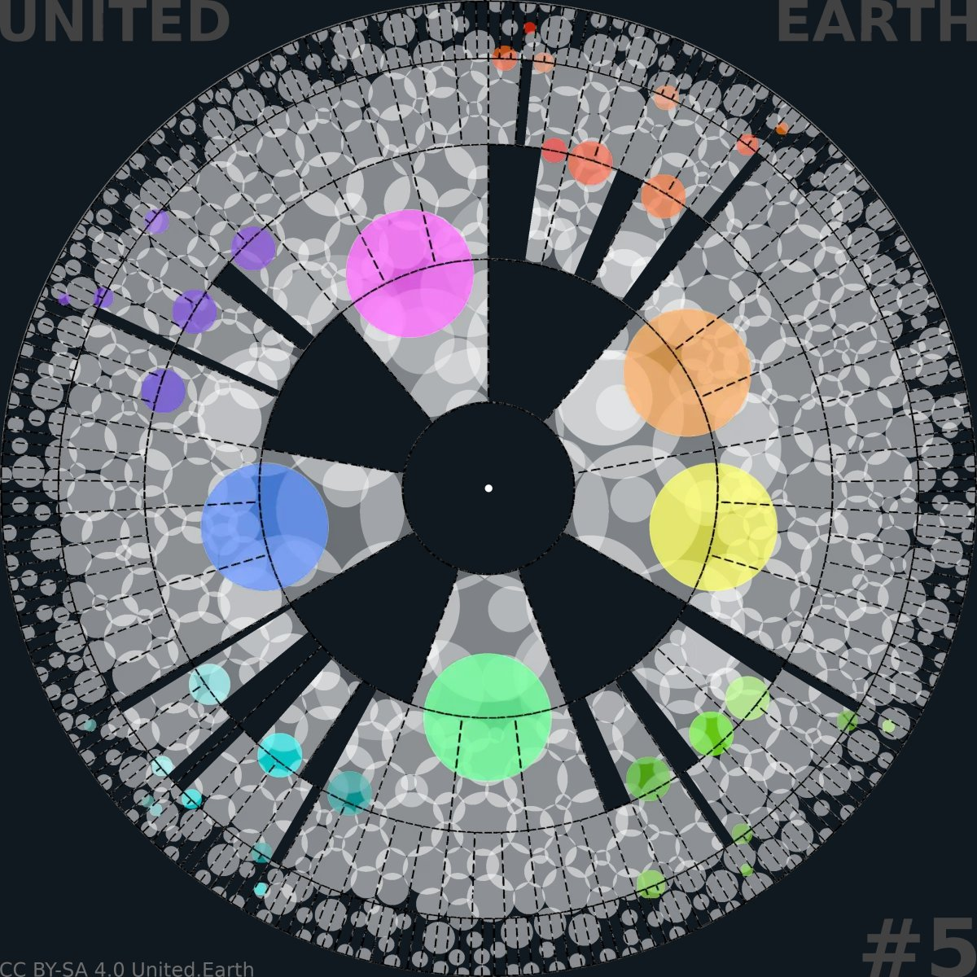
EARTHWHEEL 5/18

Aligning former ruling identities with the already stateless ones
The circles that once filled entire governance units are now fading in colour intensity, preparing them to blend in with all other identities, be it nation, ethnicity, religion, ideology, or any mix thereof. None retains the shading that marked exclusive territorial ownership in Earthwheels 1-3.
CC BY-SA 4.0 United.Earth Initiative
Accepting the premise does not by itself tell anyone what separating governance from identity actually demands in law. A working transition needs this mapped out, question by question, in the places where it will eventually matter: constitutions, citizenship law, electoral law, minority protections, religious establishment clauses, and the legal status of existing monarchies, state religions and identity-based constitutional provisions.
This mapping must move beyond political theory into legal and constitutional drafting. It can proceed through comparison of existing constitutions, contributions from affected communities and identities, assessment by the Councils of Science, Ethics and Culture once they exist in protoform, and simulated legal application within proto-AGORA.
The early work requires neither new territory nor institutions with public authority. It requires people willing to do the careful drafting work, and a place to publish, criticise and revise what they produce.

20.3 Trace the cultural consequences
A transformation this deep will meet substantial resistance because it cuts across ancient tribal patterns in human psychology and political culture. Human communities have repeatedly learned to associate collective safety, dignity and historical continuity with control of territory and state power. Removing exclusive cultural ownership of governance may therefore be experienced not as political equality, but as dispossession.
Formerly state-defining majorities may fear the loss of protection, continuity or public recognition. Minorities may suspect that formal neutrality will preserve existing domination under new language. Stateless nations and peoples may see GOV//ID as an opening for long-denied recognition, or as another reason to postpone it. None of these responses can simply be declared mistaken or expected to disappear once the principle has been explained.
The work is therefore to identify these concerns publicly and examine them with the affected communities: which forms of linguistic, cultural and institutional continuity can be protected; what must change; where formal neutrality is insufficient; and what legal or political safeguards are needed. This belongs in proto-AGORA and in the developing Council of Culture, alongside the legal mapping described above.

20.4 Carry the premise into implementation
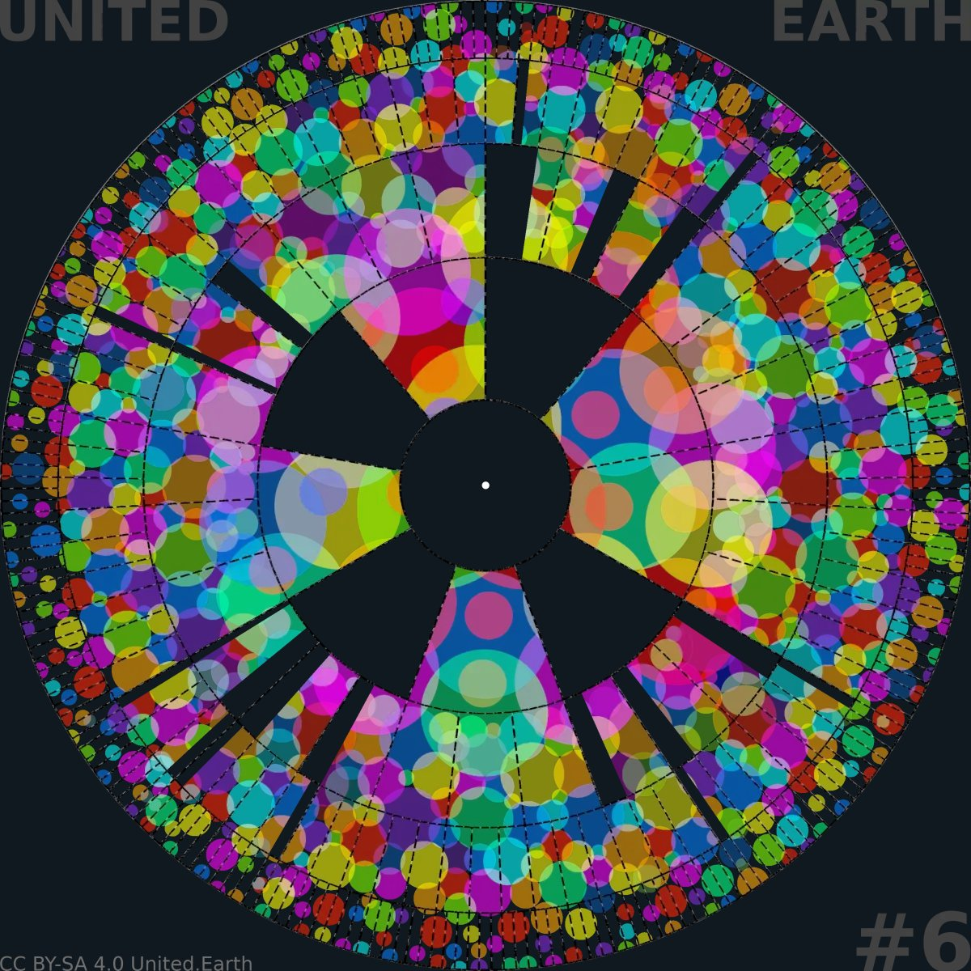
EARTHWHEEL 6/18

GOV//ID established
This wheel completes the sequence begun in Earthwheel 4. Governance and identity now appear as separate structures, connected through the citizens who participate in both. Within HOW, it shows the target condition that the transition must progressively realise, not a claim that the condition has already been fully achieved.
CC BY-SA 4.0 United.Earth Initiative
None of this remains a private exercise for long. The premise established above, once mapped and traced, has to be carried into the places where the transition is actually built: into the language United Earth itself uses; into the design of Earth Citizenship, which must not be organised around any single culture or creed; into the working practices of the nodes and the Councils; into the programmes of transitional parties; and eventually into legislation and constitutional reform within today’s political systems.
Carrying a principle into implementation is different from having agreed to it. Proto-AGORA is where that difference is first tested: where a stated commitment to GOV//ID either holds up under real disagreement, real majorities and the founders’ own incentives to retain control, or it does not.
Implementation cannot mean that the new system redraws borders or imposes GOV//ID through conquest or unilateral global decree. The transition must advance through voluntary and democratically authorised constitutional transformation within each sovereign nation-state. Read here about the political and legal instruments through which this can happen.

20.5 Build global momentum for voluntary transition
GOV//ID becomes a territorial and constitutional reality only when a constitutionally sufficient majority emerges within each sovereign nation-state that enters the transition. Depending on the constitution, this may require an ordinary majority, a qualified majority, successive parliamentary decisions, a referendum, or several of these together. In every case, the transfer of sovereignty to a higher bloc must be voluntarily and democratically authorised within the political system that presently holds it.
United Earth cannot produce these majorities from outside. Its role is to stimulate the mental, cultural and legal shift that makes them possible, together with the people, parties, movements, professional communities and institutions working toward the same transition within each country.
The strategy is therefore to work for this process across all countries and at every available level at the same time. Global work in proto-AGORA, legal research, cultural dialogue, node activity, local initiatives, political organisation, parliamentary proposals and public campaigns should reinforce one another as parts of the same transition.
Every activity can contribute to a cumulative public narrative. Each serious debate, institutional endorsement, legal reform, electoral advance and parliamentary decision makes the transition more visible and credible. Partial victories show that particular barriers can be crossed.
When a country formally authorises the transition and transfers sovereignty into a democratically constituted bloc, that decision becomes more than a national achievement. It becomes global evidence that the larger transformation is possible.
As such developments accumulate, the transition can become a recognisable global direction rather than an isolated proposal. Political actors and populations will increasingly respond not only to an idea, but to a growing structure, a body of practical experience and an increasing number of societies moving in the same direction. Each breakthrough can reduce uncertainty and make the next one politically easier.
This process will not move at the same speed everywhere, and acceleration is not guaranteed. Resistance, reversals and attempts to preserve the existing order will continue. The strategy does not depend on persuading every country in isolation before anything can move. It depends on parallel efforts creating enough connected progress that voluntary national decisions begin to reinforce one another.
Completing this process is essential to completing the bloc level. Without blocs that possess democratically transferred territorial sovereignty, administrative capacity and the dominant legitimate force on land, the global constitutional order cannot establish its intended balance of power, peacekeeping structure or territorial execution.

20.6 A parallel process that can begin immediately
The early work described in this section does not require territory, coercive power, large physical infrastructure or prior cooperation from existing states. It can begin through research, drafting, translation, consultation and public argument. At global scale, however, none of this is literally costless. Serious cultural participation, legal expertise, multilingual work and democratic testing will require resources and institutional capacity.
The strategic point is that this work need not wait for bloc formation, sovereignty transfers or the full technical construction of AGORA. It can begin now, then deepen as the political community and its institutions grow.
GOV//ID is established here as the principle of transition, but realised only through the transition as a whole.

21. The democratic proto-system
A global political community becomes democratic only once it can do more than communicate and vote. It needs a shared way of knowing what a given question is actually about, a way of building and testing relevant knowledge, and a way of turning informed judgement into decisions that carry real, if not yet binding, weight. None of these functions can be designed once by a small founding group and then scaled unchanged to billions of people. They have to be built the way the rest of this transition is built: through use, correction and revision, before any of it holds public authority.

21.1 From movement to proto-organisation
Proto-AGORA cannot begin as the full democratic infrastructure described in WHAT, and it should not try to. Its functions have to grow in step with what the community that uses it can actually do meaningfully. Complexity should follow political and organisational maturity, not run ahead of it: a system that simulates advanced democracy before its members have the knowledge base and the practised judgement to use it is not more advanced than one that grows deliberately — it is only more fragile.
This growth is not a technical roadmap alone. It is where United Earth’s most important discipline gets tested: that the organisation builds the infrastructure through which the wider community can develop its own institutions, rather than building the institutions itself and asking the community to ratify them afterwards. Every function added at this stage should widen who can shape the system, not simply widen what the system can do.
Because nothing here yet carries public authority, mistakes are affordable in a way they will not be later. Low participation, biased learning material, cultural dominance by an early majority, manipulated proposals, capture of a Council, or an algorithm that quietly favours one outcome over another — all of this can surface, be documented and be corrected here, before the same failure would carry constitutional consequences. Failure that is hidden to protect the initiative’s reputation defeats the purpose of building in protoform at all; failure that is named, criticised and revised is exactly what protoform is for.

21.2 Build AGORA, the Councils, PAI and AKS
WHAT describes the Policy Area Index, the AGORA Knowledge System and the three Councils as finished, permanent structures. None of them begin that way. Each has to be built from something much smaller, through the same open and revisable process as everything else on this page.
The Policy Area Index cannot start as a complete map of political reality. It starts as a working list of the areas the earliest Earth Citizens and nodes actually need to organise proposals and knowledge around, and it grows and gets reorganised as real use exposes categories that are missing, overlapping or badly drawn. The AGORA Knowledge System develops the same way: the first knowledge areas are narrow and concrete, built by contributors who can be checked, with errors, missing perspectives and disputed claims reported and corrected in the open, rather than concealed to preserve an appearance of authority the system does not yet have.
The three Councils — Science, Ethics and Culture, described fully in WHAT — begin as open, testable proto-institutions rather than permanent offices. Early participants can be drawn from existing professional networks, verified competence and the thematic nodes described here; their mandates can be temporary and their work fully documented. What has to be built here is not their function, which WHAT already defines, but their legitimacy: Council membership should move, deliberately and over time, from something United Earth appoints to something Earth Citizens elect through transparent, contestable procedures.

21.3 Develop knowledge-based direct democracy
WHAT sets out the full democratic decision cycle this system will eventually run: how a question is identified, structured, assessed, deliberated, decided, formalised and reviewed. That cycle does not have to be invented twice here. What protoform adds is a way of trying it safely — and a way of building the competence-weighting it depends on before that weighting affects anything that matters.
Competence weighting cannot begin with the weighting itself. It has to begin with access: open, multilingual learning material that lets anyone develop relevant understanding regardless of wealth, education or institutional connection, followed by verification methods people can actually use and trust, and only then by any adjustment to how much a verified competence counts in a particular decision. Skipping straight to weighted votes before this sequence is in place would make competence a gatekeeper rather than a support to democracy.
The votes and elections tried during this period take several different forms — consultative questions, internal organisational decisions, simulated public policy, and elections to the proto-institutions described above — and each must be presented with its correct status. Internal decisions can bind United Earth’s own organisation once a clear mandate exists for them. Simulated public votes are not global law, and results from any of this must never be presented as though they came from more than the Earth Citizens who actually took part. Personal AI tools, described fully in WHAT, are introduced the same way as everything else here: gradually, with each function tested, criticised and — where it fails — withdrawn, rather than deployed at full scale on the assumption that it will work.
A proto-system that has learned to fail safely is more trustworthy than one that has never yet been tested.

22. The constitutional order in proto version
Democratic practice on its own is not yet a constitutional order. Institutions must receive proposals, formalise decisions, implement internal mandates, resolve disputes and bind the whole structure to written constitutional rules before those rules can be put to a global vote. This section describes how the three branches, the Rights of Life and the Earth Constitution are developed and tested in protoform through the same democratic process as everything else on this page. It also explains how succession out of United Earth’s hands is designed in from the beginning rather than promised for later.
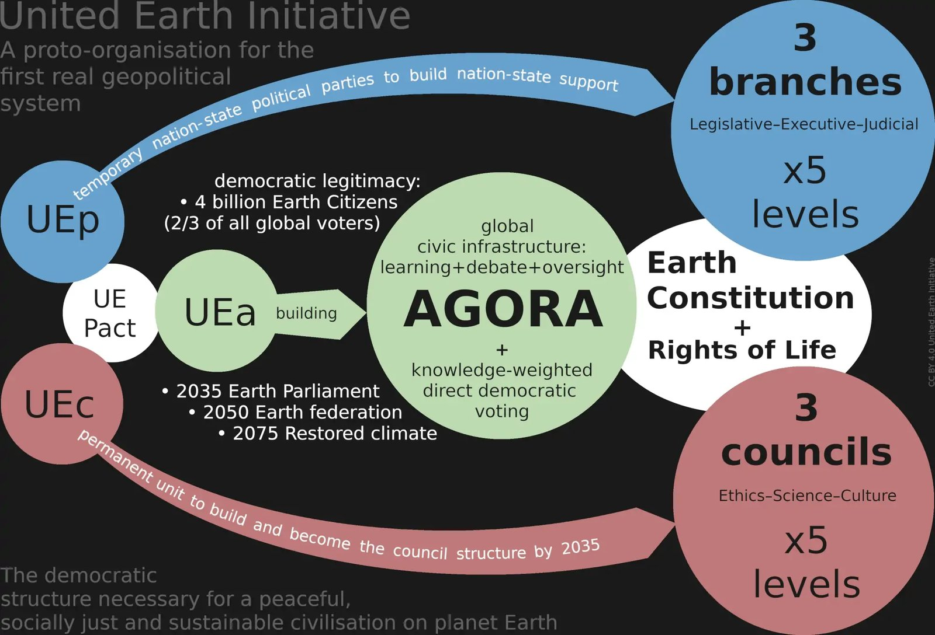
United Earth Organisation

The United Earth proto-organisation
This diagram shows how the democratic infrastructure developed through Earth Citizens, AGORA and the Councils can begin to generate constitutional institutions in protoform. It does not show an already established global state, nor does it imply that United Earth owns the future constitutional order.
All institutions remain provisional, revisable and without public authority until ratification and activation.

22.1 Build the proto-institutions
The three branches described in WHAT do not appear automatically once proto-AGORA and the Councils are working. They are developed through that democratic infrastructure.
A legislative function develops toward proto-Earth Parliament as the body that formalises what proto-AGORA produces: internal United Earth decisions at first, then constitutional drafts and simulated legislation. An executive function begins with the practical work required to run the transition itself, including administering Earth Citizenship, operating the platform, supporting the nodes and the Councils, implementing internal decisions and coordinating budgets. These are proto-executive functions within the transition, not yet Earth Government.
A judicial function begins by resolving the disputes the other functions inevitably generate: contested competence decisions, appeals against verification results, election and voting disputes, and disagreements over procedure. A system that cannot resolve its own internal conflicts fairly has no basis for claiming that it could later resolve constitutional conflicts affecting others.
None of these protoinstitutions receives its permanent form here. Their mandates must remain limited and explicit. Where provisional appointments are initially unavoidable, they must not become the permanent method of institutional recruitment. As proto-AGORA and its democratic procedures mature, officeholders must increasingly be selected and held accountable through transparent procedures controlled by Earth Citizens rather than by United Earth’s founders.
Internal rules and decisions may bind United Earth and its members within the voluntary organisation when a clear mandate exists. They are not yet public law for anyone.

22.2 Develop the Rights of Life and Earth Constitution
WHAT establishes the principles and institutional architecture that the Rights of Life and the Earth Constitution must carry. Turning these principles into ratifiable documents is constitutional development, not merely theory: comparing existing constitutions and rights instruments, gathering contributions from the Councils and affected communities, producing competing drafts rather than a single protected text, and repeatedly revising the results through public deliberation.
The drafts must also be tested against situations designed to expose their weaknesses: a bloc refusing to comply with valid global law, an emergency being used to bypass ordinary procedure, or a global majority voting for something the Rights of Life were intended to prevent. A constitution that has never been tested against its own hardest cases is not ready to be ratified.
The same applies to the distribution of coercive power between the global level and the blocs. WHAT describes the intended structure once the federation is complete. In protoform, that structure must be tested through legal simulation, strategic scenarios developed with people who understand peace, security and defence, and open evaluation of what the proposed balance would actually do under pressure.
This does not mean that United Earth builds a private military capacity. The proto-phase develops constitutional rules, procedures, relationships and transition plans. The reorganisation of actual coercive power must occur democratically through today’s political systems and the formation of the blocs described in later sections.

22.3 Build constitutional succession into the system
United Earth must be structurally unable to retain control of what it builds once the ratified conditions for activation are met. This obligation has to shape the system from its earliest working form, not only once the transition nears completion.
The software, domains, membership and verification systems, PAI, AKS, institutional archives, technical infrastructure, agreements and funds must all be held, licensed and governed in a way that makes their eventual transfer a matter of following an existing rule. The transfer must not depend on asking the people or organisations controlling these resources to give them up voluntarily once they have become valuable.
This is not a promise to be kept later. It is a design constraint that shapes ownership, licensing, organisational mandates and governance decisions now.
Succession alone is not enough. The order placed before the referendum must also be concrete enough to decide on: a defined Rights of Life, a defined Earth Constitution, identifiable institutions, a clear distribution of authority, and explicit succession and activation rules. What the Constitution itself assigns to later democratic decision must remain open, but the referendum cannot be asked to approve an unfinished framework whose decisive content will be determined afterwards.
The referendum must allow Earth Citizens to judge a real, tested and understandable constitutional order. It is not meant to hand United Earth a blank mandate to decide the rest afterwards.
United Earth can propose the first draft. It cannot decide the last one.

23. Transformation from within
A global proto-system can accumulate legitimacy, knowledge and demonstrated democratic practice, but it cannot, by itself, move sovereignty that today belongs to existing states, amend their constitutions, or reorganise the territorial and military power those constitutions currently hold.
Earth Citizens enter this work from different legal and political positions. Many are citizens and voters within existing states. Others are stateless, disenfranchised, displaced, or unable to exercise formal political rights freely. Wherever functioning democratic and legal channels exist, the transition has to run through them, not around them. Where they do not exist, the work must help prepare a democratic opening without claiming political authority from outside.
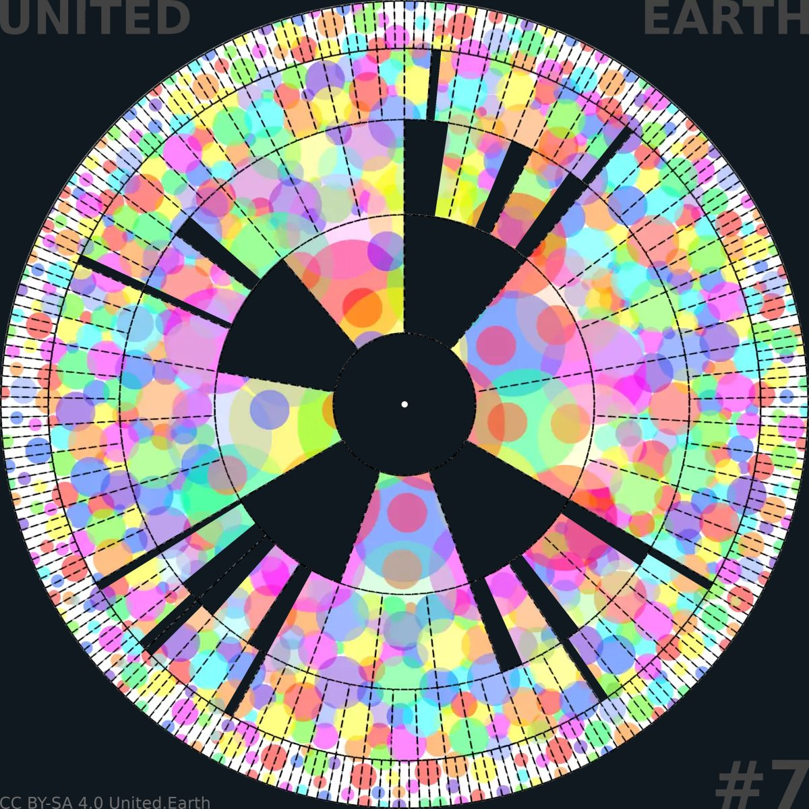
EARTHWHEEL 6/18

Opening the nation-state structure
The black territorial structures remain visible, but openings now appear in the boundaries that previously enclosed sovereign nation-states. The multicoloured field of cultural identities continues across them, following the GOV//ID condition established in Earthwheel 6.
CC BY-SA 4.0 United.Earth Initiative

23.1 Earth Citizens act in two political realities
The three bodies shown above work in parallel under a shared Pact. UEa builds proto-AGORA, the global civic infrastructure. UEc builds toward the future Councils, described in as permanent constitutional institutions for Science, Ethics and Culture. UEp is different in kind: it is the temporary political structure through which the same transition can be carried into existing nation-state systems.
Earth Citizens who already hold political rights within existing states can act in both systems at once. The same person can build and use proto-AGORA, learn, deliberate and vote within it, while also voting in existing elections, joining or forming parties, bringing cases to courts, arguing in parliaments and taking part in referendums where these exist. Developing the future system in protoform and transforming today’s political structures democratically are not separate strategies. They are parallel forms of action carried by many of the same people.
United Earth itself cannot vote in a national parliament, stand in a national election or amend a constitution. Only people and institutions that hold political standing within that system can do so. United Earth can develop shared principles, knowledge, infrastructure and practical experience that political actors within each country can put to use. UEp exists to help carry that common direction into the political systems where territorial sovereignty is still held.

23.2 Build transitional parties and alliances
Where elections determine access to legislative power, organised political actors are usually what turn votes into seats and seats into legal change. United Earth Parties exist for this transitional purpose: to carry the process through existing electoral and constitutional systems.
They can work for recognition of the Earth Parliament process, Earth Citizenship and GOV//ID; support for the Rights of Life and the Earth Constitution; the formation of democratic blocs; the transfer of the competences and sovereignty those blocs require; and participation in the global referendum.
A dedicated transitional party will not always be the most effective route. Existing parties may already be receptive. Some electoral systems may favour broad alliances over new entrants. In such cases, the same purpose can be pursued through alliances with existing parties, cross-party parliamentary groups, independent candidates, civil society coalitions, professional networks, constitutional campaigns, and federalist or democratic movements already working toward comparable ends.
None of these transitional instruments is meant to become permanent. A transitional party succeeds when the transition it exists to carry no longer needs it. The risk of these organisations outliving their purpose must therefore be addressed structurally through bounded and public mandates, time-limited offices, transparent governance and finance, and founding provisions requiring dissolution or transformation once the transitional function is complete.
The organisational separation shown in the diagram must also remain real. UEp and its territorial parties must not own or control UEa, UEc, proto-AGORA, Earth Citizenship data, the Councils or the constitutional proto-institutions. Political access gained through today’s party systems cannot become ownership of the democratic system being built to replace their transitional role.

23.3 Translate the transition into each political system
The constitutional direction is shared, but the path toward it cannot be identical in every country. Each political system has its own amendment procedures, electoral rules, relationship between parliament and courts, requirements for referendums, distribution of authority, existing international commitments and possible place within a future bloc.
A territorial transition programme must therefore identify what has to change within that particular system: which constitutional provisions must be amended; which parliamentary or popular majorities are required; which competences will move to the bloc level; which remain below it under subsidiarity; how GOV//ID will be implemented; how existing administration and law will continue during the transition; and how territorial defence and other coercive powers will eventually be reorganised.
Where functioning democratic institutions exist, elections, parliamentary legislation, constitutional assemblies, referendums and judicial review can provide the required public mandates. Municipalities, regions, existing unions and public institutions may also become early sites of participation, legal development and practical cooperation.
Where political systems are hybrid, restricted or authoritarian, open party organisation may be ineffective or dangerous. Work may instead proceed through diaspora communities, organisations in exile, professional and cultural networks, civil society, human rights work and protected participation in proto-AGORA. This activity must not unnecessarily expose people inside the country, and United Earth must not present itself as a foreign government or claim authority over a population whose consent it does not hold.
No universal sequence can specify how every closed system will eventually open. The common principles remain democracy, GOV//ID, Rights of Life, subsidiarity and voluntary constitutional transfer. The political and legal route toward them must be developed within the conditions of each society.

23.4 Open the nation-state structure
Where this work succeeds, the nation-state ceases by default to be the highest and final unit of sovereignty. It does not have to disappear as an administrative, historical or cultural fact. Existing borders, institutions, languages, laws, public services and political communities can continue through the transition.
What changes is the constitutional meaning of the unit. A nation-state that previously claimed final and indivisible sovereignty can become a subsidiary governance unit within a larger federal structure. Depending on its scale and internal organisation, it may continue as a sub-bloc, a region or another unit below the bloc level. Large existing federal states may instead develop toward the bloc level. These different paths are examined here.
This transformation cannot be declared by United Earth or imposed through an external redrawing of the map. It occurs when the constitutionally required majority within a state authorises the transfer, whether that requires an ordinary majority, a qualified majority, successive parliamentary decisions, a referendum or several of these together.
Different states will reach this point by different routes and at different speeds, and some may not reach it for a long time. That unevenness is not evidence that the strategy has failed, and it cannot be corrected through coercion. Work can continue across all countries and levels at the same time, while constitutional change occurs only where the required democratic support has developed.
Every state that authorises this transition adds more than its own territory. It adds evidence that the transition is possible. As these decisions accumulate, bloc formation can move from political proposal to territorial and constitutional reality.

24. Completing the global and bloc levels
Blocs are not finished building blocks that can be assembled first and connected to a global system afterwards. Their competences, military capacity and internal constitutions all depend on what authority is meant to exist above them. The global level cannot be completed without the blocs either, because Earth Government is not meant to hold general territorial authority over land.
The blocs and the global core are therefore mutually constituting. Neither can be designed in isolation from the other.

24.1 Form the GOV//ID blocs
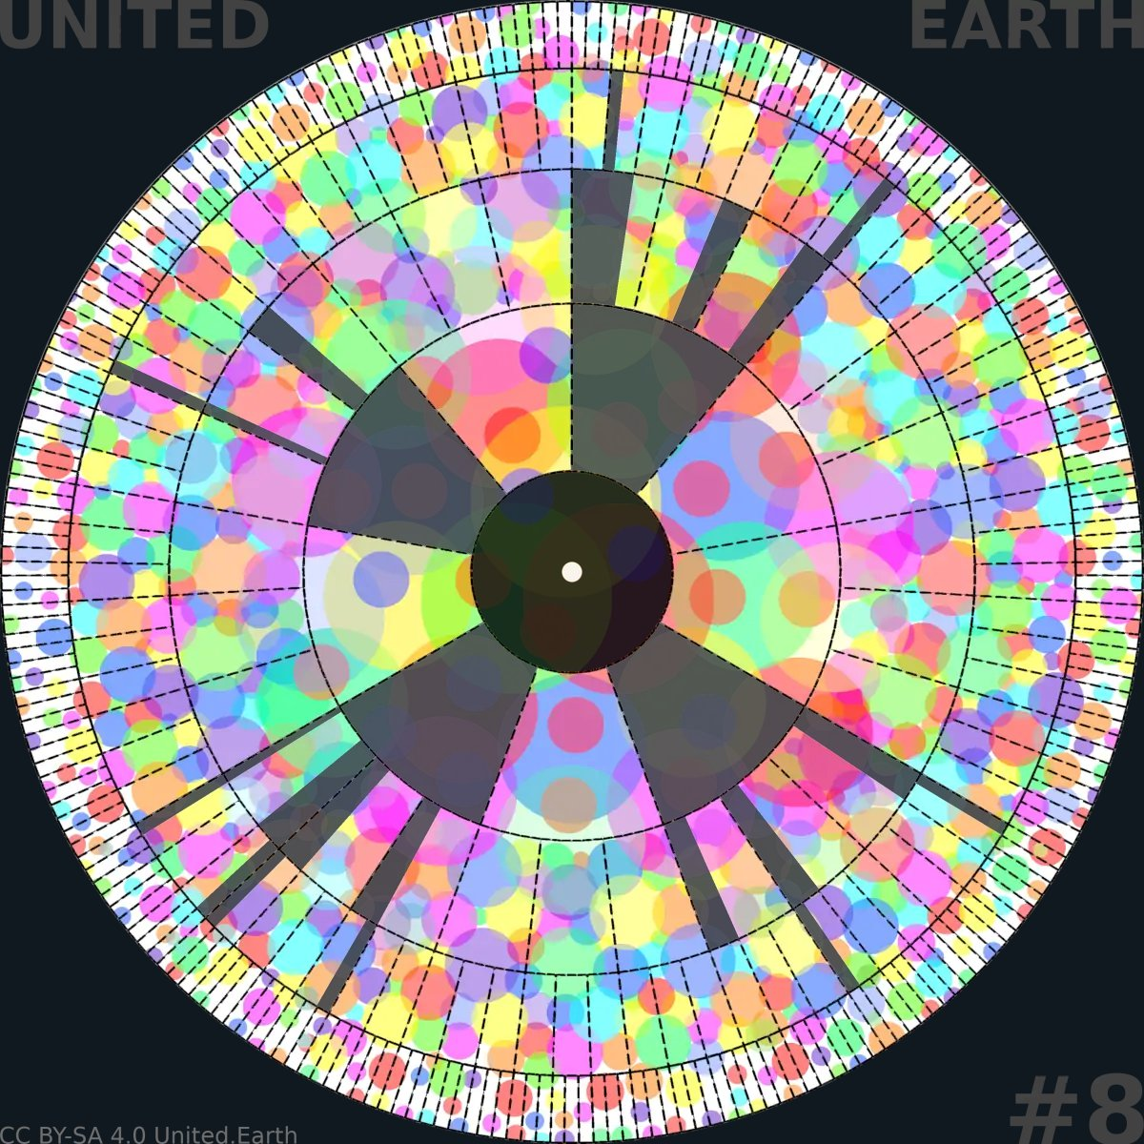
EARTHWHEEL 6/18

Two evolutions begin to converge
At this stage, the transition can no longer be understood as a single line of development. Two large-scale processes must unfold gradually in parallel, each shaped by the principles and structures outlined in WHAT. This is why the wheels from here onward are not separate illustrations of separate steps, but more like frames in a movie describing the development of the whole system.
Earthwheels 8 to 11 should be read as analytical snapshots of these interdependent processes, not as a fixed global timetable. Different territories and institutions may occupy different stages at the same time, and progress in one part of the system may require revision in another.
CC BY-SA 4.0 United.Earth Initiative
No single route leads from today’s states to tomorrow’s blocs. Existing unions with treaty structures and shared institutions can deepen and democratise into blocs. Large federal states can develop directly toward the bloc level. Large unitary states may need to federalise internally first. Groups of smaller states can form new federations from existing economic, geographic and institutional ties. In some places, transitional sub-blocs can preserve continuity while a bloc slowly takes shape around them. None of these paths needs to begin from the same institutional model.
What every path shares is the GOV//ID requirement. A bloc can include citizens of many nations, languages, religions and ideologies, but bloc citizenship cannot be derived from any single one of them.
The location, composition and internal structure of blocs must be developed through negotiations among the affected populations, governments and institutions. Population, geography, ecology, infrastructure, economic integration, existing institutions and the balance between blocs will all matter. United Earth can provide models and shared analytical tools, but it cannot draw the final boundaries from outside. The resulting structures must be ratified democratically by the people whose territorial governance is being reorganised.
A bloc’s democratic institutions must also be capable of receiving the power that will move to them. Bloc-level legislatures, AGORA participation, courts, rights protections, accountable executive functions and constitutional limits have to be developed before the bulk of territorial sovereignty is transferred. Otherwise, the transition simply relocates unaccountable power rather than limiting it.

24.2 Move sovereignty and execution to bloc level
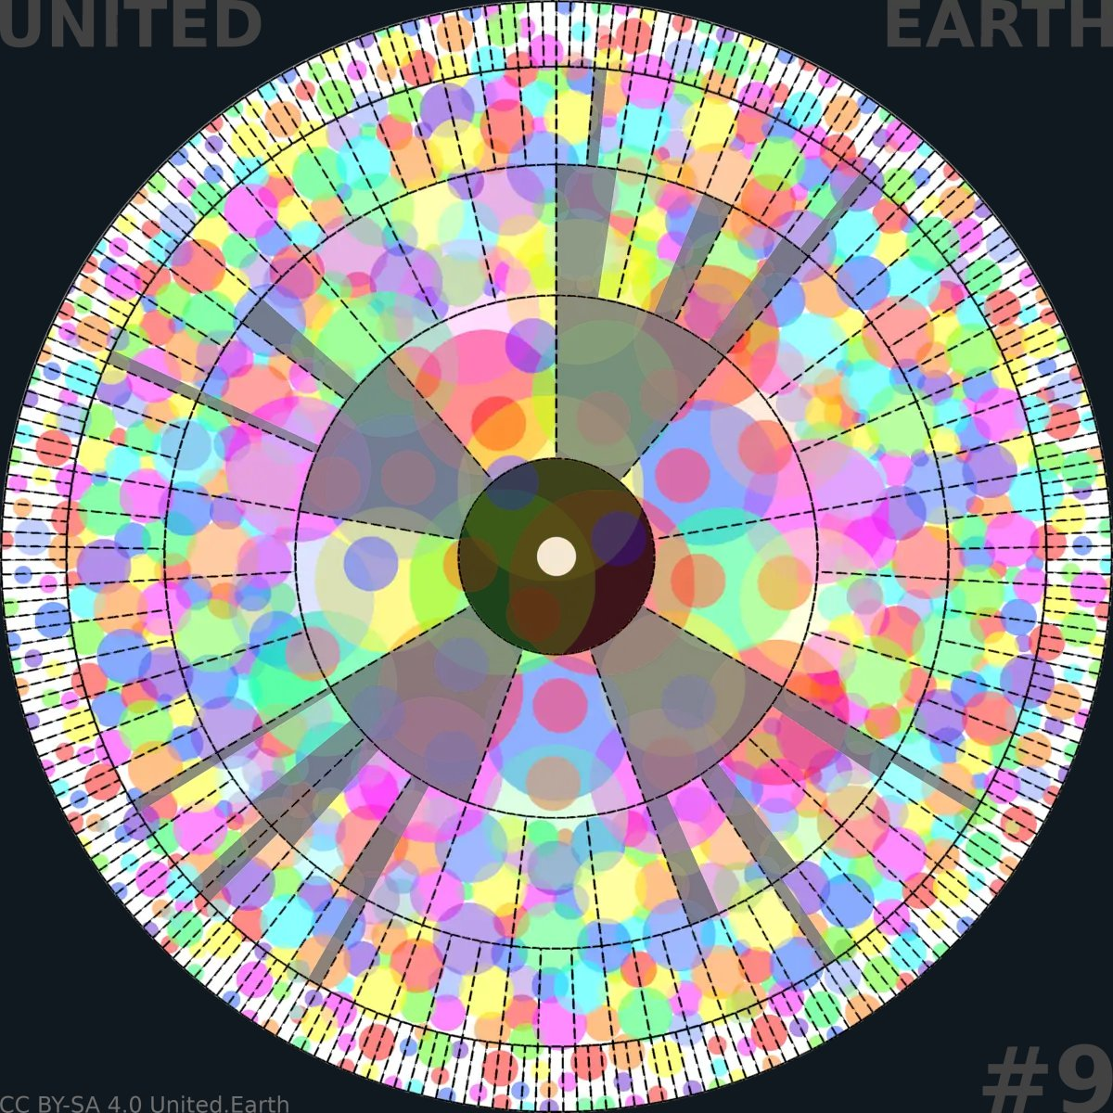
EARTHWHEEL 6/18

The blocs gain territorial substance
At this stage, the first GOV//ID blocs are beginning to develop from existing unions, large federal states and new federations. More nation-states have voluntarily opened their constitutional structures, and authority, administration and territorial capacity are beginning to move to the bloc level.
At the same time, the global democratic core continues to grow through Earth Citizenship, AGORA, the Councils and the constitutional proto-institutions. Bloc formation and global institution-building increasingly shape one another, but both remain incomplete and uneven across the world.
CC BY-SA 4.0 United.Earth Initiative
Bloc formation becomes real only once authority, administration, revenue and force actually move, not merely once a new name and map exist. WHAT defines the intended distribution of competence between blocs and the levels below them. The task here is to sequence that transfer while preserving legal and institutional continuity.
Existing law can continue until it is replaced by valid law at the appropriate level. Public employees, administrative systems, budgets, taxation and command structures can be transferred gradually rather than overnight. Rights, contracts, property, liabilities and institutional responsibilities must be carried through detailed succession arrangements within each bloc, just as the proto-version requires succession arrangements for United Earth itself.
The reorganisation of coercive power is especially sensitive. Existing armed forces cannot simply be renamed as bloc forces. Command structures, constitutional loyalty, democratic civilian control, budgets, bases, weapons and personnel must be reorganised through law and negotiated transitional arrangements.
Security guarantees must prevent early participants from becoming vulnerable while neighbouring states remain outside the emerging bloc. Weapons of mass destruction and other strategic systems require particularly strict control during the transfer.
Before constitutional activation, the emerging blocs can prepare the institutions, capacity and legal obligations through which future global law will be implemented on land. Draft laws, implementation models and conflicts between levels can be tested, but none of them yet carries binding global authority.
What cannot remain merely transitional is the substance of sovereignty transfer. Symbolic bloc membership without an actual change in who commands, taxes, administers and enforces the law does nothing to end the fragmented authority WHY identified as the underlying problem.

24.3 Build the global democratic core
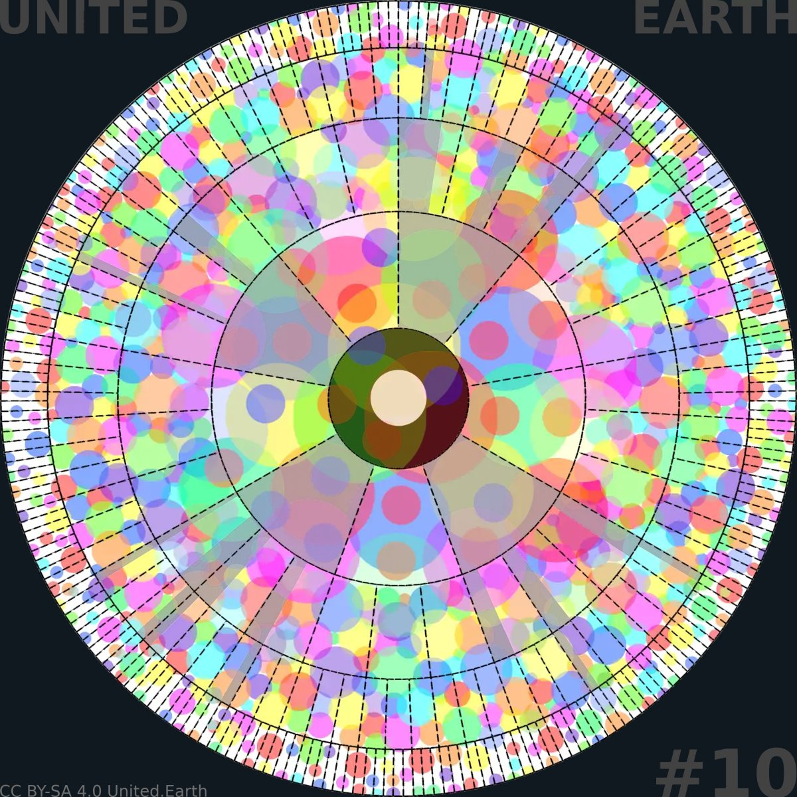
EARTHWHEEL 6/18

The global democratic core matures
At this stage, the global proto-system has developed into a substantial democratic and institutional structure. Proto-Earth Parliament, AGORA, the Councils, the constitutional documents and the proto-branches are increasingly capable of operating together and of developing the future relationship between global law and bloc-based execution.
The blocs continue to grow in number, democratic capacity and territorial authority at the same time. The global level is not being constructed above finished blocs, and the blocs are not being formed independently of the global constitutional order. Each process is now developing in direct interaction with the other.
CC BY-SA 4.0 United.Earth Initiative
The global level cannot wait for every bloc to be finished before it begins to develop. Proto-Earth Parliament matures alongside bloc formation rather than after it. It develops legislative procedures, tests the limits of global competence, and works with emerging bloc institutions to develop and evaluate their future constitutional relationship.
AGORA continues to connect Earth Citizens directly across bloc boundaries, so that global citizenship is never filtered through bloc governments in the way representation to international organisations has traditionally been filtered through states.
The Councils, PAI and AKS, already under development in the proto-system, extend across the emerging blocs so that knowledge, competence and institutional experience can be compared and shared rather than fragmented again.
A global judiciary in protoform develops procedures for conflicts between the global level and the blocs before those conflicts carry binding legal consequences. Earth Government prepares for the planetary commons and global systems it may later administer, not for general authority over land, which remains with the blocs.
All of these relationships remain voluntary and experimental at this stage. Their purpose is to make the global constitutional core concrete enough to be tested, criticised and revised before it can receive authority.

24.4 Connect Parliament and blocs
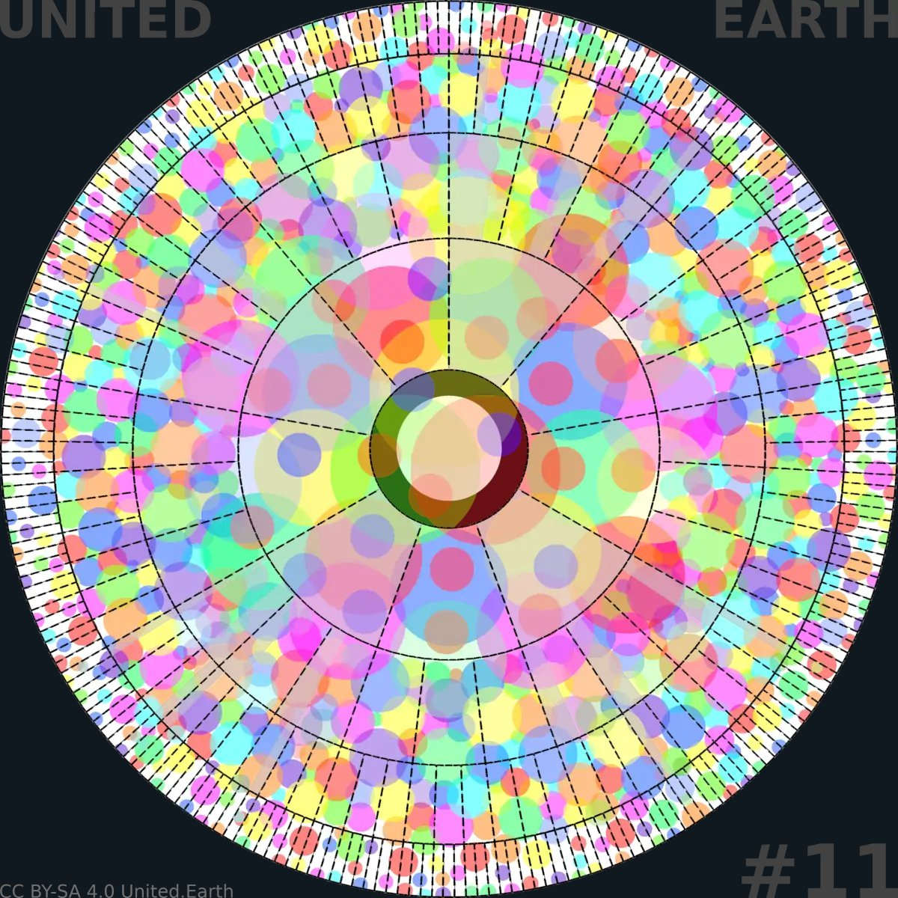
EARTHWHEEL 6/18

The federal relationship is ready for ratification
At this stage, the relationship between the global level and the blocs has been developed and tested as one constitutional structure. Global legislative authority, bloc-based territorial execution, subsidiarity, judicial review and the distribution of coercive power have been connected through procedures that can be understood, challenged and revised.
The two evolutions that began to converge in Earthwheel 8 now form a coherent and ratifiable alternative. The structure has been built in protoform, but it does not yet hold binding public authority. That requires the constituent threshold, the global referendum and constitutional activation described in the following sections.
CC BY-SA 4.0 United.Earth Initiative
Global legislative unity, territorially distributed executive power is the constitutional principle WHAT sets out for the completed federation. What must be built here is the working relationship that can later make that principle real.
This includes simulated conflicts of competence, draft framework laws that establish minimum standards while leaving implementation to blocs, and tested procedures for cases in which a bloc believes the global level has exceeded its authority. The future rules must give blocs the full right to challenge global law through the judiciary without giving them a unilateral right to nullify it. Earth Parliament and AGORA must remain able to revise the law democratically. Neither level can be allowed to give itself the last word outside the constitutional process.
This connection must avoid two failures that would look like success without being it.
The first is treating the blocs as fully sovereign powers that merely coordinate voluntarily through the global level. That would move today’s geopolitical anarchy from the nation-state level to the bloc level.
The second is allowing the global level to absorb the territorial administration and coercive force that belong with the blocs. That would concentrate precisely the kind of power the bloc structure exists to prevent.
Legitimacy must therefore run through both levels at once. Earth Citizens participate directly in global democracy and in the democracy of their own bloc as overlapping political memberships. Blocs do not represent Earth Citizens in place of their direct global participation, and the global level does not replace bloc democracy.
Earthwheel 11 shows a federal relationship that has been constitutionally prepared and tested. It does not yet show a relationship that carries the force of law. A federation that has been built and tested is not yet a federation that holds authority.

25. The threshold: 4 billion Earth Citizens
A proto-system can be technically advanced, democratically tested and constitutionally thorough without yet having enough human legitimacy to establish global authority. A large membership can, in turn, show broad support without there being a finished order to ratify. Both therefore have to develop together.
Four billion verified Earth Citizens constitute the explicit popular threshold that opens the constituent phase, but they do not by themselves give the proto-system constitutional authority. Within United Earth’s process, the threshold prevents a small, self-appointed group from establishing Earth Parliament in humanity’s name. It does not decide what Earth Parliament becomes.

25.1 Grow the movement and the system together
A constituent process needs a threshold defined in advance, one that distinguishes broad human legitimacy from an organisation simply deciding, on its own authority, that enough time has passed. Without it, a comparatively small movement could claim to speak for humanity, a well-built platform could be mistaken for an actual global polity, or political pressure could push activation before anything is ready.
The threshold closes off all three. It makes the goal public and verifiable, binds United Earth to a rule it cannot revise for its own convenience, and keeps the decision to open the constituent phase outside the discretion of whoever happens to be running the organisation at the time.
Four billion is the current rounded expression of a global democratic supermajority, not a fixed number chosen for its own sake. It represents roughly two-thirds of the world’s voting-age population. The exact threshold is meant to track that fraction as global demographics change, using a public, stable and independently checkable method. A verified democratic constituency at this scale would be larger than the electorate of any existing state and difficult to dismiss as marginal or geographically isolated.
The threshold only has this meaning if it counts unique people rather than accounts. Verification has to establish that each person counted toward it is one unique voting-age person who meets the declared eligibility rules, while still allowing public pseudonymity, minimising the identity data actually held, and providing workable alternatives for people without standard documentation.
The total number is not enough on its own either. Legitimacy also depends on breadth: participation across inhabited regions, blocs and states; across languages, income levels and social groups; and among stateless people, diasporas and people participating under real risk in restrictive states. A movement that reached four billion members through a handful of large, similar populations would not carry the same legitimacy as one that reached it broadly, even if the number were identical.
The geographical and social distribution must therefore be measured and published. Any minimum distribution required for the formal threshold must be defined in advance, not introduced after the count has been reached.
Growth has to build capacity at the same time, not just add names to a register. Each stage should strengthen translation, node capacity, moderation, the knowledge system, the Councils, technical infrastructure, legal and financial capacity, and political weight within today’s political systems. A system that works at a thousand participants does not necessarily work at a million, and one that works at a million does not necessarily work at a billion.
Democratic control has to scale at the same pace as the technology, not behind it.

25.2 Meet the popular and institutional thresholds
Four billion Earth Citizens establish the popular threshold, but a meaningful referendum also requires something ready for them to vote on.
The institutional threshold is reached when the constitutional alternative has been developed and tested to the point where we have working proto-institutions, a ratification-ready and stress-tested Rights of Life and Earth Constitution, a credible bloc structure, a functioning succession mechanism, and secure, independently auditable voting infrastructure.
The popular threshold opens the constituent phase. The institutional threshold makes the referendum possible. Reaching four billion with no order ready to ratify would not justify constitutional activation. Having a finished order with no global constituency ready to judge it would not provide democratic legitimacy.
Meeting both thresholds has to be demonstrated, not simply declared. Independent bodies need to be able to inspect the verification system under strict privacy safeguards, check for duplicates and invalid entries, measure and publish the geographical distribution, and review disputed cases. Earth Citizens must also be able to challenge their own status or the overall count through the proto-judicial process.
United Earth cannot be the sole judge of whether its own thresholds have been met.

25.3 Trigger the constituent process
Once the popular threshold is independently confirmed, the transition enters a clearly bounded constituent phase. If the institutional threshold has not yet been met, this phase is limited to completing and independently validating the ratifiable constitutional order.
Once both thresholds are confirmed, the ratification package is frozen and published in full, a global learning period begins, the voting system is independently reviewed, eligible Earth Citizen voters are formally registered, a date is set, and observation and dispute procedures are activated.
What does not happen yet is just as important. Global legislative authority does not begin. Earth Government does not exist. Bloc sovereignty does not transfer automatically. No military command changes hands, and no institutional integration is finalised.
Reaching four billion opens the process through which the decision can be made. It does not make that decision on humanity’s behalf.
Four billion Earth Citizens trigger the constituent process. They do not establish the constitutional order. The global referendum decides whether to ratify it.

26. The first global referendum
The global referendum is where the voluntary proto-system built through this whole page is put to formal democratic ratification. Earth Citizens are not asked to vote on a general ambition toward global democracy. They are asked to decide on the Rights of Life, the Earth Constitution, the institutions and the succession mechanism developed and tested through the process described in previous sections.
The result decides whether the proposed order is rejected or receives the constitutional mandate required for activation.

26.1 Ratify a known constitutional alternative
A referendum can only be legitimate if what it ratifies is already known. Earth Citizens have to be able to read, before they vote, a complete Rights of Life and Earth Constitution; a clear account of Earth Parliament’s authority and its limits; the role of AGORA, the Councils and the branches; the distribution of competence between the global level and the blocs; the judicial system; the peace and security architecture; the succession and activation mechanisms; the transitional rules; and the rules for future amendment.
None of this can be introduced or materially changed after the vote except through the implementation or constitutional amendment procedures established by the ratified order itself.
This rules out one particular outcome: a referendum that asks Earth Citizens to authorise United Earth to work out the details afterwards. What is put to a vote has to be the constitutional order itself, not permission for an organisation to decide on its behalf once the vote is over.
Ratification must authorise a constitution, not transfer discretion to an organisation.

26.2 Hold a direct global vote
The electorate is defined before the outcome is known, using rules that cannot be adjusted once results start to matter: which age qualifies, how newly verified Earth Citizens are treated after the threshold is reached, how statelessness and missing documentation are handled, and how disputes over eligibility are resolved.
The vote belongs to individual Earth Citizens, not to states or blocs. No government controls how many votes its population receives, and no bloc casts a collective vote on its citizens’ behalf. A global referendum organised as a treaty between governments would not be this referendum.
The infrastructure carrying that vote has to be able to withstand attack from any direction: technical failure, government interference, private platform control and manipulation from inside the organisation running it. Authentication, secret ballot, verifiable counting, distributed and redundant infrastructure, and independent audit are constitutional requirements here, not implementation details.
United Earth cannot be the only body checking whether these requirements were met. Independent electoral bodies, technical auditors, civil society observers and accredited Earth Citizen observers, selected through transparent procedures, need real access to the process.
Where governments actively obstruct participation, the voting system must provide protected routes for people entitled to take part: distributed and encrypted access, diaspora support, protected pseudonymous participation, extended voting periods, and documented, publicly reported obstruction. These measures must not expose individual Earth Citizens to danger in order to demonstrate high turnout in a particular territory.

26.3 Make ratification a real democratic choice
A known constitutional text and a secure vote are not enough on their own. Voters need a real opportunity to understand what they are deciding. This requires an information period long enough for genuine deliberation, accessible summaries alongside the full text, translated material, and space for critical analysis and organised opposition that United Earth does not control.
A campaign that argues for ratification while also controlling the information environment voters rely on to judge it is not a fair referendum, whatever the result.
The rule for what counts as ratification, whether a simple majority, a qualified majority, a minimum turnout, a requirement for broad geographical participation, or a combination of these, has to be fixed and publicly justified before the information period begins. It cannot be changed once the process is underway or results begin to arrive.
The process has to be built for a genuine no as much as a genuine yes. A valid rejection leaves the proto-system without formal constitutional authority and obliges United Earth and the wider democratic process to examine why the proposal failed. A future referendum remains possible after public revision, but only under rules that are again fixed and published before the new process begins.
A valid no cannot be reclassified after the fact as insufficient turnout. Where turnout is itself a ratification condition, that condition must already have been established. Nor can a crisis be treated as grounds to activate an order that Earth Citizens have rejected.
Before any activation begins, the result must be independently certified following public reporting, technical and electoral audit, and the resolution of material disputes through the established procedures.
A yes result ratifies the constitutional order, but it does not by itself complete or activate it. It creates the constitutional mandate. The following sections describe what has to happen for that mandate to become an operating global order.

27. Activate the constitution
Ratification creates the authorisation the proto-system could not give itself. Activation makes that authorisation institutionally and legally operative. Proto-institutions do not simply rename themselves and carry on under United Earth’s control. Mandates, infrastructure, resources and constitutional functions have to transfer to the new order according to rules that were ratified in advance, precisely enough to avoid both a vacuum of authority and capture by the founders of the very order meant to replace them.

27.1 Activate constitutional succession
Activation cannot begin on anyone’s say-so alone. It has to follow from conditions that were fixed and ratified in advance: a certified referendum result, confirmation that the ratification rule was met, resolution of all material disputes capable of affecting the result, the ratified Rights of Life and Earth Constitution, a working succession mechanism, and the legal and administrative conditions required to keep the system operating through the change.
Activation cannot begin on anyone’s say-so alone. It has to follow from conditions that were fixed and ratified in advance: a certified referendum result, confirmation that the ratification rule was met, resolution of all material disputes capable of affecting the result, the ratified Rights of Life and Earth Constitution, a working succession mechanism, and the legal and administrative conditions required to keep the system operating through the change.
Confirmation cannot be controlled by a single United Earth body. It requires the independent legal, democratic and technical bodies identified in the ratified process to publish their findings and reasoning, with any dissent recorded rather than smoothed over.
Once the conditions are confirmed, the ratified activation procedure takes effect on the date and through the legal mechanism established in advance. The Rights of Life and the Earth Constitution then become the highest law throughout the activated constitutional order. Earth Parliament’s authority, global legislative competence, subsidiarity, judicial review, succession obligations and the rules for future amendment take effect exactly as ratified, no more and no less.
This does not create territorial jurisdiction over states or territories that have not validly entered the constitutional order. Their later participation still requires the voluntary and constitutionally authorised transfer described earlier.
This does not create territorial jurisdiction over states or territories that have not validly entered the constitutional order. Their later participation still requires the voluntary and constitutionally authorised transfer.

27.2 Transfer the proto-system from United Earth
The prepared succession now has to happen, not merely remain possible. The AGORA infrastructure, Earth Citizenship and verification systems, PAI, AKS, the Council structures, proto-parliamentary and judicial archives, software, domains, funds, agreements and institutional records held by United Earth transfer to the constitutional bodies or public legal entities assigned to receive them.
The transfer follows rules fixed before the referendum, not decisions United Earth makes at the moment of succession. Personal and verification data remain subject to the privacy, security and purpose limitations under which they were collected, together with any stronger protections established by the Constitution.
What ends at the same time is United Earth’s private control over what has become public constitutional infrastructure. It loses any right to alter ratified institutions outside the constitutional amendment process, along with any founder’s privilege, veto, ownership position or temporary organisational mandate that conflicts with the new constitutional order.
United Earth itself may be wound down, continue as an ordinary civil society organisation with no special political authority, or transfer its remaining functions into the new order where the ratified rules provide for this. It cannot remain the private owner or gatekeeper of any part of the constitutional system it built.
“United Earth” was always the working name of the initiative and the transition. The constitutional order that succeeds it may carry a different name, decided through the democratic process or under the rules ratified with the Constitution.

27.3 Turn proto-authority into constitutional authority
Earth Parliament moves from a proto-institution to a constitutional institution according to the transition model ratified in advance. The ratified rules may provide for the last democratically constituted proto-parliament to serve as a bounded interim body pending the first constitutional election, or for a separately defined transitional assembly to complete the succession before the ordinary Earth Parliament takes office.
The choice between these or any other models cannot be made after the referendum. Whichever model was ratified, no proto-office holder appoints themselves permanently. Any interim mandate must be public, time-limited and confined to completing the constitutional transition rather than expanding global competence.
The global judiciary enters office as an independent constitutional body from the beginning. It can review the activation process, rule on succession disputes and protect the Rights of Life from the first day of constitutional operation. Proto-era rulings retain only the status assigned to them by the ratified transition rules.
The Councils also move from proto-institutions into their permanent constitutional roles under the mandates and selection procedures already ratified.
AGORA changes from infrastructure governed by a voluntary organisation into constitutional civic infrastructure. Earth Citizenship becomes a constitutional status. Elections and direct votes conducted under the Constitution acquire the public legal effects assigned to them. Access, platform governance and moderation become matters of public law, bound by constitutional rights and subject to the established forms of review.
Earth Citizens outside the territorial jurisdiction of the activated order may continue to participate through AGORA as far as the Constitution permits, but their Earth Citizenship does not by itself create public legal authority within a state that has not entered the order.
Only the executive functions assigned for immediate activation begin at this stage. Building the complete operational capacity of Earth Government, the bloc federation and the global peacekeeping system continues in the following sections.
Activation is bounded by what was actually ratified, not by what would be convenient to centralise while the system is still being assembled. Global authority begins exactly where the Constitution places it. Subsidiarity applies to the activation process itself: administrative convenience is never sufficient reason to draw upward a power the ratified order left below.

27.4 Declare the constitutional order active
Under the ratified activation rules, the designated bodies issue a public declaration once the conditions have been certified and the established activation date has arrived.
The declaration records the certified referendum result, the ratification rule that was met, the confirming bodies and their findings, the legal instruments entering into force, the territorial scope of the activated order, the date of entry into force, and the institutions and functions that now hold constitutional authority.
It cannot add powers, institutions, territories or transitional arrangements that were not ratified. Nor can it postpone or restrict consequences that follow automatically from conditions already met.
The declaration does not create the mandate. It records and activates the mandate the global referendum already created.

28. Complete the constitutional order
Activation makes the constitutional order legally binding, but the activated institutions are not yet necessarily the finished institutions WHAT describes. An interim Earth Parliament is not a fully elected legislature. Constitutionally activated Councils may still have a provisional composition. A small independent body reviewing succession disputes is not the complete judicial architecture the Constitution requires.
This section describes how these institutions reach their permanent constitutional form, how the accumulated knowledge and capacity of today’s international institutions are integrated without automatically inheriting their authority or their flaws, and how legal and administrative continuity is protected throughout the process.

28.1 From active to constitutionally complete
Earth Parliament moves from its interim or transitional form to a fully elected legislature through the first constitutional elections held under the electoral rules ratified with the Constitution. Its permanent organisation, procedures and accountability must follow the Constitution and the institutional architecture described in WHAT, rather than whatever arrangements were necessary during activation.
The Councils, already constitutional institutions in status, move from their transitional composition to their permanent form. Membership is selected through the transparent, competence-based and democratically accountable procedures established by the Constitution, replacing whatever provisional arrangements carried the Councils through activation.
The judiciary expands from the independent transitional body that reviewed activation itself into the complete judicial architecture the Constitution requires: the necessary instances, appeal procedures, distributed access and specialised competence needed to hear disputes across the system.
AGORA has also changed constitutional status through activation. Any transitional administration inherited from United Earth must now give way to its permanent constitutional governance, oversight, access protections and review procedures. The completion of Earth Government’s full operational capacity is described in the main section below.
None of this happens instantly, and none of it should. Completing an institution properly, with real elections, real competence verification and real public scrutiny, takes longer than declaring it complete.
What matters is that every partial or interim arrangement is publicly understood as partial and interim, with a clear timetable ratified in advance. Interim mandates must expire under that timetable. The people or bodies holding them cannot extend their own authority merely because permanent succession is inconvenient. Any exceptional extension must follow a predefined constitutional procedure, be publicly justified and remain subject to judicial review.

28.2 Transform and integrate existing institutions
Existing international institutions, the United Nations system above all, but also regional bodies, international courts, technical agencies and standard-setting organisations, hold something the new order cannot afford to discard: accumulated knowledge, working relationships, specialised staff, infrastructure and decades of institutional memory.
None of this transfers automatically, and none of it can simply be appropriated. Each function must be evaluated according to whether it remains necessary, whether its mandate can operate under the Constitution, and whether its internal structure, often built around voluntary state consent, veto powers and unequal representation, can be reformed to fit a constitutional order rather than an anarchic one.
Where a function is needed and constitutionally compatible, its staff, knowledge and infrastructure can transfer through lawful and negotiated succession arrangements into the appropriate constitutional body: an agency into Earth Government, a technical function into the Councils, or a court’s accumulated jurisprudence into the global judiciary’s working knowledge without automatically becoming binding precedent.
Where a function is no longer needed, or where its structure cannot be reconciled with constitutional authority, it is wound down rather than preserved out of institutional habit. Size, age or historical prestige are not, on their own, reasons for an institution to survive the transition. Function and constitutional compatibility decide what continues.
Institutional succession, not institutional amnesia and not automatic inheritance of authority.

28.3 Establish legal and administrative continuity
Completing the constitutional order also means making sure the everyday business of a legal and political system continues while these changes take place.
Rights, contracts, pending cases, professional qualifications, public records and administrative procedures need clear rules establishing what continues, what transfers, which law applies, which institution remains competent during the transition, and what falls under the new constitutional provisions. The transition rules must also identify which body resolves continuity disputes while the permanent judicial structure is still being completed.
The purpose is not to eliminate every uncertainty, which no transition of this scale could do, but to prevent avoidable legal uncertainty from being transferred to the people and organisations that depend on the system.
Public employees carried over from proto-institutions or absorbed from transformed international bodies need clear terms, responsibilities and accountability. Their previous positions cannot simply continue unchanged, but neither can their rights and accumulated expertise be disregarded.
This work is unglamorous compared with the declaration described here. It is nevertheless what makes the difference between a constitutional order that exists on paper and one people can rely on in the ordinary business of their lives. It is also the condition on which the operational federation described here depends.

29. Complete the global federation
The completion of each constitutional institution is described, and now, this section completes the federal structure those institutions operate within: the blocs as fully functioning territorial governments, the distributed peacekeeping system as an operating reality rather than a tested design, and Earth Government exercising the executive authority WHAT assigns it within the planetary commons and other constitutionally defined global domains.
Only once these connections function does the system described in WHAT stop being a destination the transition has been building toward and start being the order actually in force.

29.1 Complete the federalisation of the blocs
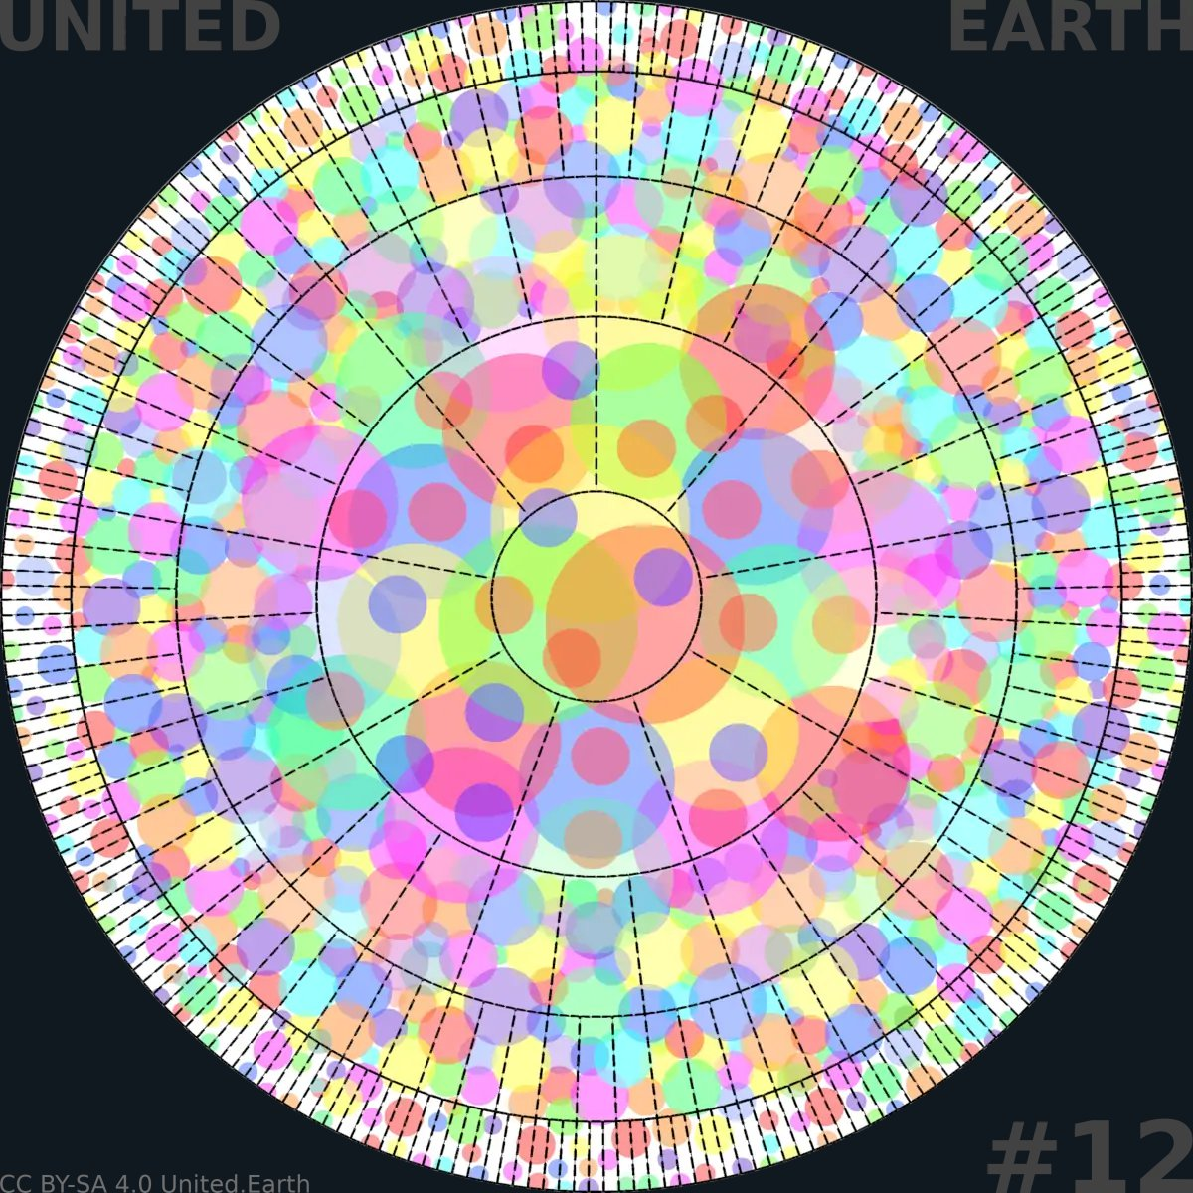
EARTHWHEEL 6/18

The global federation becomes operational
At this stage, the two evolutions introduced in Earthwheel 8 now function as one constitutional system. The blocs operate as territorial governments within the global legal order, the distributed peacekeeping system is active, and Earth Government exercises its defined authority within the planetary commons and other global domains.
The transition is not complete in the sense that every territory has reached the same point or that conflict and systemic risk have disappeared. It is complete in the narrower sense used here: the basic global federation is operational and capable of carrying the work that follows.
CC BY-SA 4.0 United.Earth Initiative
The blocs that emerged from the parallel process described already, together with the territories and institutions reorganised, now complete their federal operaction. Their ratified bloc constitutions are fully implemented through elected bloc parliaments, bloc-wide AGORA participation, bloc Councils, accountable executive and judicial branches, and public finance operating as WHAT describes the finished bloc level.
What is tested and negotiated in protoform now becomes each bloc’s actual, staffed and operating system of government.
This does not happen at the same pace everywhere. Blocs that formed earlier from more developed proto-democratic institutions will reach full federal operation sooner than blocs still absorbing sovereignty transferred by states that authorised the transition later.
Completion therefore does not mean that every bloc reaches the same operational state on the same date. It means that every territory within the activated order is subject to a constitutionally responsible bloc authority, while any remaining transitional arrangement is temporary, public and governed by a defined route toward full federal operation.
The constitutional order accommodates unevenness through transitional arrangements, not by lowering what a completed bloc is required to be.

29.2 Make the peacekeeping system operational
The distributed peacekeeping architecture WHAT describes, developed in protoform and rehearsed through the scenarios and negotiated transitional arrangements, now becomes operational rather than simulated.
Command structures, weapons registries, custody arrangements and the ratified controls on weapons of mass destruction are put into effect. The balance between bloc-held territorial force and the limited global capacity WHAT defines becomes an operating fact rather than only a constitutional principle. Civilian democratic oversight, judicial review and the established escalation procedures govern the use of force throughout the transfer, not only after the new system has become convenient to operate.
At every point in the handover, the lawful chain of command and the responsible civilian authority must be explicit. No armed force may be left under undefined or competing jurisdiction while old structures are dismantled and new ones assume responsibility.
This transition carries its own risk. States and emerging blocs still completing sovereignty transfers, forces moving between old and new command structures, and the general uncertainty created by a large reorganisation of coercive power together produce exactly the kind of instability the finished system is meant to prevent.
Confidence-building measures, transparency, phased handover and continuous civilian oversight during the changeover are not optional extras. Without them, the operational transition itself could produce the crisis the whole design exists to avoid.

29.3 Make Earth Government operational
Earth Government, prepared in protoform since and given only its immediate executive functions at activation, now builds the full administrative, technical, monitoring and enforcement capacity WHAT assigns it within the planetary commons and other constitutionally defined global systems.
These domains include the open oceans, the atmosphere, the polar regions, orbital space and the Earth and Moon system. They also include other global infrastructures, ecological systems and risks placed within Earth Government’s competence by the Constitution. This is operational capacity, not merely a constitutional description of what Earth Government is entitled to do.
Making Earth Government operational also requires establishing the distributed physical and digital presence described in WHAT. The global precincts and top-level AGORA nodes located alongside the principal institutional centres of the blocs, together with replicated records, secure communications and distributed administrative capacity, must function as one global network.
No single city or bloc becomes the physical or technical centre of the global level.
Earth Government’s authority does not extend to general territorial administration over land. The blocs continue to hold that authority under the same constitutional distribution and principle of subsidiarity that have applied throughout this page.
When this work is complete, the federation described in WHAT is no longer a destination. It is the operating structure through which humanity can act.

30. Resolve the global crises and restore the Earth
Everything described on this page exists to produce one thing: the capacity to act together on problems that no state, bloc or voluntary coalition can solve alone. This section returns to the crises that made the whole transition necessary in the first place and asks what an operating global system actually makes possible.
It does not offer a finished policy programme. The content of that programme is for Earth Citizens to decide through the system this page has described, not for this page to decide in advance.

30.1 Turn knowledge into coordinated action
The most important practical change this system produces is not the existence of new institutions by itself. It is a working connection between knowledge and consequence that fragmented sovereignty has never been able to sustain at the global level.
PAI identifies what a problem actually is; AKS organises what is known, uncertain and disputed about it; the Councils assess its scientific, ethical and cultural dimensions; Earth Citizens deliberate and decide; parliaments formalise valid democratic decisions and legislate within their mandates; Earth Government, the blocs and the levels below them implement decisions within their respective jurisdictions; the judiciary reviews them; and AGORA makes the processes and results visible enough to evaluate and correct.
None of these steps collapses into the next automatically. Knowledge does not become law by itself. A Council warning does not become policy by itself. A democratic decision does not implement itself.
What changes is that, for the first time at the global level, these steps are connected through a legitimate chain of authority rather than left to depend on voluntary coordination among states that retain final sovereignty. Disagreement does not disappear. It moves inside a process that can produce a binding and revisable decision rather than remaining outside every process capable of implementing one.
This connection has to keep working under real pressure, not only under the tested conditions described earlier on this page. Real decisions carry real costs, real losses and real interests fighting to protect themselves. Competence weighting, Council independence, AGORA’s resistance to manipulation and the judiciary’s willingness to check power all have to hold up once something is actually at stake, not only while the outcome is still a rehearsal.

30.2 Protect and restore life
The purpose of this capacity is bounded by the Rights of Life and the Earth Constitution. The priorities and policies pursued within those limits are for Earth Citizens to decide through the system itself, not for this page to determine.
The shape of the task is already visible from WHY: climate stabilisation and the restoration of damaged ecosystems; the disarmament and constitutional control of weapons of mass destruction; the democratic governance of artificial intelligence and other technologies operating at planetary scale; preparedness for pandemics and other systemic shocks; and oversight of transnational economic and financial systems that today largely escape accountable authority.
None of this is decided here. A global governance capacity does not mean that every one of these questions is settled globally. Subsidiarity applies here exactly as it applies everywhere else.
What global authority protects are the shared conditions that lower levels cannot protect separately: a stable climate, functioning ecosystems, peace and security under law, safe technology, and resilient economic and supply systems. These conditions make it possible for local communities to continue governing the matters only they can govern well.
Global capacity of this kind does not compete with local life. It defends the conditions local life depends on in a world where the forces threatening those conditions have long since become global themselves.
Global capacity of this kind does not compete with local life. It defends the conditions local life depends on in a world where the forces threatening those conditions have long since become global themselves.
The Rights of Life and the Earth Constitution give the underlying obligations constitutional continuity. The Councils and AKS preserve the knowledge and the record of what has been tried. AGORA keeps the policies used to fulfil those obligations open to democratic evaluation and revision as conditions and understanding change. Long-term commitment must not collapse into either abandonment or a policy that no later generation is allowed to reconsider.

30.3 The system is a means, not the end
Earth Parliament, AGORA, the Councils, the branches, the blocs and Earth Government have no value independent of what they make possible. Their purpose is to increase the probability of good decisions, not to guarantee them.
A constitutional democracy must be able to defend itself against capture, destruction and authoritarian replacement. But its institutions cannot treat their own continuation, or the continucation of their current officeholders, as an overriding purpose. A system that protects particular institutions as ends in themselves rather than protecting the rights and conditions they exist to serve has begun to fail on its own terms.
Subsidiarity does not stop applying once the federation is operational. The task of the global level was never to govern as much as possible, only to govern what cannot be governed well below it.
Subsidiarity does not stop applying once the federation is operational. The task of the global level was never to govern as much as possible, only to govern what cannot be governed well below it.
It is designed to prevent a failure in any single institution from becoming a failure from which the whole planet cannot recover. That is the limit of the claim being made here.
The system cannot abolish the risk of human failure. It can prevent any single failure from becoming planetary collapse.
United Earth’s legitimate role in defining future political outcomes ends with the foundational commitments and constitutional structure placed before the referendum. Democracy, GOV//ID, the Rights of Life, subsidiarity and the limits on concentrated power are constitutive commitments of the system described here.
Within those commitments, and within the constitutional rules ratified with them, specific economic choices, technological paths, implementation methods and balances between competing legitimate priorities remain for Earth Citizens to decide continuously through the system itself.
This page has not been describing the last political decision humanity will ever need to make. It has been describing the structure that finally makes it possible for humanity to keep making the rest of them together.

31. How the transition could unfold
This page has been organised thematically because each process it describes has to be understood as a coherent thing in itself before it can be understood in relation to the others: the political community, GOV//ID, the proto-system, the constitutional order, the transformation of today’s states, the blocs and the global core, the threshold, ratification and activation.
None of them, in practice, will wait politely for the others to finish. This closing section draws the threads back together into one illustrative sequence, and then returns to the only question that actually matters right now: where each of us begins.

31.1 One possible sequence
A single storyline can make the whole transition legible without pretending to predict it. It might begin with alarm turning into organisation: an initial community forming around Earth Parliament Day, Earth Citizenship and the first proto-AGORA, while the mental and legal work of separating governance from identity begins in parallel, with limited initial material requirements. As the community grows, it starts building and testing the actual democratic infrastructure it will need: PAI, AKS, the Councils, competence-weighted voting, and the proto-institutions and constitutional drafts that infrastructure makes possible.
None of this stays confined to the proto-system for long. The same Earth Citizens carry the same direction into the political systems they already belong to, through transitional parties, alliances and existing democratic mechanisms, opening nation-states to constitutional reorganisation one democratic decision at a time. As states open, blocs begin to form, and the global democratic core matures alongside them rather than after them, each shaping what the other can become.
Eventually, the popular threshold has been reached and the institutional threshold has also been met: enough of humanity has joined as verified Earth Citizens, and a ratification-ready constitutional order has been developed, tested and independently validated. A global referendum puts that order to a direct, secure and independently observed vote.
If the result is certified and the ratified activation conditions are met, succession transfers the proto-system out of United Earth’s control, and the constitutional order becomes legally operative according to the rules fixed in advance. The constitutional institutions, the blocs and the federation as a whole can then be completed, unevenly but progressively, into an operating global system, capable at last of doing the work of restoring the planet.
Read this way, the sequence has a shape. It is not a timetable, and no part of it is guaranteed. Each stage described above depends on political decisions, technical development and human choices that cannot be scheduled in advance, and the actual path will loop back, stall and restart in ways a single narrative cannot show.

31.2 Different places, different speeds
At any real moment in this process, different parts of the world will be at different points in the sequence just described. That unevenness is not in itself evidence that the strategy has failed, because it was never designed to move at one pace everywhere.
A territory may have a mature node network and a functioning proto-Council while its national government has not yet opened a single constitutional question. A bloc may be fully federalised while a neighbouring state has only just authorised its first transfer of sovereignty. The governing institutions of authoritarian states may remain outside the process for long periods, while people connected to those societies participate through the protected and indirect forms.
This unevenness has already been addressed at each point where it actually matters: in how blocs form, in how the federation completes, and in how participation is protected under unfree political conditions.
What matters here is simply the general principle for reading the whole page: no single global clock governs this transition, and treating any one part of the world as representative of all of it will misread both its progress and its risks.

31.3 Begin where we are
The later stages have real prerequisites, but no one needs to wait for the whole sequence to exist before beginning the parts that can begin now.
Someone can join as an Earth Citizen today. A node can be founded in a city, a profession or a field of knowledge before the platform that will one day connect it to millions of others is fully built. A contribution to PAI or AKS, a proposal tested in an early vote, a chapter of the Rights of Life drafted and criticised in the open, or a political alliance formed to carry GOV//ID into a single parliament: all of it is real work on the actual transition, not preparation for some later, more meaningful phase of it.
United Earth must build the democratic global system before the world is forced to choose a global system in panic.
The future cannot be predicted. The democratic path can be built.
Let’s build it.

